The Royal International Air Tattoo 2024
Delivery Instruction
Number: 6.3
Title: Volunteer Campsite
Owner: Alicia Pullen
RIAT Ext: 5666
Department: Volunteer Engagement
Revision: 0.1
Date: 24.04.24

Objective: | To outline the administrative, logistic, and organisational arrangements applicable to the Volunteer Campsite on Site 14
Applies to: | Volunteer Engagement  Campsite Manager (FTC)  Team Reception  Ground Operations  IT & Comms
Policy or handbook reference: | RIAT 2024 CAD Map  RIAT 2024 Event Risk Assessment
Pre-requisites: | N/A



This Delivery Instruction is a part of a series of publications as described in the RIAT 2023 Event Plan. Delivery Instructions are produced by the Royal Air Force Charitable Trust Enterprises to ensure that the Royal International Air Tattoo is staged effectively, efficiently, and most importantly, safely. Should there be any concerns regarding the content of this document, please refer the matter to your RIAT Manager, the author, or in their absence to SOC (Ext 5131 during the show week) as soon as possible.

RAF Fairford is always an operational airfield, and many critical rules apply.

Standard Distribution
All completed LIs can also be accessed via: RIAT23 Showbook
All Directors and Heads (Sharepoint)
All Staff (Sharepoint)
Comms and IT (Sharepoint)
Volunteer Managers (via RIAT Managers)

420 ABS (USAF RAF Fairford) - Mrs D Blake (via Ops Director)

Additional Distribution
(responsibility of author and must be in PDF)
For Action:  Volunteer Engagement  Campsite Manager (FTC)  Team Reception  Ground Operations  IT & Comms | For Info:  People & Sustainability Director  Operations Director  Night Duty Officers
Emergency Telephone Numbers | General Communications
3333 Dial from RIAT Ext. only  (01285) 713999  when dialling from a mobile phone or external telephone (diverts to Ext 3333)  999 Dial from any Ext or phone | Tel: 01285-713300 for operator  Web: www.airtattoo.com  Email: customer.services@rafcte.com
Postal Address
RAFCTE, Douglas Bader House, Horcott Hill, Fairford, Gloucestershire GL7 4RB, UK

In organising The Royal International Air Tattoo, The Royal Air Force Charitable Trust Enterprises (RAFCTE) aims to support its parent charity, The Royal Air Force Charitable Trust (RAFCT). RAFCT’s mission is to Promote the Royal Air Force and Inspire young people and Royal Air Force personnel to fulfil their potential in air, space and technology (further information at www.airtatttoo.com). The Charity will do this by: staging the Royal International Air Tattoo and other similar activities; by giving financial grants to satisfy the Trust’s objectives; and, by funding scholarships and other awards. RAFCTE will deliver RIAT to provide the highest possible standard of entertainment for those visiting. The event aims to foster friendship, co-operation and understanding among the many air forces participating from around the world and to inspire the audience and in particular, the next generation, in all aspects of aviation.

Purpose | The Volunteer Campsite provides a temporary camping area with facilities, including toilets and showers, a small dressing area and water boiler for volunteers and staff who choose to camp whilst volunteering at RIAT.  Volunteers and staff are welcome to bring their own camping equipment, to include a tent, caravan or motorhome and associated equipment. They must request a pitch during their online registration process, which should be completed prior to arrival.  On arrival all volunteers must check-in at Team Reception first and campers will be directed to the campsite cabin, located on Site 14, where a member of the campsite team will be waiting to allocate them a pitch. Wherever possible, campers will be allocated a pitch situated within their team.  Electric hook-up can be requested at registration stage for motorhomes and caravans, however, cannot be guaranteed. Volunteers are requested not to arrive early as their passes will not allow access to the site or Dining Facility.  An area of the Volunteer campsite is dedicated to the UAS (University Air Squadron), who attend RIAT to support various teams. Volunteer Engagement hire 40 x Stardom Tents from Tangerine Fields for this purpose. Tangerine Fields will rig and de-rig the Stardom Tents and will space them according to our regulations (3m spacing)  There will be an area on the campsite for 40 x Rockdom Tents which have also been hired from Tangerine Fields, for those volunteers on the Customer Experience and Merchandise & Programmes Teams, who are staying for 2-4 nights. Tangerine Fields will rig and de-rig the Rockdom Tents and will space them according to our regulations (3m spacing)  Military Style Tents (USAF) & Bed-Stay Pods: 22 USAF Tents (Alaska) loaned by USAF. 120 bunkbeds/ pods hired from UK Bed-Stay, to place inside the USAF Tents. Each volunteer will be allocated a bunkbed to themselves and can use the second vacant bed space as storage.  Two Military (Alaska tents) will be attached as one. 7 tents will have a configuration of 9 bunkbeds and 4 tents will have a configuration of 16 bunkbeds. Each bunk bed will have a curtain and the configuration of 9 bunkbeds will have an additional ‘changing area’ for privacy.  Lockers will be provided to assist with the safety of valuables. Ablutions will be in the campsite for use. Volunteers are required to supply their own bedding for the duration of their stay. USAF to rig Alaska style tents. For volunteers staying approximately 2 - 6 nights.  Marquee & Bed-Stay Pods: 40 bunkbeds/ pods hired from UK Bed-Stay, will be put inside a 12m x 24m marquee (hired from Good Intents) on the volunteer campsite. One volunteer will be allocated a bunkbed to themselves and can use the second vacant bed space as storage. Lockers will be provided to assist with the safety of valuables. Ablutions will be in the campsite for use. Volunteers are required to supply their own bedding for the duration of their stay. Each bunkbed will have a curtain for privacy and will have a changing area. For volunteers staying approximately 2 - 6 nights.

Location | The campsite is split into the following areas:  - Campers bringing their own tents who have requested a pitch via registration are to use the grassed areas on Site 14, adjacent to the Commissary  - The Commissary front carpark is for motorhomes and caravans only  - The Commissary back carpark can be used for a ‘holding bay’ area, for those volunteers who may arrive overnight  - USAF tent location - middle of site 14  - Marquee location - used to be ‘free camping’ area to the left of the front of the commissary  - Rockdom tent location - along the parking bays on site 14  - Stardom (UAS) location - area of the volunteer campsite nearest ablutions

Volunteer Campsite Responsibilities | Ground Operations are responsible for getting the grass cut on Site 14, by 30th June.  Volunteer Engagement and the Campsite Manager are responsible for layout/ mark out the week prior to the campsite opening.  Ground Operations will book and arrange the rig and de-rig of any ablutions (toilets and showers) and will source and arrange for power and water etc via an external contractor. A site visit should take place from any contractors beforehand via Ground Ops.  The campsite manager has overall responsibility for the day-to-day management of the campsite during volunteer arrivals and departures and will report to the Team Reception Manager.  The campsite team is made up of 1 campsite manager and 3 campsite assistants, who are all part of Team Reception, see DI 6.1 Team Reception. The campsite team are split into 2 ‘shifts’ as per the Team Reception Rota. Team Receptionists can assist with the campsite if required.  Team Reception Manager to provide an expected list of campers to the Campsite Manager prior to arrivals. This is to include Name, Team, Contact Details, any special requests and electric hookup requests.  Volunteer Campsite Team are responsible for allocating pitches, providing a campsite safety brief, ensuring toilets and showers are clean each day, campers are adhering to campsite rules, litter picking, reinforcing quiet hours and ensuring the safety of all campers. They can help with maintenance issues onsite.

Concept of Operations

Operating Hours | The Volunteer Campsite mark out/ layout will take place on the weekend of Saturday 6th July. The Volunteer campsite will be available for use from 12th July to 23rd July 2024.  Team Reception operating hours are shown in Table 1. The campsite manager and 3 campsite assistants are part of Team Reception; hence the operating hours are the same. The campsite team should be ready to welcome arrivals and see off departures during these timings. The team may also be expected to stay post-closing hours to ensure the area is clean and tidy for the next day.
  Date | Open | Closed
  Friday 12th July | 1230 | 1730
  Saturday 13th July | 0830 | 1730
  Sunday 14th July | 0700 | 2000
  Monday 15th July | 0700 | 2000
  Tuesday 16th July | 0700 | 2000
  Wednesday 17th July | 0700 | 2000
  Thursday 18th July | 0700 | 2000
  Friday 19th July* | 0700 | 1700
  Saturday 20th July* | 0700 | 1700
  Sunday 21st July* | 0700 | 1700
  Monday 22nd July | 0800 | 1500

Access | Volunteers can request a small 6m x 4m or large 8m x 6m pitch via registration. There will be space for one vehicle per pitch. If volunteers request to share a pitch and have 2 cars, one car will be required to park in the team carpark, located opposite Site 14, next to Douglas Bader House.  If sharing a pitch, the lead volunteer (as recorded during registration) will be issued a Site 14 vehicle pass on arrival at Team Reception. This vehicle pass will detail Site 14 parking permissions and should be displayed in the vehicle window.  Campers can arrive the day of their volunteering start date or the day prior.  On arrival at RAF Fairford all volunteers should check in at Team Reception, to obtain their welcome pack, along with personal ID pass and vehicle passes and will be directed over to site 14 if camping.  On arrival at the campsite, campers should check in with the campsite manager or a member of the campsite team (usually located at the campsite cabin/ reception). The campsite cabin/ reception is located at the beginning of the trackway onto the campsite (near ablutions).  Campers can choose an appropriate pitch for their tent, caravan, or motorhome – pitches cannot be reserved and will be confirmed by the campsite manager. The campsite manager will situate campers within their teams where possible. They will be issued with a campsite safety brief and their pitch number and vehicle number, will be captured by the campsite team.

Management and organisation

Campsite Facilities | The Volunteer Campsite will be arranged to permit caravans, motorhomes, tents, and campervans. The layout of the site is at Annex B. The site will consist of pitches 8m x 6m and 6m x 4m. There should be a minimum of 3.5m between structures and there will be clear lanes for access in the event of an emergency. The campsite manager will advise campers on arrival of where they can safely arrange their equipment.  Ablutions are provided in a centralised area within portacabin type structures, which are connected to mains fresh water and waste services. The facilities will be cleaned at least twice daily by an external contractor.  Those using their own chemical toilets will have access to a waste tank and adjacent tap.  Electrical Hook Up points (EHU) will be provided for caravans, campervans, and motorhomes where possible. These will be available to request during registration. If the maximum number of points is reached a member of the Volunteer Engagement team will contact the relevant volunteer to advise them. Please be aware that this is a temporary site and there could be unforeseen circumstances when the EHU is not available, and we have been advised to inform users that they should not rely on the EHU for any medical equipment as they are not guaranteed as a 24hr supply.  Drinking water will be available to all using the Volunteer Campsite.  Parking adjacent to pitches is not guaranteed, however a space will be available as close as possible for one vehicle per pitch as advised above. Care must be always taken when driving on the campsite and a maximum speed limit of 5-mph must be observed.  Grey water disposal will be available and clearly signed.  Cleaning The campsite ablutions will be cleaned twice daily throughout the period of operation. The Campsite Manager will have details of the planned cleaning schedule, should any issues arise with the condition of facilities campsite users are requested to contact the Campsite Manager or a member of Team Reception during the normal opening hours to advise them of the issue. Outside of these hours please contact the Night Duty Officers (NDO’s) who will be able to assist.

Campsite Rules | The Volunteer Campsite is on Site 14 and there is to be no public access under any circumstances.  Noise levels should be kept to a minimum between 0700 > 2300.  When using EHU staff must completely unroll any surplus cable to reduce the fire risk through overheating.  No campsite fires  No BBQs  No parties  5MPH speed limit on campsite

Rig and De-Rig
By 30 June - Ground Operations arrange for grass to be cut on Site 14
6 July - Campsite Manager arranges mark out, supported by Volunteer Engagement
12 July - Campsite opens (see Rota)
23 July - Campsite closes, and facilities dismantled by Ground Operations

Campsite Manager Responsibilities | The Team Campsite Manager will be responsible for all aspects of the campsite. These include:  1. The layout of the site, stewarding and positioning of the pitches. Supervision of appointed deputies and any volunteer personnel allocated to work on site.  2. Pitch allocations, including safe separation of tents and vehicles.  3. Ensuring the facilities are working as they should, and the standard of cleanliness is acceptable. They will liaise with the appropriate contractor/ staff member to remedy any faults/ issues.  4. Ensuring the campsites are kept clean and rubbish bins are emptied in a timely manner.  5. The situation and daily check of fire points, firefighting equipment and alarms across both sites and ensure access routes are kept clear.  6. In as far as is possible report any H&S incidents or improper behaviour to the necessary authority.  7. Maintain an up-to-date list of the contact details of all campers for use in emergency.  NB the NDO will also have a nightly report, which will detail pitch allocations.  8. Leading a small team of volunteers (1 campsite supervisor and 2 campsite assistants).  9. Having a small stock of items such as a pump for airbeds, spare airbeds, bedding.

Fire Assembly Point | The Fire Assembly Point is opposite the Campsite Reception/ Cabin – see map for location.

Health & Safety

Risks | In addition to the RIAT 2024 Event Risk Assessment there is an activity-based risk assessment at Annex D.

Maps and signs A CAD Map of the Volunteer Campsite is at Annex B to this DI.

The following information/ facilities/ services are signed:

Quiet Hours – 11pm – 7am
Drinking Water
Waste Water
Fire Fighting and Alarm Points
Evacuation Points
Ablutions
Team Campsite Reception/ Cabin
Waste and recycling points

Please:
Respect other residents and their property
Speak to a member of Team Reception if the campsite team are not available
Keep pitches rubbish free
Always observe the 5mph speed limit

Logistics

Logistics requirement coverage | The Logistics requirement for the Volunteer Campsite:  - Structures including ablutions  - Supporting Equipment  - Power  - Vehicle  - Signage  - Pitch Marking (spray paint, mine tape and fixing posts or plastic stake pitch markers)

Logs bid | A detailed logs bid, is located on smartsheets. In addition, the following items are required:  Pitch Tags - reusable.  Steps for the ablution’s

Cleaning

Campsite ablutions will be cleaned a minimum twice daily, if they require attention outside of these times, please speak to a member of the campsite team or Team Reception.

Telephone, IT and radio | The Telephone and radio requirement for Team Campsite is:  - Emergency Phone  - Radio located in campsite reception/ cabin  - Laptop/ PC

List of Annexes
ANNEX A - ORGANISATIONAL CHART
ANNEX B - CAMPSITE LAYOUT
ANNEX C - TEAM RECEPTION AND NIGHT DUTY OFFICER OPENING HOURS
ANNEX D - RISK ASSESSMENT

ANNEX A – ORGANISATIONAL CHART

ANNEX B – CAMPSITE LAYOUT
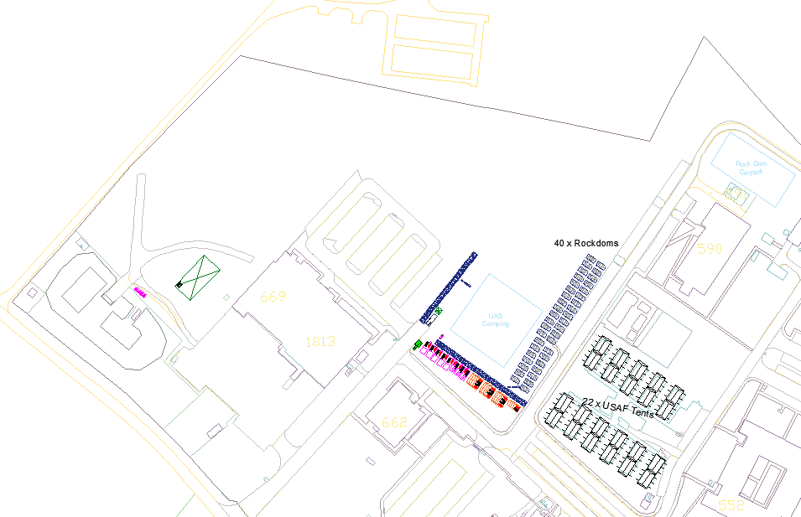
ANNEX C – TEAM RECEPTION AND NIGHT DUTY OFFICER OPENING HOURS
Team Reception Opening Hours:
Date | Open | Closed
Friday 12th July | 1230 | 1730
Saturday 13th July | 0830 | 1730
Sunday 14th July | 0700 | 2000
Monday 15th July | 0700 | 2000
Tuesday 16th July | 0700 | 2000
Wednesday 17th July | 0700 | 2000
Thursday 18th July | 0700 | 2000
Friday 19th July* | 0700 | 1700
Saturday 20th July* | 0700 | 1700
Sunday 21st July* | 0700 | 1700
Monday 22nd July | 0800 | 1500

Night Duty Officer Opening Hours:
Date | Open | Closed
Monday 15th July | 2000 | 0700
Tuesday 16th July | 2000 | 0700
Wednesday 17th July | 2000 | 0700
Thursday 18th July | 2000 | 0700
Friday 19th July* | 2000 | 0700
Saturday 20th July* | 2000 | 0700
Sunday 21st July* | 2000 | 0700
Monday 22nd July | 2000 | 0700
ANNEX D – RISK ASSESSMENT

