Arboricultural Report

Planting specifications for the new development at 28 Horsepool, Bromham

Prepared by: Paul Marshall

Marshall Tree Services
5 The Close
Gastard
Wiltshire
SN13 9PX

01249 701836

Prepared For: Block 9 Developments LTD

Date 31st October 2025

Contents

Page

3 Section 1 -Instruction, Section 2 -Site description and current condition
4 Section 3 -Planting considerations for the new hedge
5-7 Section 4- Directions for planting the new hedge
8-9 Section 5 -planting a new tree
10-12 Section6 -Suggestions for the new planting at the front of the house

1.0 Instruction

1.1 I am instructed by Stephen Kingshott and Jessica Gibbings to visit a development site at 28 Horsepool, Bromham. I am to write;
- A planting specification for a new native hedge to the rear of the development site, number 28 and number 30, as per the prescriptions of the Ecologist’s report compiled by Eco Logic.
- A planting specification for a new tree in the Northwestern corner of the development site.
- I am also to advise on the planting of a new shrub and perennial bed to the South of the new house.

1.2 My credentials to advise on arboricultural matters are that I am a tree surgeon and arboricultural consultant with 22 years of qualified experience in tree surgery and 19 years of experience in arboricultural consultancy. In 2006 I attained the highest marks in the country in the Arboricultural Associations annual examinations for their Tech. Cert. Arbor. A. Qualification. I have also worked as a head gardener before getting into arboriculture.

2.0 Site description and current condition

2.1 The site that I am to advise on is a development plot to the West of Number 28 Horsepool. Numbers 28 and 30 have fully landscaped gardens.

2.2 Thisdevelopment plot is currently under construction. All surfaces are currently being re-modelled.

2.3 Topsoil has been savedin a good manner and is stockpiled in a heap.

2.4 A temporary surface of scalpings has been laid to the South of the new house’s footprint. This will be removed where a new shrub and perennial bed is to be laid at the end of the building project. This bed will be made using saved topsoil.

3.0 Planting considerations for the new hedge

3.1 The Ecologist’s plan recommends planting a new hedge of Hazel,Blackthorn, Hawthorn, Elder and Dog-rose, planted in equal proportions. This hedge is to be sited along the Northeastern boundary of the development site. The Ecologist’s report specifies on in table 4.6 (on page 18) that 0.0128 kilometres -12.8 metres- of new hedging will be required.

3.2 When choosing hedging plants, there are always trade offs to be made.
Smaller trees tend to fare better in the long term and eventually reach full size quicker than larger plants planted at the same time. This is because they have suffered less shock from being transplanted. However, one also does not want to plant tiny plants that may be easily killed by accidental damage or browsing animals.

3.3 Larger plants will look better early on, they are less vulnerable to accidental damage or to being totally wiped out by animal browsing. However, they will demand more water in their first summer and so will need to be watered more often. Larger plants are also more vulnerable to blowing over in strong winds. Bromham is vulnerable to strong winds. I have seen a number of trees blown over in Bromham. When I visited site, the builder told me that this was the only site where he had ever had new block work blown over before the cement cured. This site is likely to be unusually windy and so larger plants will be less appropriate.

3.4 Tighter planting densities allow hedges to thicken up faster but eventually they can lead to trees being less healthy.

3.5 A good balance between these conflicting benefits is to plant a hedge of bare root whips 0.9 to 1.2 metres high. Each whip will need staking with a bamboo cane and a rabbit guard to both protect it from rabbits and reduce the risk of it being blown over. Pot grown stock may be used in place of whips if whips are not available.

3.6 It is important to protect a young hedge from competition from weeds. Removing large numbers of weeds can damage the new trees, either from root disturbance, strimmer damage or herbicide damage. It will therefore be desirable to plant the new hedge through a weed resistant membrane.

3.7 Hedges grow faster if mulched with woodchip (20% to 45% faster depending on the species of tree used to make the wood chip). Wood chip also suppresses weed germination.

3.8 If deer browsing becomes a problem, the hedge will need protecting with temporary deer fencing. However, this risk has not been highlighted by anyone who knows the site, so I am not going to specify it from the start. If, however deer damage is observed, any losses must be made good in the next planting season and deer fencing must be installed.

3.9 It will be important to inspect the new hedge during dry spells and to have a hose pipe on site to water the hedge as soon as the soil under the mulch is observed to
be dry. Drought is the greatest enemy of newly planted trees, which have yet to establish a good network of roots to extract sufficient water in dry conditions.
4.0 Directions for planting the new hedge

4.1 The following supplies must be ordered before the next planting season (November to March). Planting earlier is preferable to planting later in the season, provided ground conditions are not too wet. Minimum quantities are given for a hedge length rounded up from 12.8 to 13 metres. It may be wise to order slightly greater quantities than specified to allow for breakages and losses during planting.

- 65 tree whips 0.9m to 1.2m in height of Hazel, Blackthorn, Hawthorn, Elder and Dog-Rose must be ordered in advance of the next planting seasons. Equal proportion of the trees should be ordered -13 whips of each species.
- 65 Bamboo canes 1 metre in length
- 65 Spiral rabbit guards
- 13 Metres of weed resistant membrane at least 1.5 metres wide
Landscaping membrane
- 52 staples to peg down the membrane -at least 4 staples per metre
- 2 Cubic metres of wood chip mulch

Notes:
The Ecologist’s report specifies planting Elder. Elder is not commonly sold as a hedging plant. If Elder proves hard to source, Guelder Rose (Viburnum opulus) could be substituted. This is a common native hedging species, which like Elder provides white flowers and bears fruit.

4.2 Ordering all the supplies from a single large hedging supplier will save considerable effort and may allow for all the supplies to be delivered at once.

4.3 3 to 4 weeks prior to the planned planting date, all vegetation in a 1.5 metre wide swathe along the line of the new hedge should be sprayed with glyphosate to kill it.

4.4 If the new hedging plants arrive early or if weather or ground conditions do not permit planting, the new plants should be heeled in in their bundles until it is time to plant them.

4.5 The area for planting is already in good condition. It should be prepared by removing the existing length of fence. It is not necessary to turn over good soil provided it is level and free of roots and stones. Loose soil will make young trees more prone to windthrow on this very windy site.

5.6 This is exceptionally fertile soil and no fertiliser is needed to establish the new hedge. Fertiliser is rarely needed by young trees. They can obtain all the nutrients they need from the soil. They do not need to increase their size by a great percentage in a growing season like crops or annual bedding plants which benefit from fertiliser.

4.7 The membrane should be rolled out and pegged down along the lie of the new hedge.

4.8 The new hedge plants should be planted through the membrane. To do this the membrane must first be slit, using a knife at the correct spacing. The correct spacing is 5 plants per metre in a zig zag pattern. The two rows will be approximately 30 centimetres apart. This will result in plants being about 38 centimetres apart in their rows. It is impossible to be exact in planting a hedge like this but if 5 plants are used per metre and the aim is to plant them in two rows that are a boot length apart, a good hedge will result.

Diagram to show how a hedge of whips can be planted through a slit, weed resistant membrane
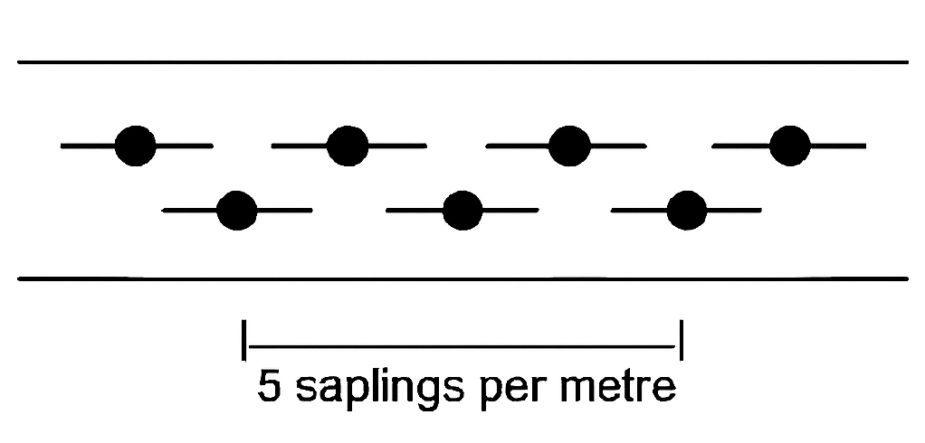

4.9 A good tree planting spade should be employed to make a slit in the earth and the whip should then be slid down the face of the spade into the hole with its roots well spread out. Alternately, trowel may be used. If planting proves awkward, an additional slit may need to be cut in the membrane and soil to make each slit a T shape, allowing the membrane and soil to be better opened. After planting, the ground should be gently firmed with a boot.

Note: Do not lay whips out before planting as their roots will dry in wind and be damaged. Keep the roots of whips wrapped up in a moist cloth or covered with soil, removing them when you actually need them for planting.

4.10 After planting each whip (or pot grown plant) should be given a cane and a spiral rabbit guard. This will give the new trees a degree of protection from animals and from strong winds. The new hedge should then be watered in to help to settle the soil around the new trees’ roots.

4.11 The new hedge should be mulched to a depth of 10 centimetres. Care should be taken to not leave wood ships touching the bases of young trees. Trees can be harmed if fresh wood chip composts next to their stems in warm most conditions.

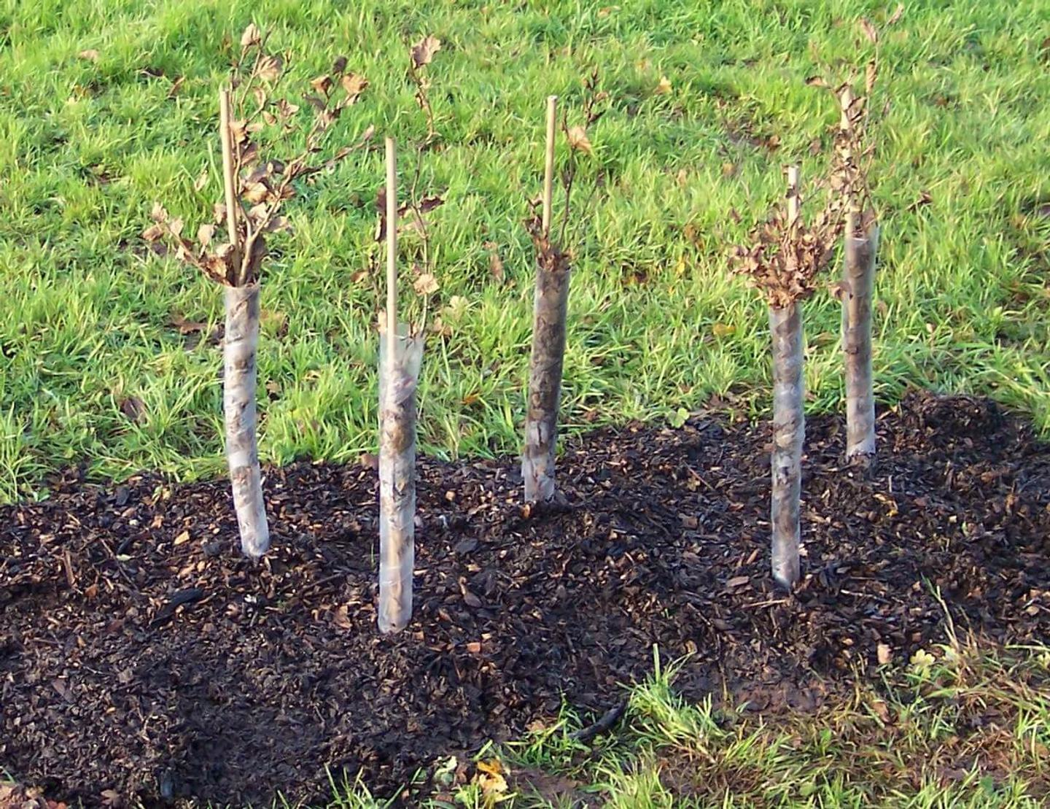
Above is an example of an adequately planted, guarded and mulched metre of double row whip hedging. The job might be improved by fitting the guards to not compress the branches together and the woodchip could be more clearly separated form the base of the trees

4.12 Post planting hedge care

- The new hedge will need to be regularly inspected to make sure plants have not been blown over, damaged or disturbed by animals. Any damage that can be rectified must be rectified as soon as possible.

- If deer damage is found, a temporary deer fence at least 1.5 metres in height should be erected to fence the hedge off from the field behind.

- During dry soil conditions, the new hedge must be watered. Regular checks must be made during dry spells. It is important to pass this information on to the eventual occupant of the property to ensure the hedge establishes well.

- The new hedge should be weeded if more than a few weeds have broken through the woodchip.

- Any losses should be made good with new plants in the next planting season.

5.0 Planting a new tree

5.1 Choice of tree
This is a small site. The proposed development will cover over half of the plot’s surface area with structures with the house, paved areas and the new hard standing. Space is going to be at a premium on this site.

Most native tree species will grow to be at least 12 metres in diameter across their canopies. This gives an area of at least 113 square metres. There are only going to be a limited number of good species that we can choose that will be small and attractive.

It is not always easy to procure a specific specified tree in the correct size. I will therefore give a list of good trees. The following are suggestions. There is no perfect answer but any tree from this list will be fulfil the specifications of being small and having some attractive feature such as flowers, fruit or ornamental bark.

- Flowering Cherry -flowers
- Tibetan Cherry -bark
- Judas tree-flowers
- Small root stock fruit tree such as Apple or Plum -flowers and fruit
- Ornamental Hawthorn tree of a small size -flowers and fruit
- Amelanchier -flowers
- Rowan -flowers and fruit
- Small variety of Magnolia -flowers
- Japanese Maple -delicate form

5.2 Tree size: the tree should ideally be a “Standard” tree -as per British Standard 3936 -Nursey sock specification for trees and shrubs- having a girth of 8 to 10 centimetres at 1 metre height. Not all species of trees are often trained as standards (Japanese Maple for example) and a “Feathered tree” of equivalent size may be substituted.

5.3 Tree planting materials;
- Standard tree -rootballed or pot grown
- Spade
- Stake 1.25 to 1.5 metres in length
- Strong tree tie
- Sledge hammer or post driver
- Small hammer
- Clout nail
  - cubic metre (100 litres) of woodchip mulch

5.4 Planting directions;
- Planting season is November to March. Pot grown trees may be planted outside these dates but they will require more watering
- Clear all surface vegetation from a square metre of ground
- Dig a hole large enough to accommodate the tree’s root ball without bending any of the tree’s roots
- Make sure this hole is exactly as deep as the root ball. To bury the tree too deep will harm it, as will leaving its roots exposed
- Place the tree in the hole and backfill gradually firming soil around the root ball as you go. Do not over compact the soil, especially if conditions are wet but make sure the soil is firm, so the tree won’t rock in the wind
- Stake the tree at 1/3 clear stem height (on a “Standard” tree) on the side from which the predominant wind blows
- Do not damage the tree’s roots with the stake. If possible, drive it diagonally to avoid the root ball.
- Attach the tree tie with a clout nail, not hammered quite home (into the stake not the tree!). This nail may be removed and replaced if the tie needs adjusting
- Cut off any excess stake if it is unsightly
- Water the tree in to settle the soil around its roots
- Mulch the tree to a depth of 10 centimetres, being careful not to leave mulch piled up against the trunk as this could compost in hot wet conditions, damaging the tree

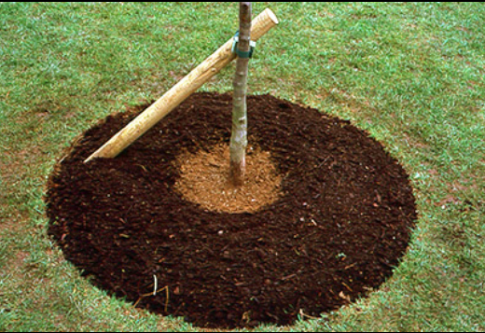
The base of a well planted staked and mulched new tree. Note the stake has not damaged the root ball and the mulch has been moved away from the tree’s base. It may not be necessary to move the much this far from the tree’s base.

5.5 After care of a new tree
The tree will need weeding to remove competition from weeds and grasses which can be a major source of competition for new trees, slowing their growth

The tree will need watering in all dry weather for at least a year and maybe 2 years following planting

The tree tie must be checked annually to make sure it is not too tight

After 2 years the tree should be checked to see if it is firm in the ground. If the tree is firm, the stake should be removed.

6.0 Suggestions for the new planting at the front of the house

6.1 This is a small bed 2.5 by 7 metres in size. This bed will not be suitable for any shrub that has a large eventual size.

6.2 I have looked in neighbouring gardens so as to be able to recommend a number of species that will fit in with the local character

6.3 Suggested planting materials;
- Small shrubs -5 to 7 in number in 2.5 to 5 litre pots
- 15 to 20 perennials in 2 litre pots, to be planted in groups of the same species
- 6 grasses in 2 litre pots, to be planted in groups of 3
- 60 bulbs of 3 different species to be planted in drifts
- 1.75 cubic metres of attractive woodchip or bark

6.4 Suggested planting layout
- At the rear; colourful low shrubs for structure
- In the middle; medium sized perennials and grasses
- At the front; low growing perennials and bulbs in drifts

6.5 It is almost impossible to specify an exact shrub and perennial planting scheme that is achievable with a reasonable level of effort and expense. Inevitably no nursery stocks all of the plants recommended in the sizes recommended. Usually, many nurseries would need to be contacted to source the scheme with unrealistic timescales for supply and high shipping costs.

I will make some general recommendations, which should enable a landscaper to select good plants that will make an attractive long, lived bed. Many of these suggested plants can be found in nearby gardens.

6.6 Some small low growing shrubs
Roses -Hybrid tea, “English” Roses, shrub roses
Lavenders
Cotoneaster horizontalis
Hebes
Euonymus cultivars (silver and golden)
Small Hydrangeas
Spirea japonica
Hypericum
Pieris
Sarcococca

6.7 Some perennials
Oriental poppy
Delphinium
Verbena
Pulmonaria
Salvia
Geranium
Nepeta
Sedum
Aquilegia

6.8 Some ornamental grasses
Blue fescue
Japanese forest grass
Japanese sedge
Liriope
Dwarf fountain grass
Sweet Flag grass

6.9 Some bulb suggestions
Snowdrops
Crocuses
Daffodils
Tulips
Alliums

6.10 Sequence of bed preparation
- If possible, wait till the house construction is complete
- Remove the layer of scalpings and contaminated and compacted soil below
- Edge the new bed with a suitable material such as kerbing, sleepers, bricks or thick paving stones on edge
- Lay the new driveway surface
- Take soil from the storage heap and fill the new bed
- Set out the new plants on the surface of the bed arranging the groups well
- Plant each plant carefully with a trowel
- Water the new plants in
- Mulch the bed being careful not to cover plant stems with mulch

I hope this advice is useful to you and please do not hesitate to contact me if you need any further information or clarification.

Yours sincerely,



Paul Marshall BA Hons. Tech. Cert. Arbor. A. 31st October 2025

