Fram and
Stoke Farm, Broad Chalke
Pond Creation Baseline Habitat Assessment and BNG
Simon Smart & Helen Green
18 November 2025
Version Number – 2.0



Introduction
The following assessment captures the habitat, historic environment and flood risk factors relating to the proposal to create a 2 new ponds at Stoke Farm, Broad Chalke, and potential BNG implications.

Location

Site A is a level site on land currently in a temporary grassland rotation, close to an outlying farm building.

Site B is a level site in a valley bottom, currently modified grassland.

Photograph 1: Site A

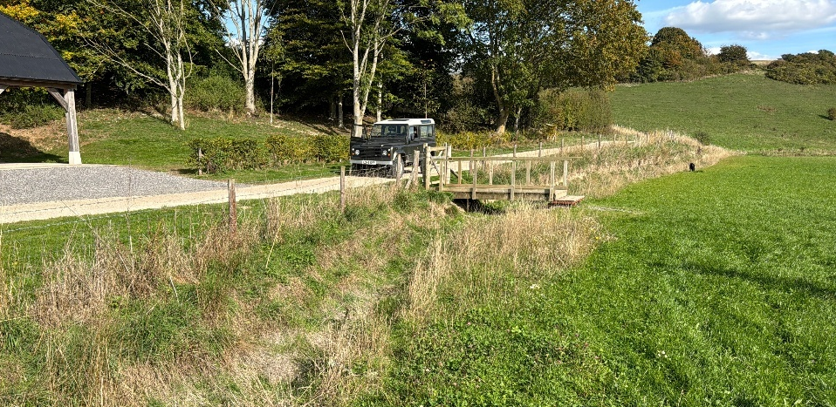

Photograph 2: Site B

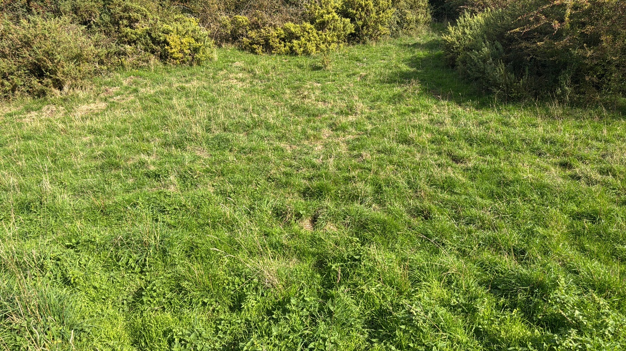
Figure 1: Ownership and Site boundaries
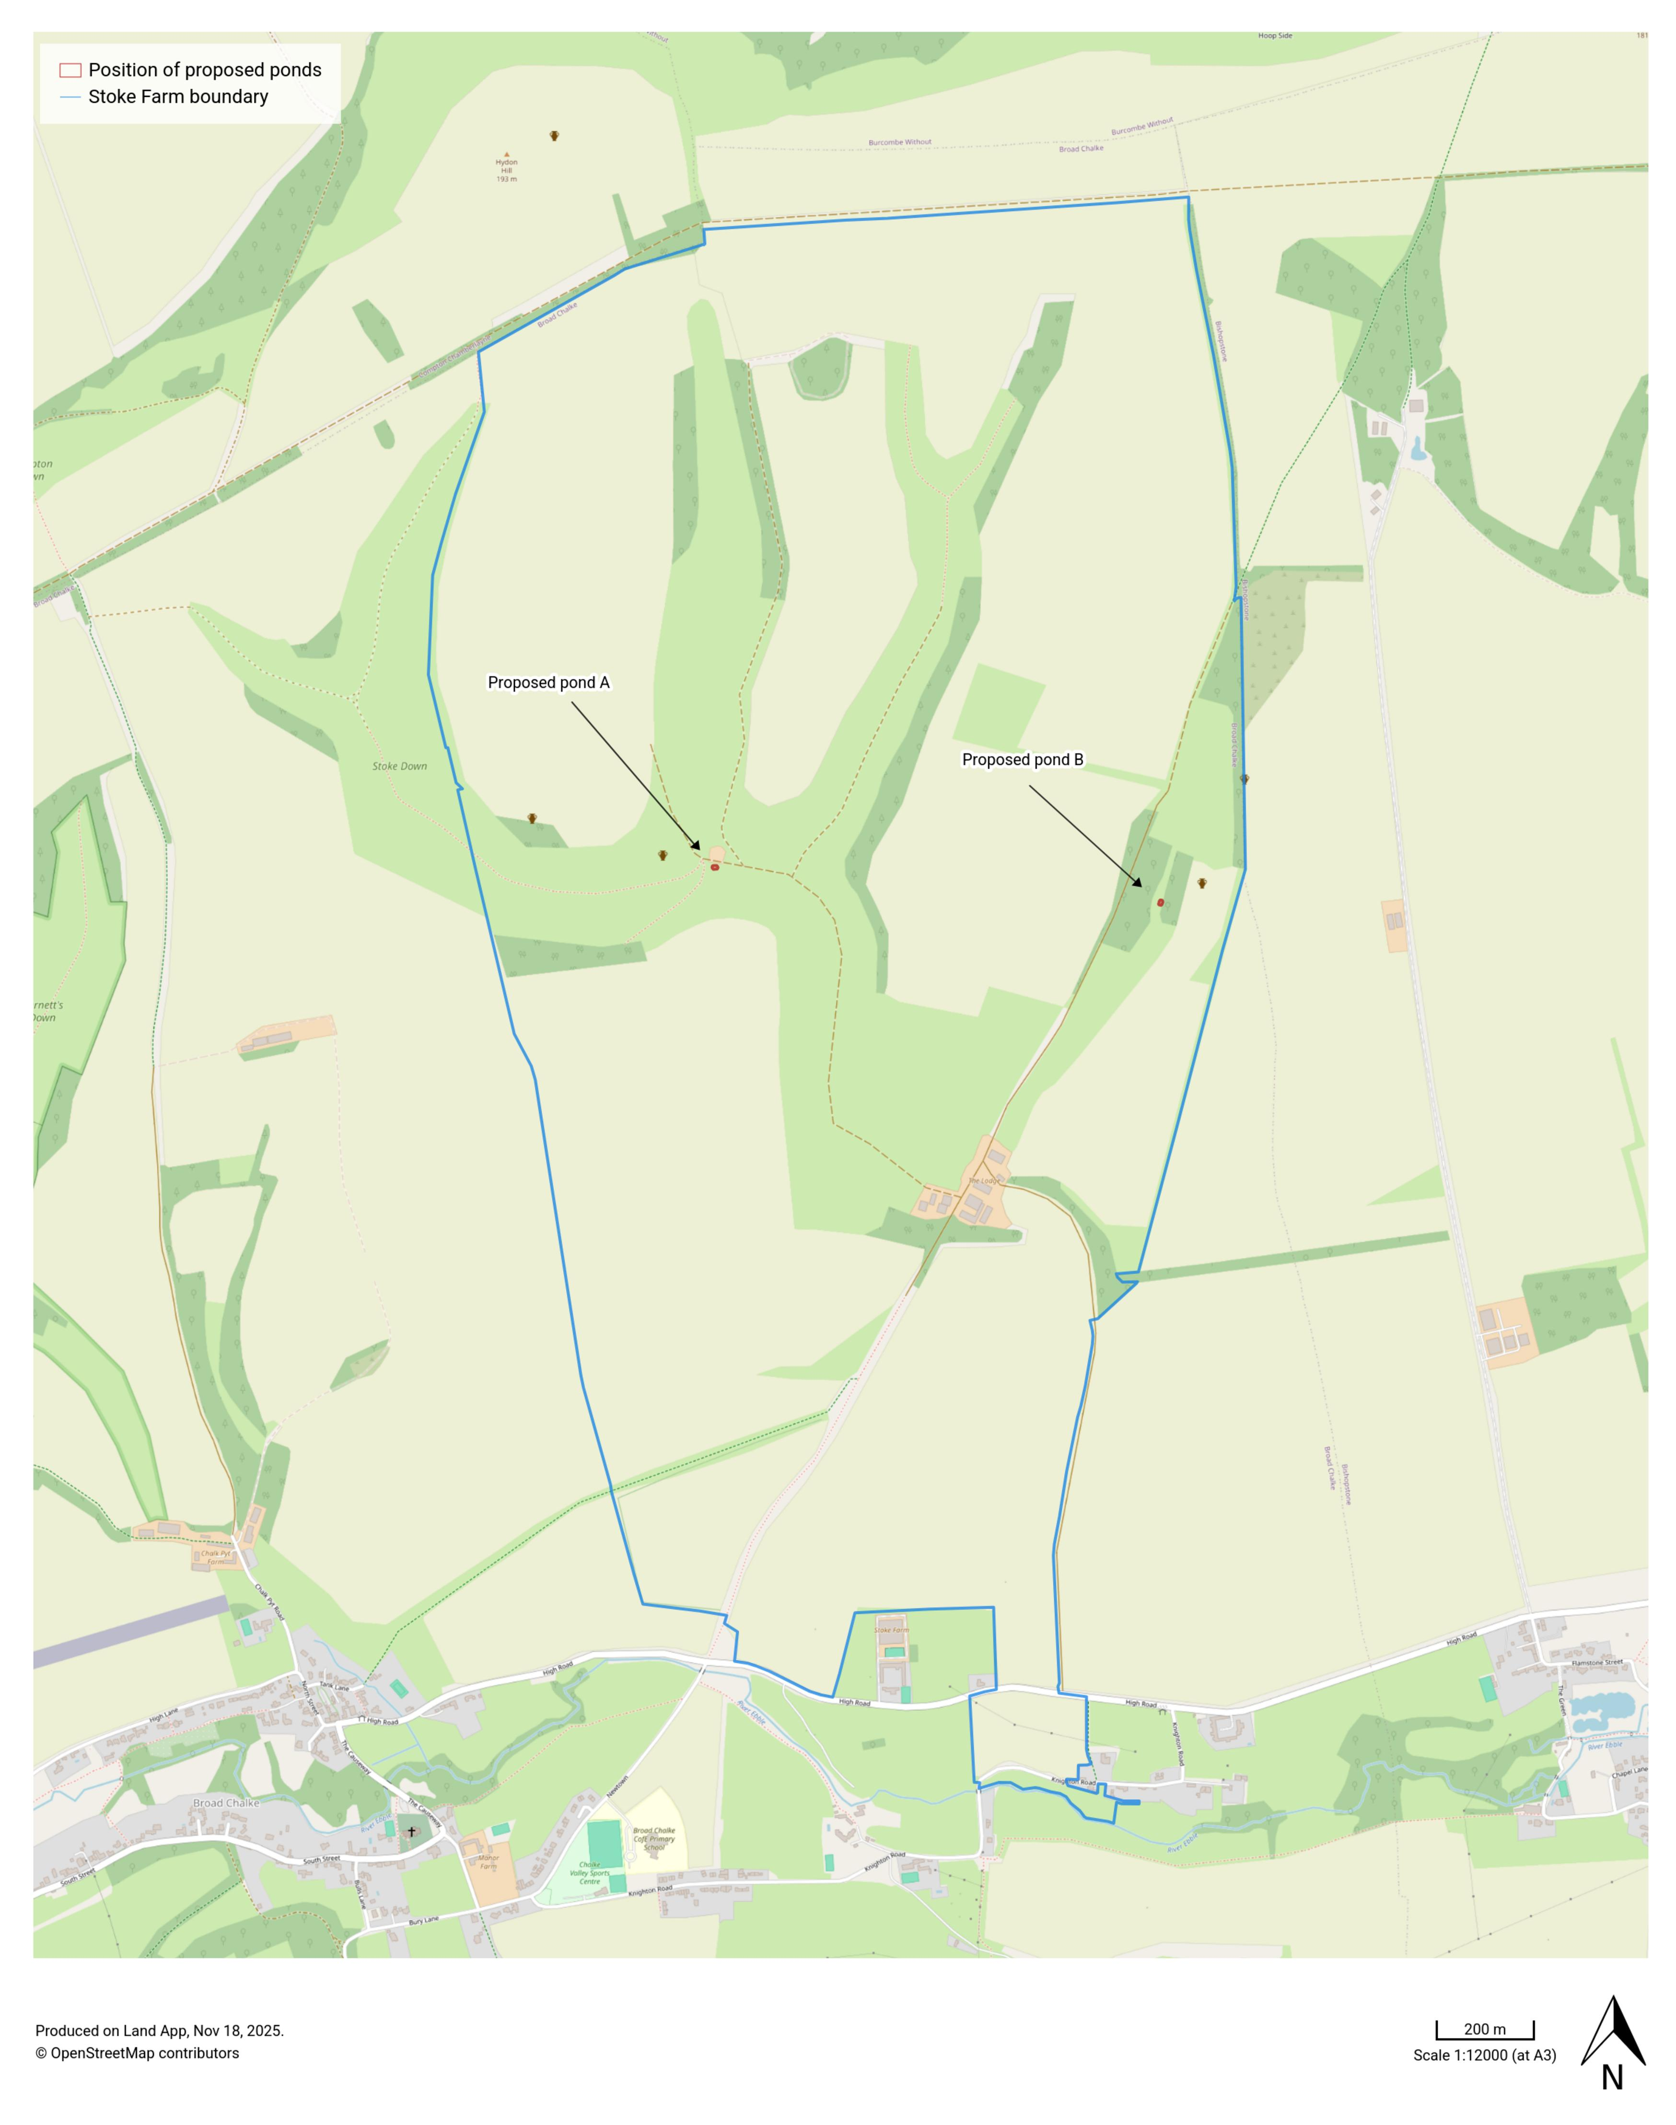

Figure 2: Site boundary A
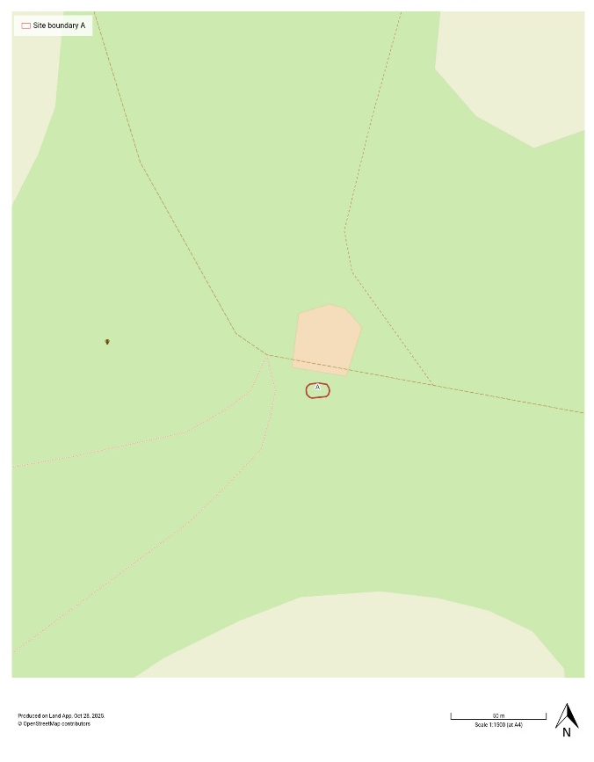
Figure3: Site boundary B
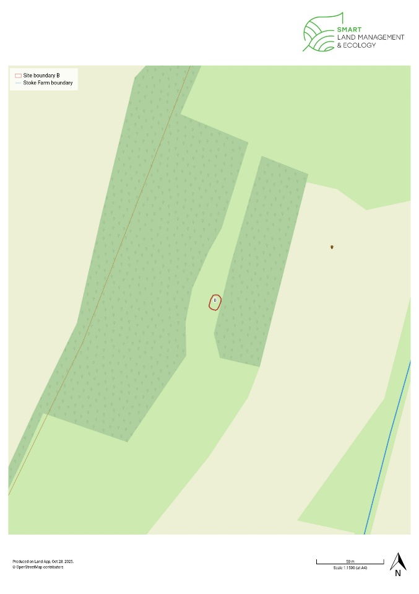
Proposal
The proposal is to create two wildlife ponds by excavating areas 12m x 8m, lining, and letting marginal habitat develop. Pond A will be fed with rainwater from the roof of the adjacent farm building. A full specification is at Annex 1.

Figure 4: Sectional diagram for ponds A and B
1250mm
500mm
200mm
12m
8m
Specification for ponds A and B:
Length max 12m
Width max 8m
Depth max 1.25m
Approx area: 80m²
Scale: 1m = 1cm

Methodology
Data on statutory designations, habitat, species, historic features and flood risk was collated from publicly available data sets.

A survey of the habitat in site B was carried out in November using the UK Habitat Classification (UKHab) system. As site A is in temporary grassland, a survey / condition assessment was not carried out. UKHab is a comprehensive approach for classifying habitats across the UK, designed to support habitat mapping, monitoring, and ecological assessments. It provides a standardised framework that integrates with other classification systems and is widely used in conservation, land management and ecological research. The system is aligned to Governmental Biodiversity Net Gain requirements and has been designed to provide a more consistent baseline for monitoring land use change. The Natural England statutory Metric tool was used to interpret the data and provide the BNG data output.

Results

Landscape: Both sites fall within the Cranborne Chase National Landscape.

Flood risk: Neither site fall within a flood zone.

Habitat: The Wiltshire & Swindon Local Nature Recovery Strategy identifies increasing the number and habitat quality of ponds as a priority across the wider countryside.

Site A is on temporary grassland; the Priority Habitat Inventory shows it is close to areas of Lowland Calcareous grassland (Figures 5 and 7). Site B is on permanent grassland; there is an area of Priority Habitat Deciduous Woodland to the west (Figure 6). The permanent grassland in site B is assessed as Modified grassland (Figure 8) in poor condition (see annex 2). There are no other statutory designations on or within 1km the two sites.

Neither site falls within the area designated as County Wildlife Site (CWS), however site A is near to the CWS on 3 sides (Figure 9).

Figure 5: Priority habitat inventory - site A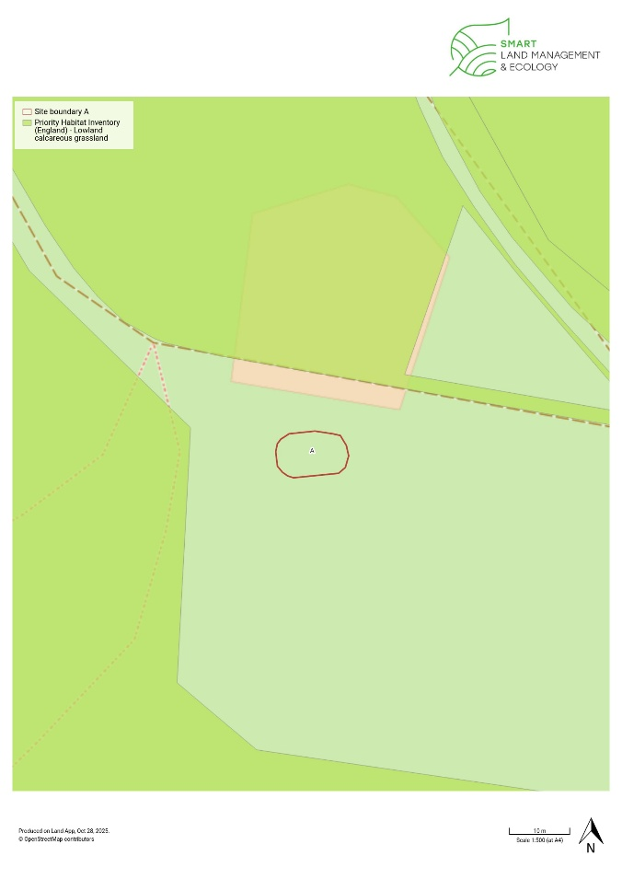Figure 6: Priority Habitat Inventory - site B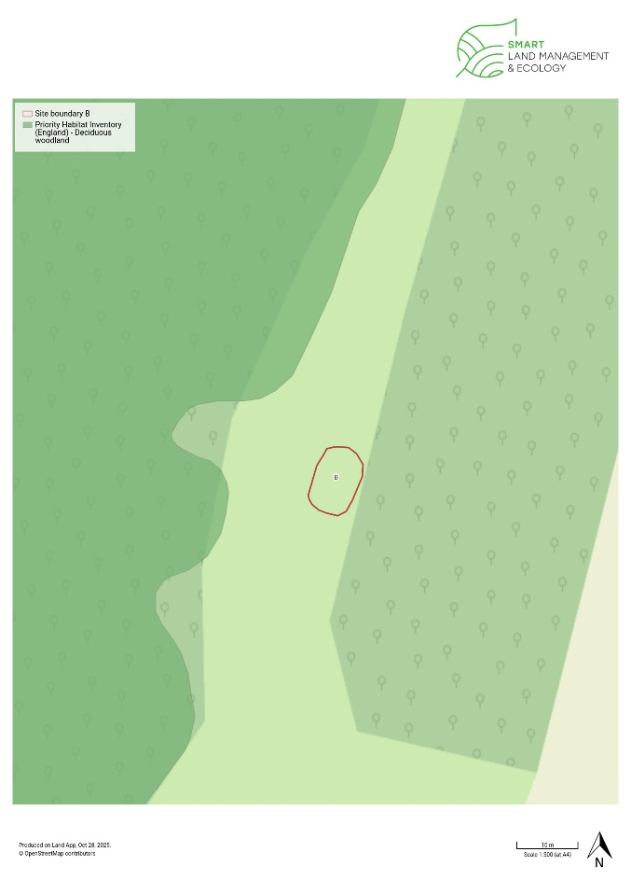

Figure 7: Habitat assessment – site A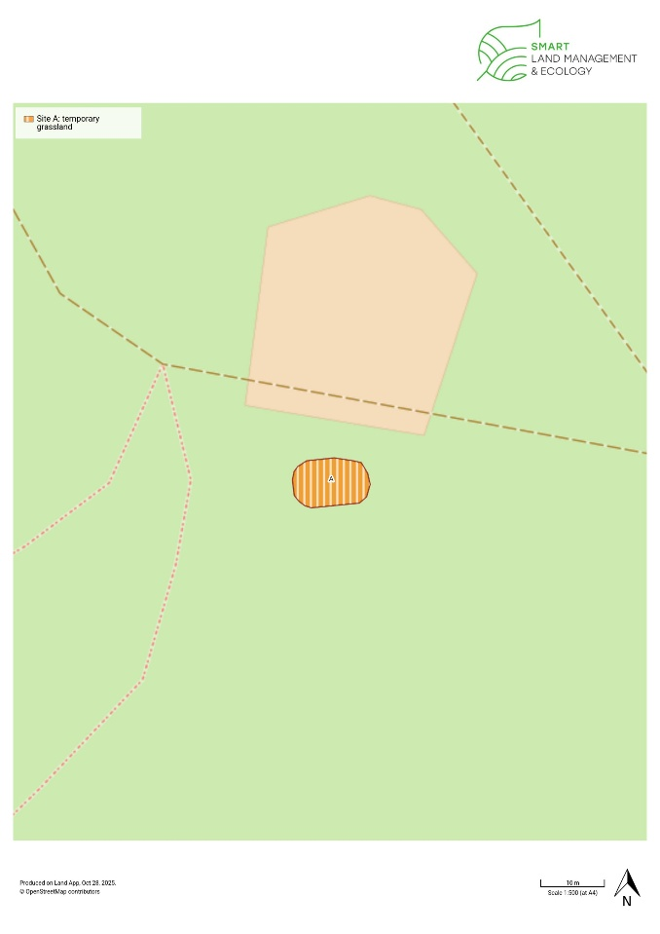

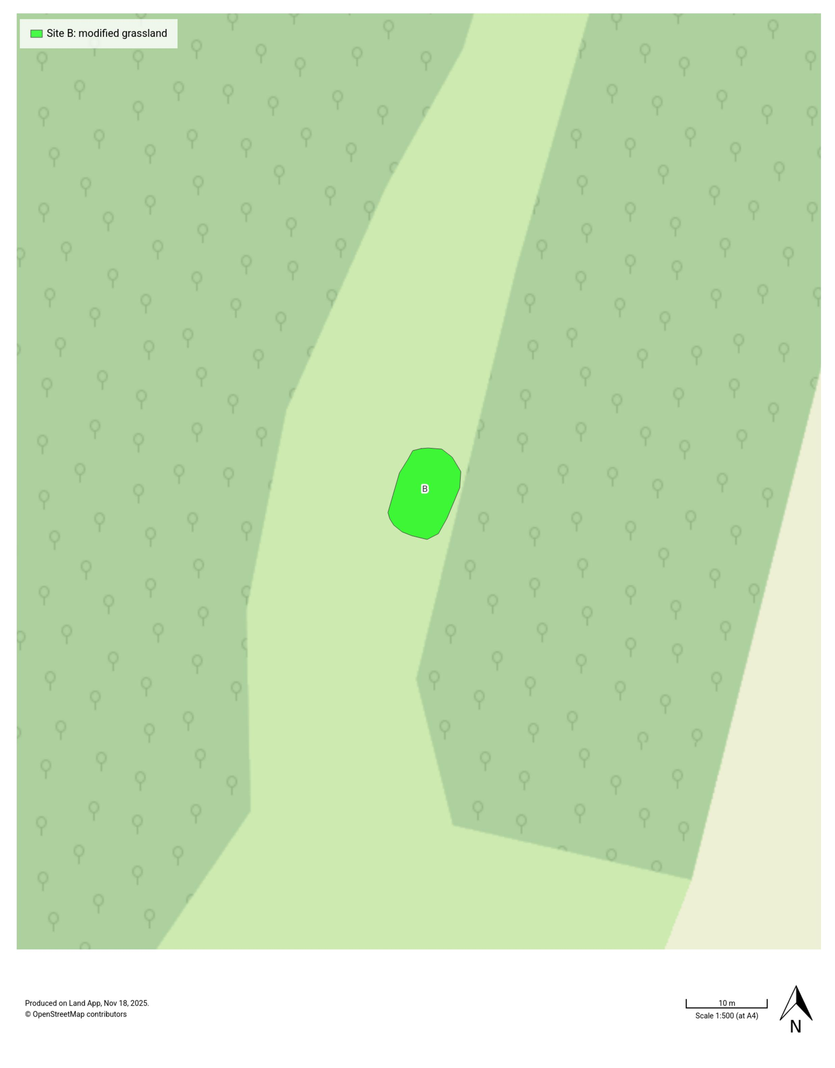
Figure 8: Habitat assessment – site B

Figure 9: County Wildlife Site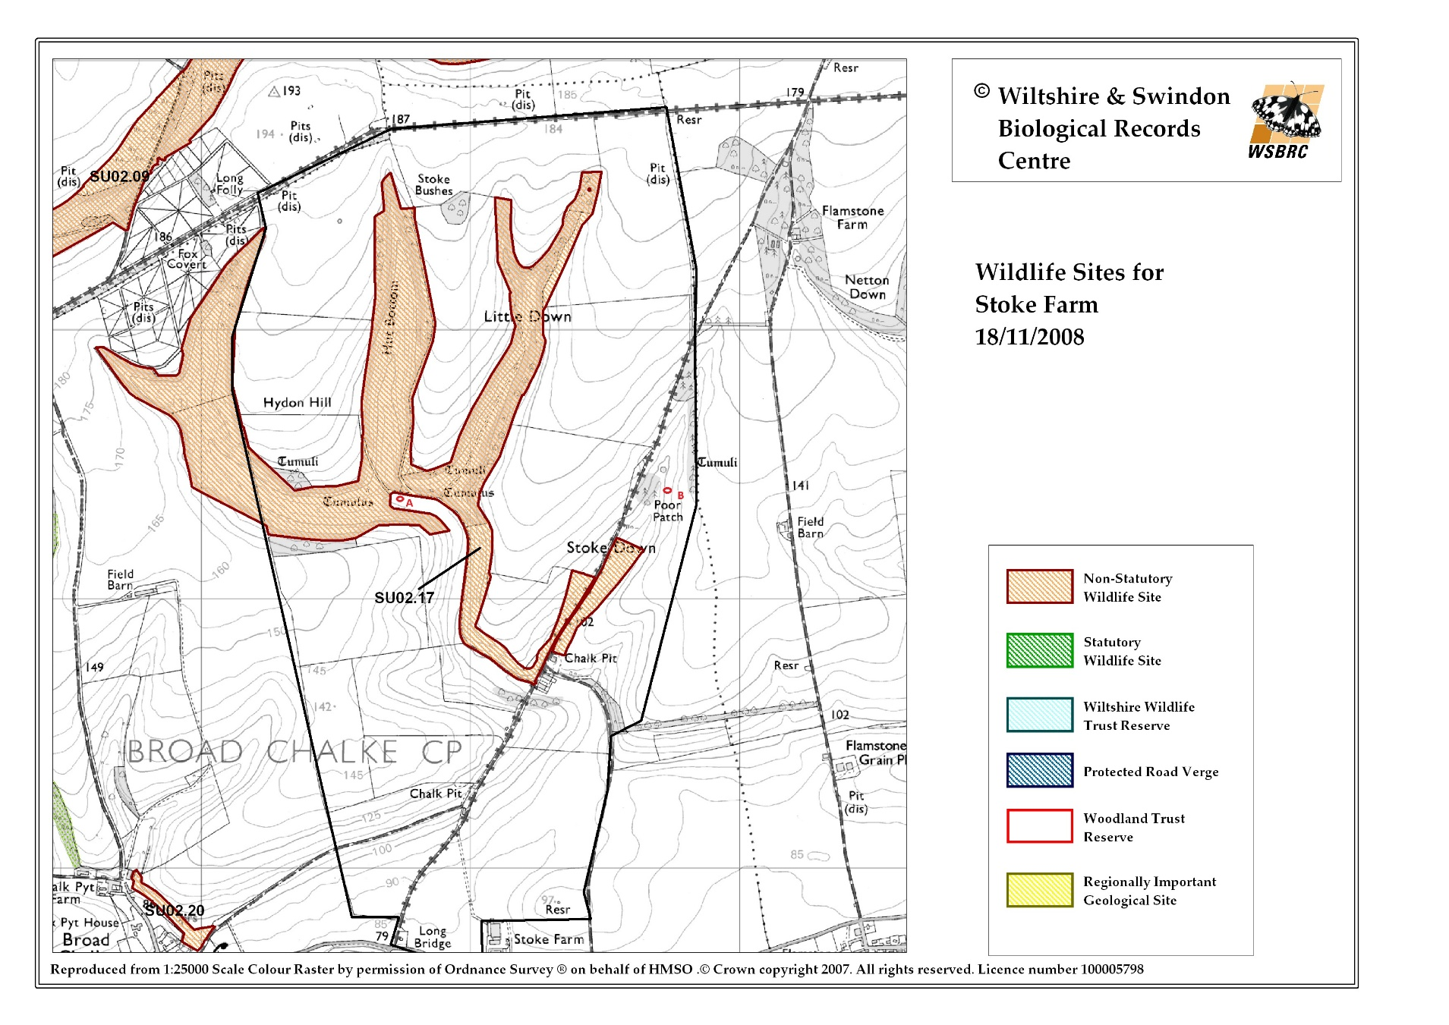

Species: The NBN Atlas was consulted for species records in the proximity of the proposal. All the records within 0.1km of Site A were for plants associated with the nearby Lowland Calcareous grassland. Within 0.5km of Site A there are numerous records for insects, again many of which are associated with the Lowland Calcareous grassland such as Adonis Blue, and bird records (see Annex 3).

For Site B, there are no priority species records within 0.1km of the site. Within 0.5km there are records for plant species associated with the surrounding neutral grassland and scrub as well as a small number of insect records also associated with the grassland habitat such as Red-shanked Carder Bee.

There are no bat records within 0.5km of the site, however, a number of bat species are known to be present within the Chalk Valley including Greater and Lesser Horseshoe, and Barbastelle. Bats as well as a number of farmland birds found within the area, including corn bunting, lapwing, yellowhammer and linnet will benefit from the presence of ponds in the landscape. Additionally, the local farmer group has a priority to attract Turtledove back in to the area (they are present at Martin Down NNR), for which the provision of freshwater is a key habitat requirement.

Historic Environment: There are no Scheduled Monuments or SHINE features identified on the Wiltshire Historic Environment Record within or adjacent to the proposed site boundaries.

Figure 10: Historic features
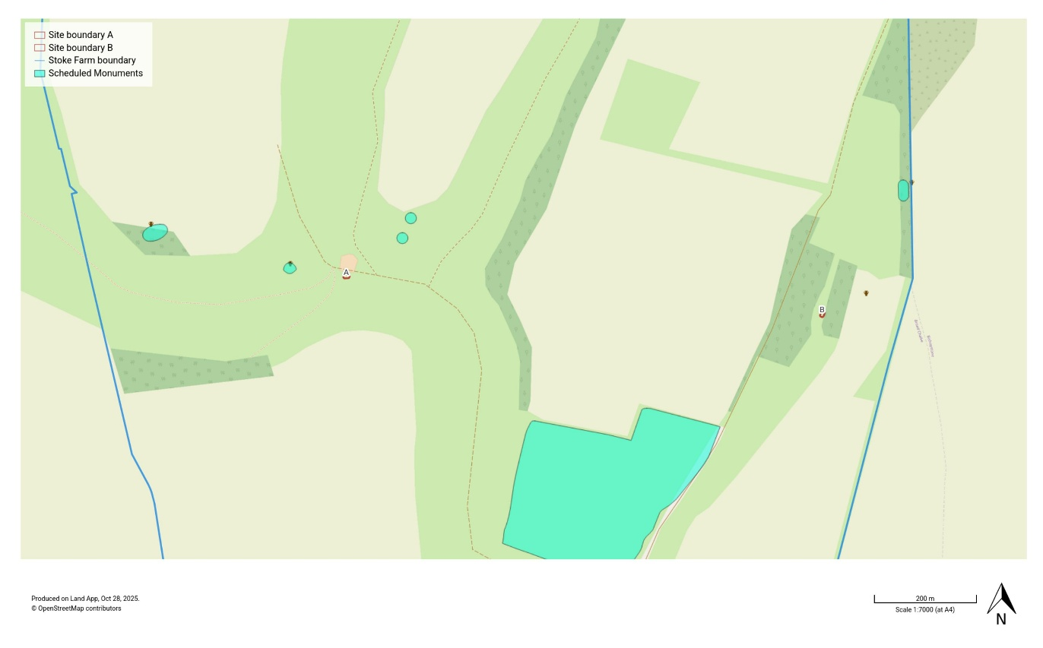

Biodiversity Net Gain (BNG) Implications

Under the statutory framework for biodiversity net gain¹, subject to some exceptions, every grant of planning permission is deemed to have been granted subject to the condition that the biodiversity gain objective is met (“the biodiversity gain condition”). This objective is for development to deliver at least a 10% increase in biodiversity value relative to the pre-development biodiversity value of the onsite habitat.

The statutory biodiversity tool was used to calculate the BNG requirements for these proposals; the metric indicates that the proposal delivers a 397.87%(table 1) total net % change.

Table 1: BNG summary
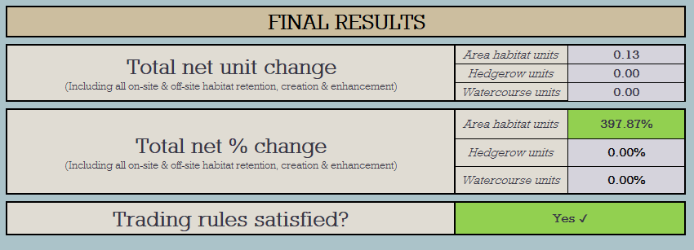

Annex 1

Specification for works:

- Transport all plant and machinery to site
- Mark out pond locations and set levels
- To strip complete areas of topsoil and stockpile for reuse within landscaping
- To excavate ponds to the desired shape and depths, all excavated spoil is to be blended into the adjoining valley bottom and sown with native grasses.
- To excavate a perimeter anchor trench for the securing of the lining system
- To supply and install a 3-layer lining system comprising of 300 gram per m2 underlay. 1mm LLDPE and 300 gram per m2 overlay. All 3 layer are to be placed within the anchor trench and well compacted. Alternative liner material to be agreed in advance.
- To level and grade topsoil down the inner faces of the ponds
- To level and grade topsoil around all perimeter banks
- To leave site clean and tidy upon completion of the works
- Where fencing is required this should be placed a minimum of 2m away from the top of the pond and incorporate a wire gate (minimum length 2m) at agreed location.

Annex 2
UKhab grassland condition assessment for Site B

Condition Sheet: GRASSLAND Habitat Type (low distinctiveness)
UK Habitat Classification (UKHab) Habitat Type
Grassland - Modified grassland
On-site or off-site, site name and location | Stoke Farm, Broad Chalke - area of proposed pond in parcel SU0527 6232 | Survey date and Surveyor name | 17 November 2025 - Simon Smart
Limitations (if applicable) |  | Survey reference (if relating to a wider survey)
Grid reference | SU05662731 | Habitat parcel reference | SU0527 6232
Habitat Description
Modified Grassland
ukhab – UK Habitat Classification
Condition Assessment Criteria |  | Criterion passed (Yes or No) | Notes (such as justification)
A | There are 6-8 vascular plant species per m2 present, including at least 2 forbs (these may include those listed in Footnote 1). Note - this criterion is essential for achieving Moderate or Good condition.  Where the vascular plant species present are characteristic of medium, high or very high distinctiveness grassland, or there are 9 or more of these characteristic species per m2 (excluding those listed in Footnote 1), please review the full UKHab description to assess whether the grassland should instead be classified as a higher distinctiveness grassland. Where a grassland is classed as medium, high, or very high distinctiveness, please use the relevant condition sheet. | No
B | Sward height is varied (at least 20% of the sward is less than 7 cm and at least 20% is more than 7 cm) creating microclimates which provide opportunities for vertebrates and invertebrates to live and breed. | Yes
C | Any scrub present accounts for less than 20% of the total grassland area. (Some scattered scrub such as bramble Rubus fruticosus agg. may be present).  Note - patches of scrub with continuous (more than 90%) cover should be classified as the relevant scrub habitat type. | Yes
D | Physical damage is evident in less than 5% of total grassland area. Examples of physical damage include excessive poaching, damage from machinery use or storage, erosion caused by high levels of access, or any other damaging management activities. | Yes
E | Cover of bare ground is between 1% and 10%, including localised areas (for example, a concentration of rabbit warrens)2. | Yes
F | Cover of bracken Pteridium aquilinum is less than 20%. | Yes
G | There is an absence of invasive non-native plant species3 (as listed on Schedule 9 of WCA4). | Yes
Essential criterion achieved (Yes or No) |  |  | No
Number of criteria passed |  |  | 6
Condition Assessment Result (out of 7 criteria) | Condition Assessment Score | Score Achieved ×/✓
Passes 6 or 7 criteria including passing essential criterion A | Good (3)
Passes 4 or 5 criteria including passing essential criterion A | Moderate (2)
Passes 3 or fewer criteria;  OR  Passes 4 - 6 criteria (excluding criterion A) | Poor (1) | Poor
Suggested enhancement interventions to improve condition score
See attached species list
Footnotes
Footnote 1 – Creeping thistle Cirsium arvense, spear thistle Cirsium vulgare, curled dock Rumex crispus, broad-leaved dock Rumex obtusifolius, common nettle Urtica dioica, creeping buttercup Ranunculus repens, greater plantain Plantago major, white clover Trifolium repens and cow parsley Anthriscus sylvestris.
Footnote 2 – For example, this could include small, scattered areas of bare ground allowing establishment of new species, or localised patches where not exceeding 10% cover.
Footnote 3 – Assess this for each distinct habitat parcel. If the distribution of invasive non-native species varies across the habitat, split into parcels accordingly, applying a buffer zone around the invasive non-native species with a size relative to its risk of spread into adjacent habitat, using professional judgement.
Footnote 4 – Wildlife and Countryside Act 1981 (as amended).

Grassland species – Site B

Common name | Latin Name | DAFOR
Cocksfoot | Dactylis glomerata | D
Nettle | Urtica dioica | A
Dove's-foot Cranes-bill | Geranium molle | O
Groundsel | Senecio vulgaris | R
Mouse-ear Chickweed | Cerastium fontanum | R
White Clover | Trifolium repens | R
Red Fescue | Festuca rubra | O
Cow Parsley | Anthriscus sylvestris | F
Broad Leaved Dock | Rumex obtusifolius | R
Perennial Ryegrass | Lolium perenne | O

Annex 3: Priority bird species (Red List - Birds of Conservation Concern) within 0.5km of site A

Common name | Latin name
Corn bunting | Emberiza calandra
Skylark | Alauda arvensis
Yellowhammer | Emberiza citronella
Lapwing | Vanellus vanellus
Fieldfare | Turdus pilaris
House sparrow | Passer domesticus
House martin | Delichon urbicum
Linnet | Linaria cannabina
Mistle Thrush | Turdus viscivorus
Swift | Apus apus
Goldeneye | Bucephala clangula
Greenfinch | Chloris chloris
Marsh tit | Poecile palustris
Turtle dove | Streptpelia turtur
Starling | Sturnus vulgaris

