DESIGN AND ACCESS STATEMENT

Proposal: Chimney Extension
Location: Coldharbour Farm, High Street, Pitton, Salisbury, SP5 1DQ
Applicant: Guy Moverley

1. Introduction

This Design and Access Statement (DAS) supports an application for Listed Building Consent and Householder Planning Permission for the extension of an existing chimney at Coldharbour Farm, Pitton. The property is a Grade II listed, thatched farmhouse of significant heritage value. The proposed works are required to ensure compliance with the Building Regulations 2010, specifically relating to the safe discharge of flue gases above a combustible thatched roof. It sets out the design rationale, contextual considerations, and access arrangements, demonstrating compliance with national and local planning policies, including the Wiltshire Core Strategy and the National Planning Policy Framework (NPPF).

2. Site, Surroundings and Heritage Context
- Location: Coldharbour Farm is located on the High Street in Pitton, a rural village east of Salisbury.
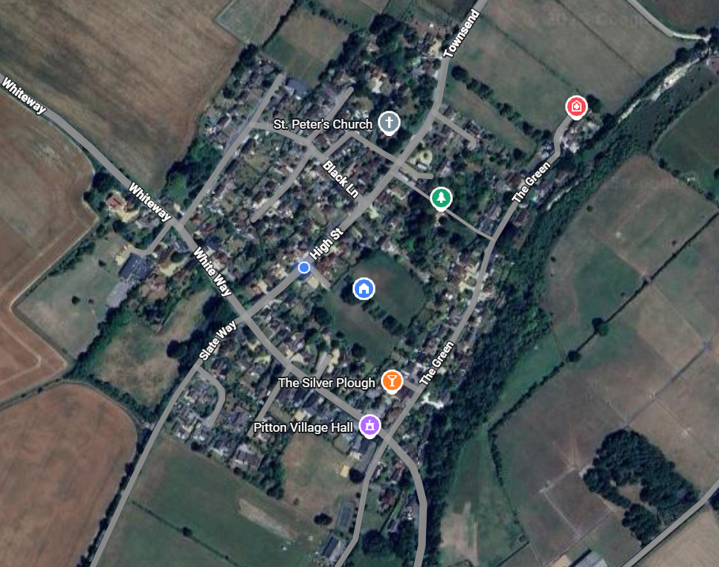
- Heritage Context Listing: The farmhouse is Grade II listed, recognised for its vernacular character, traditional thatched roof, and historic construction; sympathetic design is essential.
- Character: The property exemplifies rural Wiltshire architecture, with a timber frame and prominent thatched roof.
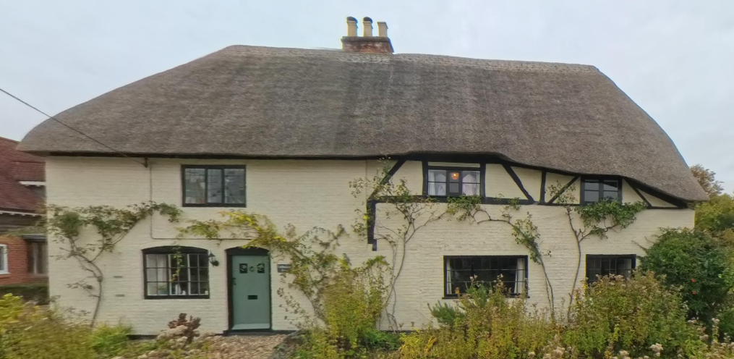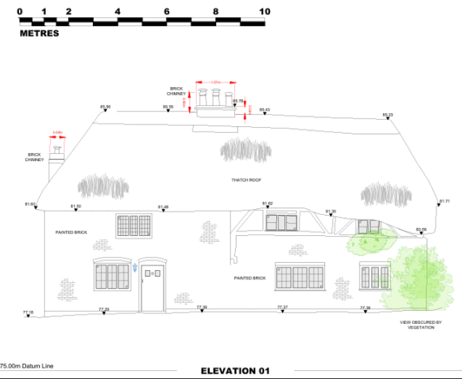
- Setting: The site lies within a village which has a mix of modern and historic dwellings, some of which retain traditional materials and forms.
- Planning History:
  - S/2004/1131 - "New 3 bed dwelling and garage and alteration to access" at The Black Barn Coldharbour Farm, High Street, Pitton, Salisbury, SP5 1DQ.
  - S/2007/0119 - "Move first floor partition walling and doors to widen landing add door and divider stud wall to accommodate new bathroom" at Coldharbour Farmhouse, High Street, Pitton, Salisbury, SP5 1DQ.
  - 14/07939/APD - "Prior notification for the erection of a barn for the storage of machinery and hay" at Coldharbour Farm, High Street, Pitton, Salisbury, SP5 1DQ.

3. Design Rationale
- Description of Works: The proposal seeks to extend the existing chimney stack to a total height of 1.8m above the ridge line, in accordance with Approved Document J of the Building Regulations 2010, which requires chimneys serving solid fuel appliances to terminate at least 1.8m above the thatched roof to reduce fire risk.
- Scale and Form: The extension is modest in relation to the overall building, designed to meet regulatory requirements while maintaining traditional proportions.
- Materials: The extension will be constructed in matching brickwork with lime mortar joints and finished with clay chimney pots and cowls. Materials will be carefully sourced to harmonise with the existing historic fabric.
- Appearance: The design is sympathetic, retaining the traditional form of the chimney while subtly increasing its prominence. The extension will not detract from the thatched roof or wider heritage character.
- Functionality. The extension supports improved safety.

4. Heritage Considerations
- Listed Building Impact: The works are designed to preserve the special architectural and historic interest of the property. The chimney extension is necessary for functional and safety reasons, particularly given the vulnerability of thatched roofs to fire risk.
- Reversibility: The extension is a minor alteration and could be reversed without significant harm to the historic fabric.
- Conservation Principles: The proposal follows Historic England guidance on alterations to listed buildings, ensuring minimal intervention and maximum respect for original materials and design.
5. Access Considerations

- Vehicular and Pedestrian Access: No changes are proposed to existing access arrangements.
- Inclusive Access. The proposal does not alter existing access arrangements to the property. Entrances, pathways, and circulation remain unaffected.
- Construction Access. Temporary access for construction will be managed to minimise disruption to neighbouring properties.
- Emergency Access. No impact on emergency vehicle access or safety provisions.

6. Planning Policy Compliance
The proposal has been designed with regard to:
- Wiltshire Core Strategy (2015):
  - Core Policy 51 (Conservation & Enhancement) – the proposal will conserve the existing landscape character.
  - Core Policy 57 (Ensuring High Quality Design and Place Shaping) – the chimney extension respects the local character, materials, and scale.
  - Core Policy 58 (Conservation of the Historic Environment) – the proposal conserves the listed building’s special interest and wider village character.
- National Planning Policy Framework (NPPF):
  - Section 12 (Achieving Well-Designed Places) – the extension is sympathetic to local character and history.
  - Section 15 (Conserving and Enhancing the Natural Environment) – the proposal sustains the natural environment.
  - Section 16 (Conserving and Enhancing the Historic Environment) – the proposal sustains and enhances the significance of the heritage asset.
- Building Regulations 2010. The chimney extension ensures compliance with statutory requirements in the Wiltshire Building Regulations aligned with HMG Building Regulations 2010 Document J Combustion Systems and Fuel Storage Systems, Para 2.12 and Diagram 18 which requires the top of a chimney pot on a thatched property to be a minimum of 1.8 metres (approx. 6 feet) above the highest point of the thatch.

7. Impact Assessment
- Visual Impact. The chimney extension will have minimal visual impact due to its modest scale and use of matching materials. It will be in keeping with similar features on traditional rural dwellings.
- Neighbouring Amenity. The works will not result in any loss of light, privacy, or outlook for neighbouring properties.
- Environmental Impact. The extension improves the safe operation of the chimney, reducing fire risk to the thatched roof.
8. Conclusion

The proposed chimney extension at Coldharbour Farm is a modest and sympathetic alteration that preserves the special architectural and historic interest of the Grade II listed farmhouse. It is necessary to comply with the Building Regulations 2010, thereby enhancing safety without compromising heritage value. The proposal aligns with relevant local and national planning policies and will have no adverse impact on neighbouring amenity or the surrounding environment.

Accordingly, Listed Building Consent and planning permission are respectfully sought for the proposed works.

