November 2025
Holt, Land at Melksham Road
Planning permission PL/2025/04414
Condition 4 Samples of Materials to be used on the buildings
No development above slab level shall commence until the details of the materials to be used in the walls, roofs and windows have been submitted to and approved in writing by the Local Planning Authority. The development shall then be carried out in accordance with the approved details.

Please see submitted

- Materials Layout Plan ML01 Rev C

- Main facing Brick
Brickability - Esher

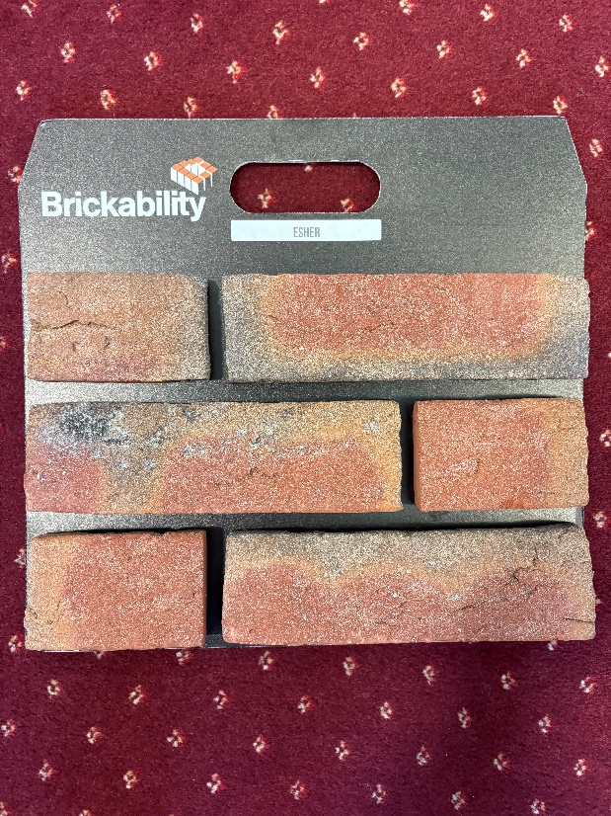

- Feature Brick
Brickability - Ascot

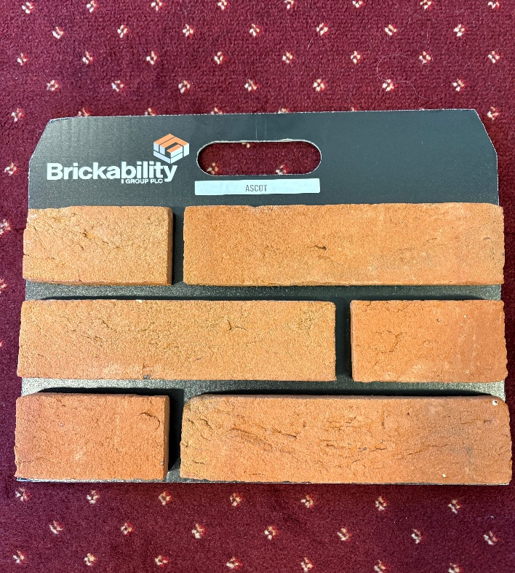

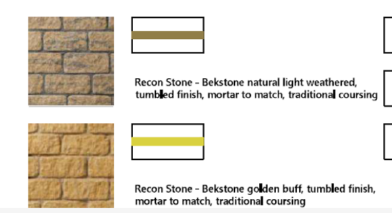

- Roughcast monorouche in Silver Pearl Render

- Colour of dark timber boarding - Hardie plank in Rich Espresso
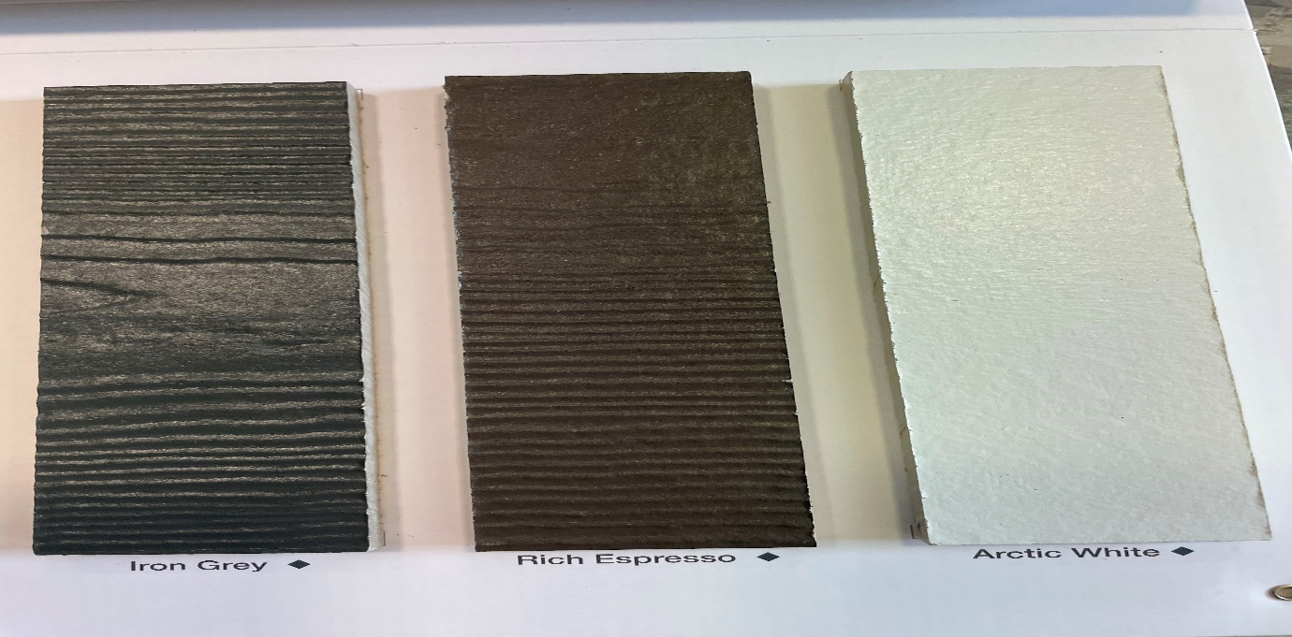

Roof Tile
Marley Double Roman (smooth brown)

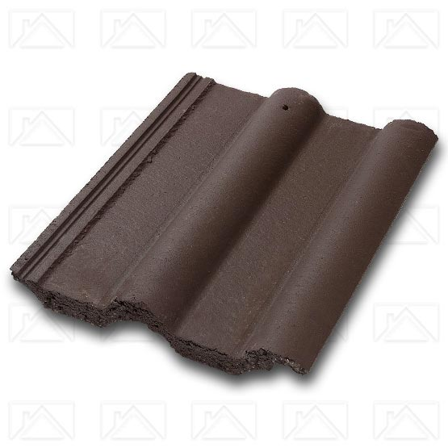

Slate
Spanish slate
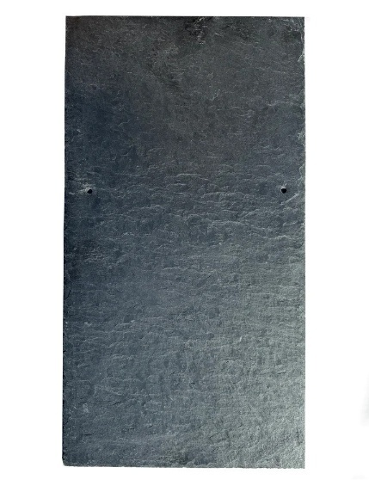

Roof Tile
Redland Plain (Cotswold granular )

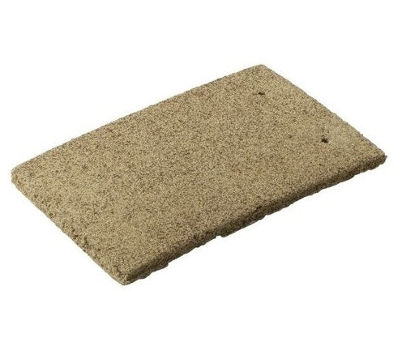

Windows
Eurocell GFT White UPVC windows will be used.

