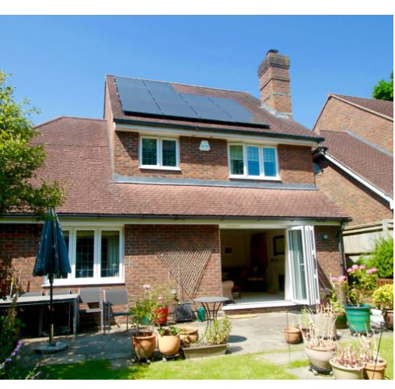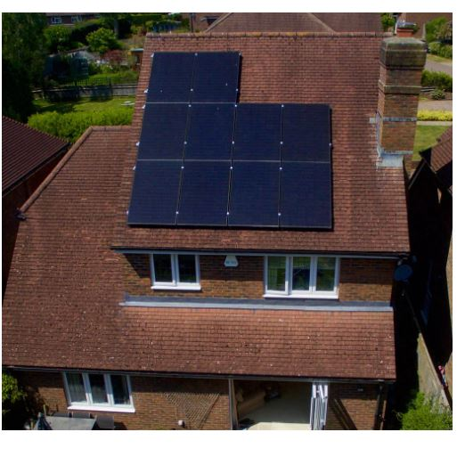
Mr C Butcher, Chandlers Farm Barn, Chandlers Lane, All Cannings, SN10 3PG.
Proposed Solar Panels
Photographs of proposed panels 12 November 2025.

