DESIGN AND ACCESS STATEMENT

Design and Access
Heritage Statement
Proposed addition of energy efficient solar panels at

Grange Farmhouse
61 Lower Road
Bratton
Westbury
BA13 4RQ

Design and Access Heritage Statement
Design and Access Heritage Statement Pursuant to Section 42 of the Planning and Compulsory Purchase Act 2004 and Government Circular 01/2006, the following Design and Access Heritage Statement has been prepared in order to demonstrate the acceptability of the proposed addition of solar panels at Grange Farmhouse, Lower Road, Bratton, Westbury, BA13 4RQ by considering the planning history of the site, the heritage and the design.
  - Site Description
Site Description The site is located to the Northern side of the village of Bratton, which itself lies to the East of Westbury. Grange Farmhouse is situated on the North side of Lower Road, near the junction with Trowbridge Road

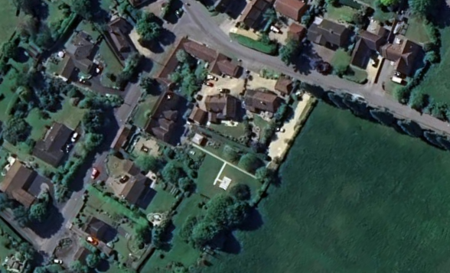
Google Earth (2025)

  - History of the Site
History of the Site Grange Farmhouse was given Grade II listed building status on the 11th September 1968 by English Heritage, List Entry No. 1036518. The following description forms the listing of this property, the below photo is from the sale particulars for the property in 2020:
• BRATTON LOWER ROAD ST 9152 (north side) 11/28 Grange Farmhouse (formerly listed as Bratton Farmhouse) 11.9.68 GV II Farmhouse. C17, altered mid C18. Flemish bond brick rebuilding of timber-framed house, tiled roof with hip to left and brick stacks. Two-storey, 5-window main range. Central 9-panelled door with integral transom light in roll-moulded surround with flat stone hood on brackets, two 12-pane sashes in beaded architraves either side. Moulded string course over lintels; first floor has five B sashes in beaded architraves, datestone with initials I A / 1739. Attached to right is range with surviving C17 brickwork opposite stack, two 12-pane sashes to ground floor, 2-brick plat band with projecting headers to lower course, one sash to first floor. Right return has 2-light casements, left return has sash to ground floor. Rear has two blocked 2-light cyma-mullioned windows to right, central bay retains square-panelled timber-framing with straight bracing and 3-light steel casement, late C18 lean-to 2-storey extension to left has planked door and casements. Interior not accessible at time of survey (May 1986), but said to contain C18 fittings. The initials on the datestone are those of John Aldridge Ballard, who rebuilt the house. (M. Reeves, Sheep Bell and Ploughshare, 1978)

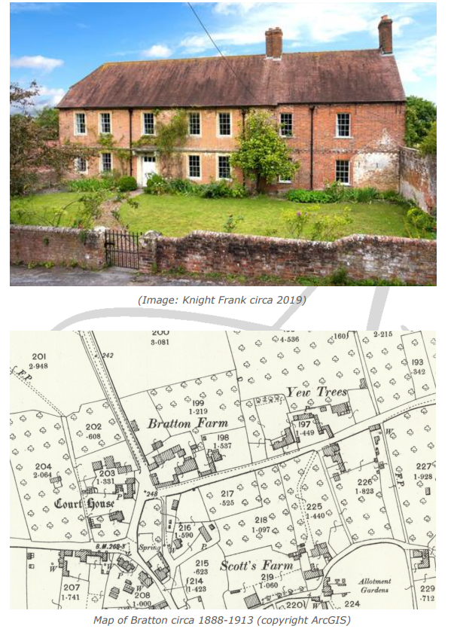Further information on Grange Farmhouse can be found attached in:
Grange Farm by Jean Morrison First published by Bratton History Association in 1993 and edited for the website in 2015
  - Development Process
The site in relation to this application has some previous Planning history. The below applications are recorded on the Council’s records;
• 20/03647/TCA - T1 Cypress, reduce by 5m in height and prune laterals by 2m. T2 Fig, reduce to a 2ft framework to regenerate as a fruit shrub. T3 Cherry, prune in the area of the crown hanging over the neighbour's boundary back to the boundary – No objection
• 16/06714/TCA - T1 - Cypress - Remove to ground level - No objection
• 14/00696/TCA - T1 - Cypres - reduce by 25 - 30% .Height - 3 - 4 Metres. . Reduce westerly limb. Re balance where necessary by 1m and deadwood. T2 - Overall prune by 1m to relieve the weight at the end of the branches - No objection
• W/91/00448/CON - Demolition of barn and derelict outbuildings rebuilding existing stable and milking sheds - Approved
• W/93/01428/CON - Demolition and rebuilding of milking parlour to form two dwellings - Approved • W/93/01379/FUL - Demolition and rebuilding of former milking parlour to form two dwellings - Approved
• W/95/00015/FUL - Replacement two storey extension and alterations - Approve with Conditions
• W/95/00562/FUL - Change of use of agricultural land to domestic curtilage and new vehicle access onto Trowbridge Road - Approve with Conditions
• W/95/00032/LBC - Demolition of rear single storey extension replacement two storey extension and alterations - Approve with Conditions
• W/93/00992/FUL - Two detached houses with garages, conversion of former milking parlour to two dwellings with garage extension and new access to Grange Farmhouse - Approve with Conditions
• W/91/00407/FUL - Demolition of barn and derelict outbuildings rebuilding of existing stable and milking sheds to form 2 units of housing plus 4 new houses - Approve with Conditions
• W/90/00539/FUL - Residential redevelopment comprising conversion of timber framed barn to two dwellings and replacement of concrete blockwork barns with two dwellings – Refused
- PL/2022/02010 - Discharge of condition 3 (Materials) of planning application PL/2021/05837 - Proposed internal and external alterations together with reinstatement of Greenhouse and addition of Garage to rear Garden - Approve
- PL/2021/05837 - Proposed internal and external alterations together with reinstatement of Greenhouse and addition of Garage to rear Garden – Approve with Conditions
- PL/2021/07447 - Proposed internal and external alterations together with reinstatement of Greenhouse and addition of Garage to rear Garden – Approve with Conditions
- PL/2024/11685 – Erection of a greenhouse – Approve with Conditions

  - Neighbourhood Plan
Lower Road is within the village of Bratton which has recently adopted a Neighbourhood Plan. The proposed solar panels do not contravene any guidance which has been included in the Bratton Neighbourhood Plan.
You can read the Neighbourhood Plan by following the link above or using the QR code.


  - Planning Policy
The main planning policies which relate to this development are in respect of the location of the site within the Bratton Conservation Area and relating to the standard of development proposed given its Grade II Listed status.
In respect of the Conservation Area, Core Policy 58 (Ensuring the conservation of the historic environment) requires that development take place only where it can be shown to preserve or enhance the historic and visual character of the area in which it is located and to be sensitive to its character and appearance.
Core Policy 57 (Ensuring high quality design and place shaping) of the Wiltshire Core Strategy requires a high standard of design together with adherence to general principles of good development.
In addition, NPPF section 12 requires no significant harm to the character, appearance or setting of a listed building take place.
  - Use
The Farmhouse is currently an six-bedroom domestic dwelling with a detached workshop which is positioned to the front and side of the dwelling, adjoining Lower Road. Several extensions have been made over the years, some historic, some more recent.
The existing outbuilding adjoining Lower Road to the front of the site is no longer considered practical for use as a garage given a vehicle would have to blindly drive on to the highway.
  - Amount
The proposed addition of solar panels achieves multiple purposes: firstly, a property of the size and age of Grange Farmhouse is expensive to run in relation to heat, further compounded by the lack of double glazing due to its Grade II listing status.
Secondly, the addition of solar panels would result in a significant benefit to the preservation of the environment, using renewable energy for the electricity used not just in heating but also lighting and cooking. The cooking facilities in the kitchen are electric (ovens and induction hob) with no gas powered cooking facilities installed for cooking purposes.
The addition of the solar panels is expected to generate 5656 kWh per year initially.
  - Scale
The scale of the proposed addition of solar panels do not constitute an unnecessary infringement on the historic fabric of the dwelling, as the panels will be sited only to the rear of the property where they will not be seen from the front of the property, Lower Road or Trowbridge Road. Furthermore, as the solar panels are proposed for the rear gable ends, they will not be readily seen from the garden of the property either, while still generating significant energy for the benefit of the property and the environment.
The suggested siting of the panels is appropriate both in relation to the size of the plot, and the way in which they are orientated on the roof, east-west facing.
  - Layout
The layout of the roof will not change, the proposed panels sit on top of the existing tiles. The layout of the panels, as seen in the proposed drawings, are arranged to achieve maximum performance with the proposed number of panels, and yet to minimise the impact on the heritage appearance of the property.
  - Appearance
The proposed siting of the panels is to the rear of the property only, on two gable ends which were built in the mid 1990s. The siting of the panels here protects the heritage view of the former farmhouse from Lower Road. Siting the panels to the rear means that they can not be seen from Lower Road and is sympathetic to the historic structure and in an appropriate manner whilst ensuring that the property is fit for purpose for future generations thus safeguarding the long-term upkeep of this historic asset.
The proposed battery system will be installed within the existing workshop, ensuring that there will be no affect on the appearance of the building by hanging a battery on the outside of the property where it could be seen from the garden.
The proposal is to run the cables to the battery from the main property, along an existing path where they will not be seen.
Founded in 1980, DMEGC has more than 40 years of experience in high-tech manufacturing, establishing a long legacy in the industry. It is a Bloomberg Tier 1 Solar Panels Manufacturer, a rating that has a reliable production history.

The company installing the solar panels has suggested the temporary erection of two scaffolding towers, which will be brought onto the property via existing routes namely the rear access and brought through the garden by hand. These structures will be removed once the installation is complete, thereby there will be no permanent impact on the heritage appearance of the property from the installation process.
The installation is carried out by Wiltshire Council approved contractors, as they will be purchased and installed through the Solar Together scheme. The panels can also be easily removed at the end of their operational life.
As the panels would be installed by experienced fitters using experience and correct equipment there will be no lasting damage to the existing roof or tiles.
Pigeons and other birds can use solar panels to nest and seek shelter underneath which can cause issues with panels and the associated electrical cabling. The best method to prevent this from happening is to use bird guards around the panels at the time of installation to prevent birds from accessing the space beneath them.
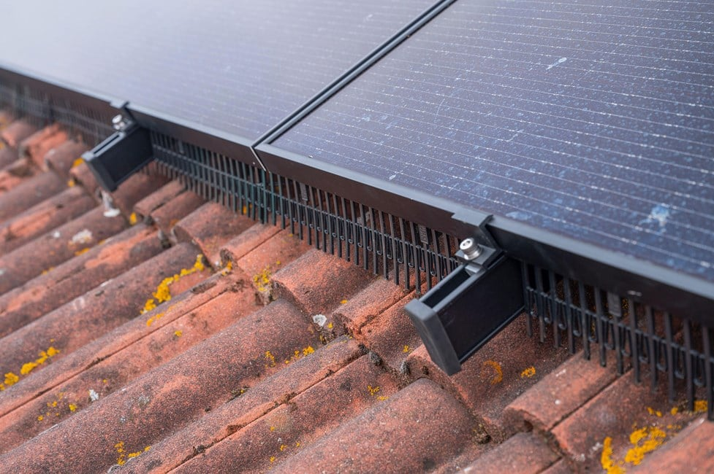
It is intended to fit a birdguard to protect the solar panels and the local bird population preventing them from nesting under the solar panels and causing damage.

The company has recommended using Fastensol black universal clamps, end caps, portrait concrete tile rook hooks, rail splice and 3550mm rail.
  - Access
  - There is no impact or change to access to the property.
  - Conclusion
The solar panel system is expected to generate 5656 kWh per year initially, decreasing gradually as the solar cells degrade. Over the 25 year term of this financial projection the total generation is expected to be 132899 kwh, of which 74213 kWh will be consumed on site and 51192 kWh exported.
Overall the panels will be making a big contribution to reducing CO2 not just by lowering the carbon intensity of used electricity, but by putting low-carbon electricity back in the grid for others to use too.
This ensures a more sustainable future for Grange Farmhouse and represents a net gain in relation to the use of sustainable, renewable energy and therefore:
Recommendation: That the listed building consent is GRANTED

End of Design & Access Heritage Statement

