DRAFT

Highway Condition Survey in association with Melksham Road, Holt - PL/2024/05435
Project number: | P25-1396
Document Ref: | TR02
Project Name: | Melksham Road, Holt
Date of survey: | Tuesday 21st October 2025
Start of survey: | 10:00
End of survey: | 10:30
By:  Conditions: | Emily Barker (Pegasus Group)  Cloudy and Dry

- Introduction
  - This Condition Survey has been prepared by Pegasus Group on behalf of Redcliffe Homes Ltd. to record the existing highway condition of the local highway network which comprises the B3107 Melksham Road.
  - The site is located approximately 950 metres east of the Holt High Street. The scheme comprises 55 residential dwellings on Melksham Road, Holt. Planning permission PL/2024/05435 was granted, subject to conditions, on the 3rd July 2025. Wiltshire Council are the local highway authority.
  - Condition 13 of the Decision Notice requires a Construction Management Statement and part 10 requires a pre-Condition photo survey.
  - This pre-construction Condition Survey has been prepared to discharge Condition 13 (item 10) of permission PL/2024/05435.
  - The extent of the Condition Survey includes 250 metres either side of the site access point on the B3107 Melksham Road. The scope of the survey was agreed by email on 14th October 2025 with Wiltshire Council prior to commencement of the survey. Officers declined the invitation to accompany Pegasus Group on the site visit but suggested that a video evidence would be helpful.
  - The Condition Survey was carried out by Pegasus Group on Tuesday 21st October 2025.
  - Photographic and video evidence of the Condition Survey is provided alongside this report. All evidence gathered was prior to the commencement of construction activities at the site. The video evidence should be viewed in conjunction with this report and is included with the wider submission.

- Definitions
  - Fatting – is a carriageway defect where excess bituminous binder has come to the road surface through periods of hot weather. This results in excessive binder in the road content or embedment of aggregate particles.
  - Edge deterioration – is a defect where the carriageway surface is beginning to break away at the edges and is generally caused by poor edge support and / or vehicle over run.
  - Cracking – is a defect that may indicate that the carriageway layers are in partial or complete failure.
  - Rutting – is a continuous longitudinal depression in the wheel track which can create ponding or manoeuvrability issues.

- B3107 Melksham Road
  - There was no fatting, edge deterioration, cracking, or rutting observed at the time of the site visit as seen in Images 1, 2, 3, and 4, below and in the video. Inset 3.1 indicates the location of the Images.
  - Further detail of the B3107 Melksham Road is included within the video evidence and will be submitted to Wiltshire Council, as the local highway authority, via email.

Inset 3.1 - Photo Locations

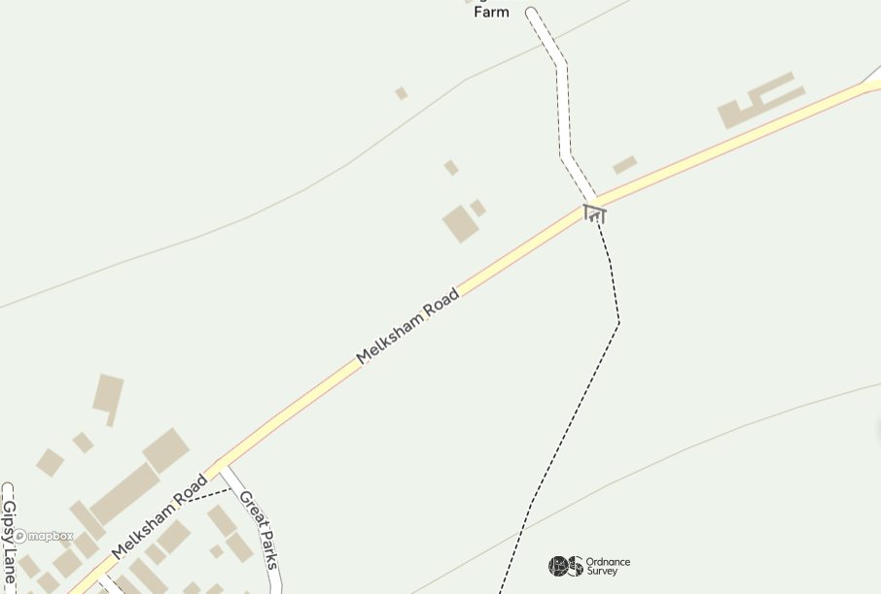
Image 3
Image 4
Image 1
Image 2

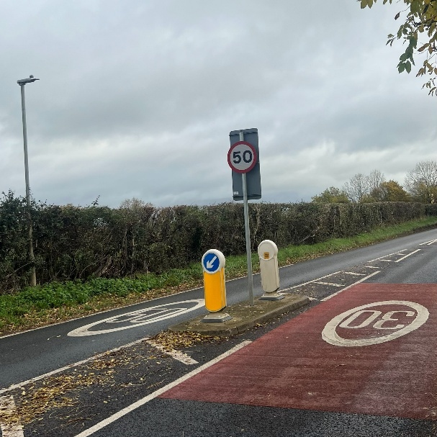  Image 1 | 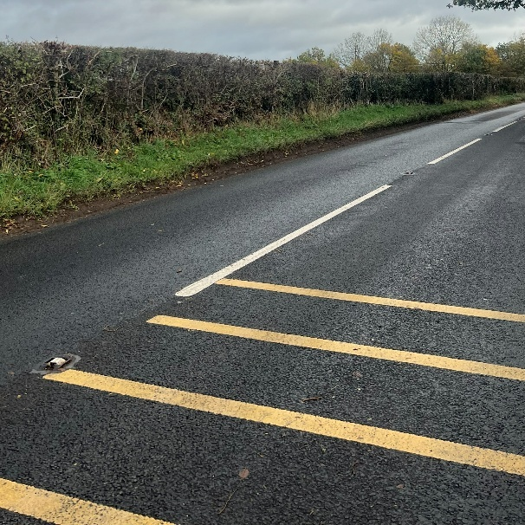  Image 2
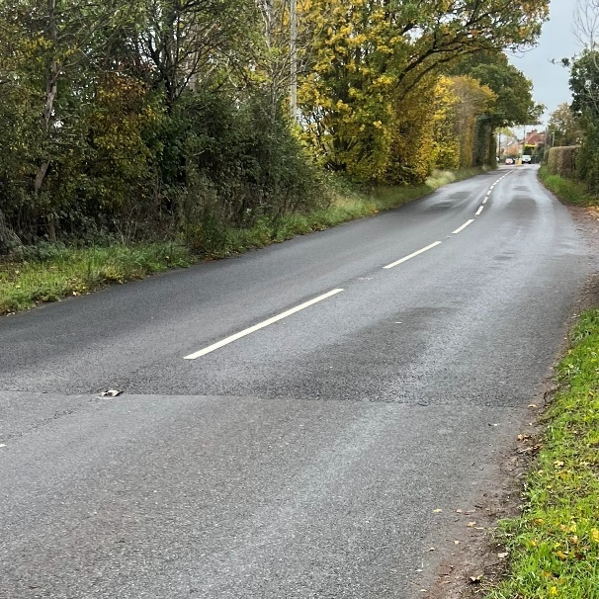  Image 3 | 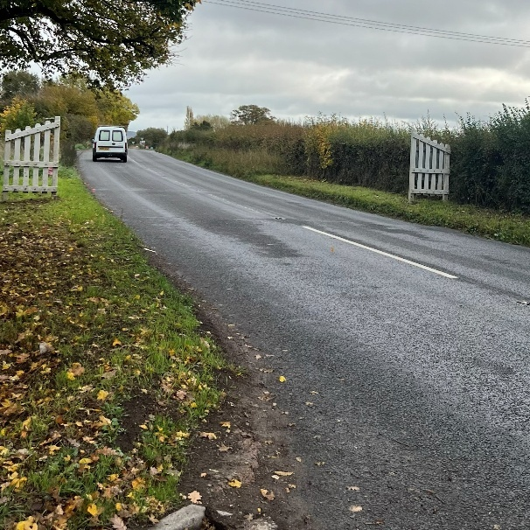  Image 4

- Summary
  - The Condition Survey undertaken by Pegasus Group on Tuesday 21st October 2025 has recorded no instances of damage and signs of wear along the study area on the B3107 Melksham Road.
  - Photo evidence of the survey is provided within this report, and video evidence will be provided separately by email to Wiltshire Council highways team.
  - The areas highlighted in this report will be monitored post completion of the construction activities to assess whether deterioration has occurred. A post-construction Condition Survey will be undertaken to assess the condition of the surveyed areas.
  - Where remediation works are required as a result of construction activities associated with construction activities at the site, the extent and details of the repairs will be agreed with Wiltshire Council, as the local highway authority, as appropriate.
END

