BRADFIELD MANOR : Planning App. No. PP 137943652
DESIGN AND ACCESS & HERITAGE STATEMENT
DESCRIPTION OF WORKS TO REAR LAVATORY EXTENSION

HISTORY
- Bradfield Manor is a Grade I listed mediaeval manor house, described in the Victoria County History of Wiltshire vol. ix p.110 . The site has been occupied since at least 1086 (Domesday) and the current building has changed shape significantly many times over the last 600 years. It is now U-shaped – the central section being 15th c., the east wing c. 1600 and west wing mid to late 19 c. The south and north elevations of the central section contain three 15th century stone traceried Perpendicular windows with 19th c. diamond-pattern lead glazing.

A two-storied north kitchen wing was added in the 18th c. This appears to have been altered in the late 19th c. In the 20th c. the east wing and upper rooms of the central section became derelict. In 1990, the west wing was functioning as a working farmhouse. Apart from late 18th c/19th c. stone mullioned windows, this wing exhibited no special architectural features.

An amateurish, poorly-constructed lavatory extension was built on to the rear of the west wing by the farmer-occupants themselves, probably post-1945. (see photo Fig. 1 below)

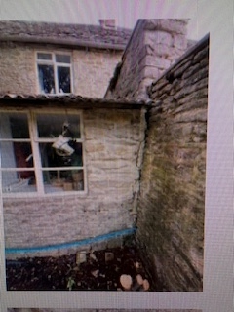
Fig. 1: Original state of post-war extension, showing the south wall protruding beyond the line of the external wall of the extension

- Until the early 1990s, the east wing and upper floor of the central section were partly roofless, ruinous and derelict. Only the west wing and two ground-floor rooms of the central section were habitable, amounting to less than half the floor area of the house. The central courtyard at the rear was filled with corrugated iron sheds which completely covered up the 15th c. north window.

- In about 1992, the manor house was separated from the farmyard and sold. The purchasers then carried out very substantial repairs and renovations over several years under close supervision of North Wiltshire District Council conservation officers.

- The post-1945 lavatory extension was poorly constructed using local rough-stone, broken bricks and miscellaneous rubbish in-fill. There were no foundations, cavity walls or damp-proof course. Lack of stable foundations had caused the south wall to lean outwards and that section was detaching itself from the west wall (see Fig 1 above). The roofing material was corrugated asbestos sheeting. Inappropriate Crittal-style mass-manufactured industrial metal-framed windows were inserted in the walls (see Fig 2 photograph below).

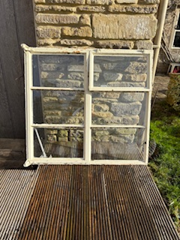
Fig. 2: Old Crittal-style metal-frame window (removed and stored)

- The roofing materials eventually failed, causing water to cascade down the internal walls. These walls were also plagued with irremediable damp at ground and higher levels on account of the absorbent filler material used in construction of the walls.

The only effective method of dealing with these inherent defects was to take down the walls and re-build to modern building-control standards, re-using the salvaged stone. In the process, the inappropriate brick-and-rubble in-fill was removed.

The industrial metal window was replaced by two smaller fixed casement windows (one in the north and one in the south wall) using materials and design more appropriate to the historic architectural setting.

RENOVATION WORKS
- The west and south rough-stone walls of the extension were taken down, brick and other rubble removed. The salvaged stone was re-used to rebuild the walls on foundations to modern building-control standards with damp-proofing. Lime mortar was used between the courses, replacing the original inappropriate cement. (See photographs below)
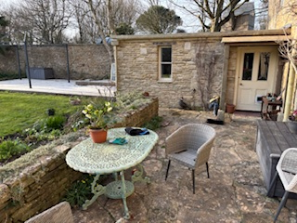
Fig. 3: South elevation (February 2025))
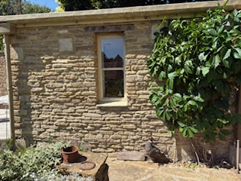
Fig 4: South elevation (April 2025) – (renovated stonework is to left of the climbing plant).
- The inappropriate metal-framed windows were removed from the west wall and replaced by an old oak door (see photographs in Figs 5 and 6 below) which was inserted in the aperture formerly occupied by the window in Fig 2. This door was left in a barn when we purchased the property in 2004 and fortuitously happened to be the same width as the window. Steel hinges for the door were made to match those hanging the oak door leading from the east wing of the manor to the internal courtyard.
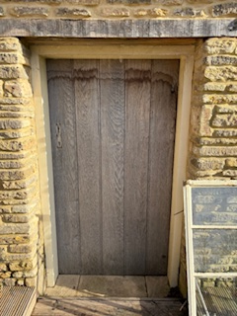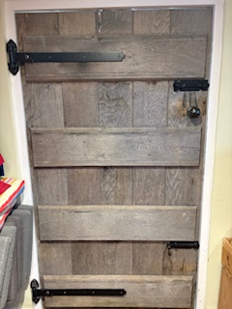
Fig 5: Oak door external aspect Fig 6: Oak door internal aspect

A simple hardwood-framed, vertical-rectangular fixed casement window bisected by a thin glazing bar was inserted in the renovated south wall, matching in shape the 3 windows in the adjacent door and wall of the west wing. (See Figs 3 and 4 above and Figs. 7 and 8 below). This window contains 2 double-glazed sealed unit-s.
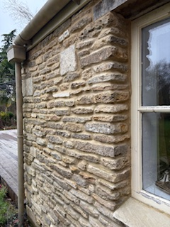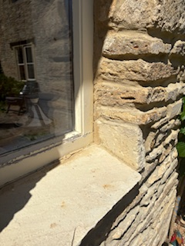
Fig 7 and Fig 8: South wall of extension (showing re-used stone and lime-mortar pointing with new window and stone sill).
- The north wall of the house and lavatory extension had always merged into the stone wall of the walled garden to the west of the house. Where it now adjoins the extension, much of the stonework had been lost, allowing access to the oil tank area behind. We repaired the wall with matching Cotswold limestone found in piles left from the days when the entire property was a working farm.

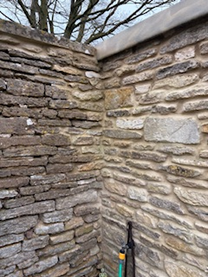
Fig 9: Junction of west and north walls, showing untouched (north wall) and renovated stonework (west wall).
A small hardwood-framed horizontal-rectangular window bisected by a single vertical glazing bar was inserted in the previously dilapidated north wall. The ground rises steeply to roof-level at the rear and, from a short distance away, the window appears to be at ground level or below. The area in front of the north wall is now planted.
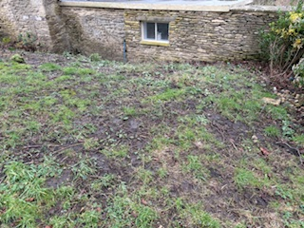
Fig 10: North wall of extension merging into garden wall and showing steeply-rising ground behind.

- The south wall of the lavatory extension had protruded beyond the west wall (see Fig. 1 above). We re-built the west wall to connect the end of the extended part of the south wall with the existing north wall. This incorporated approximately 1.5m of ground between the north and south walls previously used for a tap and hose storage.

- The corrugated asbestos roof sheets and rotten woodwork underneath were removed and replaced with new timbers and boarding covered with a waterproof sealed fibre-glass membrane.

IMPACT ON HERITAGE

- No historic fabric has been touched.
The only part of the manor in this application is the post-1945 extension at the north-west corner of the 19th c. west wing. This extension was home-made and structurally defective, with no foundations, damp-proof course or cavity walls. The west wall was over two feet thick, filled with rubble and sand and irremediably damp.
- Frankly, it was an eyesore (see photo at Fig.1 above):
- The rough-stone walls contained some odd broken bricks and the whole was pointed with cement mortar.
- The roof material was corrugated asbestos sheeting.
- The windows were mass-produced industrial/commercial Crittal-style metal frames suitable for a modernist office-block or pre-fab but not a historic manor house.
Apart from the rough-stones themselves, the materials and effect were inappropriate to the 19th c. west wing (to which the extension was attached), let alone the mediaeval section of the manor.
- I have been a member of the SPAB for 50 years and subscribe to its principles. The renovation works described in the application respect the historic setting and architectural integrity of the manor.

- The old asbestos roof was defective and the concealed softwood supports were irretrievably rotten through damp and insect damage. It was necessary to take down the walls to create solid foundations and cure the damp problem with a DPC and cavity-walling. However, all the stones taken down were salvaged, re-used in the re-construction and pointed with lime mortar.

- The inappropriate industrial metal windows were removed and replaced by glass panels in custom-made simple hardwood frames bisected by a single glazing bar and surmounted by oak lintels similar to the two windows on the north-west side of the west wing.

The old Crittal window aperture was incorporated into a doorway. We found an old oak door (stored in one of our barns when we purchased the property in 2004) which happened to be exactly the same width as the Crittal window.

- A discreet vertical-rectangular window bisected by one horizontal glazing bar was inserted in the rebuilt south-facing extension wall, its shape complementing similar-shaped windows in the adjacent west wall of the house.

- The north wall of the post-war extension merged into the north wall of the walled garden. The extension's south wall had, for unknown reasons, extended nearly 2 metres beyond the west wall (as shown in Fig 1). The open area between these north and south walls had no practical use apart from housing a garden tap, hoses etc. We took advantage of the essential remedial works to incorporate this small area into the extension - making a more logical stone structure and more usable cloak and boot room area.

- CONSERVATION METHOD

It is submitted that the work done applies conservation principles sympathetically and the result complements, even enhances, the untouched stonework, especially insofar as it replaced the previous sub-standard walls and roof built with unsuitable/inappropriate asbestos and metal materials.

- As previously stated, I have been a member of SPAB for 50 years and have tried to apply its principles –

" to promote the value and good sense of caring for the fabric of old buildings. SPAB takes a long-term view, urging that in our own actions we consider the legacy we will leave to future generations......The SPAB Approach therefore stands against Restorationist arguments that it is possible and worthwhile to return a building to its original - or imagined original - form.

Equally, the SPAB Approach generally rejects arguments that original design or cultural associations are more important than surviving fabric. For the Society, protecting fabric allows meaning and significance to be drawn from it by individuals, groups and successive generations."

- Bradfield Manor has evolved over 1000 years (human habitationon on the site pre-dates the Domeday Book survey). Its shape and structure have altered many times. In 1992, it was semi-derelict and surrounded by a motley collection of sheds and lean-tos, with rubbish-heaps at the rear entrances.

- In the last 30 years it has been painstakingly restored according to SPAB principles. It is a living structure but the aim has always been to re-use old materials and preserve the patina of age where possible. We regard ourselves not just as owners but trustees for posterity and also believe that the work done has been in keeping with Wiltshire Council's CN3 principles.

- Old houses are living bodies and conservation often requires sympathetic change for structural and aesthetic reasons. The manor has altered its shape significantly many times over the 700 years since the main hall (now our dining room) was built with Perpendicular windows.

- The west wing was constructed (a) in the 18th and 19th centuries, (probably in three separate projects. The kitchen probably dates pre-1800, the back scullery appears to have been added some time in the mid or late 19th c.) and the lavatory extension in the mid-20th c.

- Other significant changes were made more recently as part of the 1990s restoration.

Notably, consent was granted

- to raise the height of the south wall of the front (south) courtyard of the manor by 2 metres to create a curtain wall enclosing a box-parterre and rose beds with a herbaceous border adjacent to the wall (see Figs. 11, 12 and 13);

- to connect the manor and the adjacent small barn by a new Tudor-gothic archway. These consented changes are a great aesthetic enhancement (Fig. 15), and

- to create new Tudor Gothic doorway to the east wing from the rear courtyard (Figs. 16, 17 and 18)

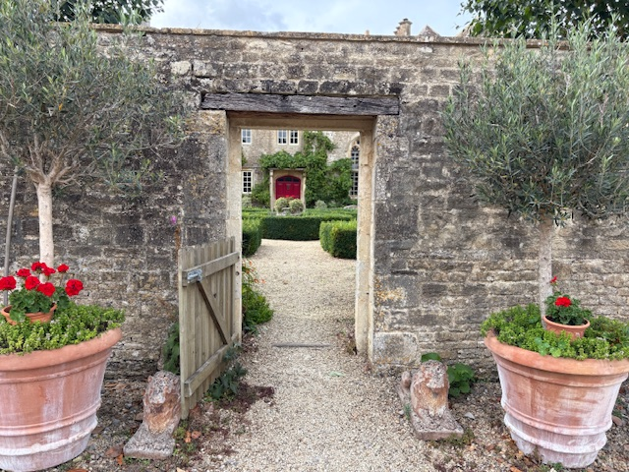
Fig. 11 – Raised curtain wall – (original height was to height of wooden gate)

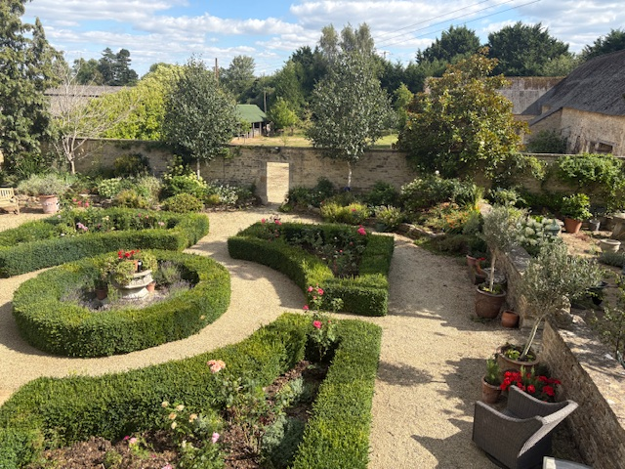
Fig. 12 Raised curtain wall – showing relationship to south courtyard, parterre and barns.

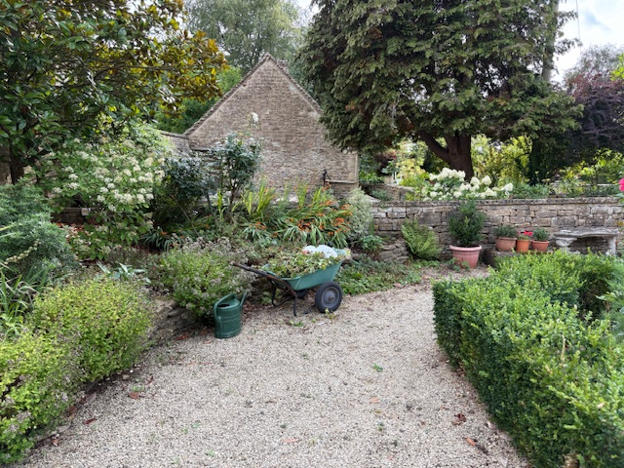

Fig. 13 Raised curtain wall (partly obscured by magnolia and hydrangea) connecting to brewhouse roof, with raised flower beds in south courtyard.

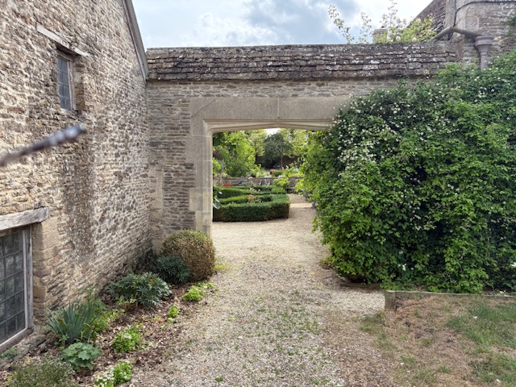

Fig 15: New (1990s) Tudor gothic archway connecting the Grade 1 manor with the Grade 2 small barn

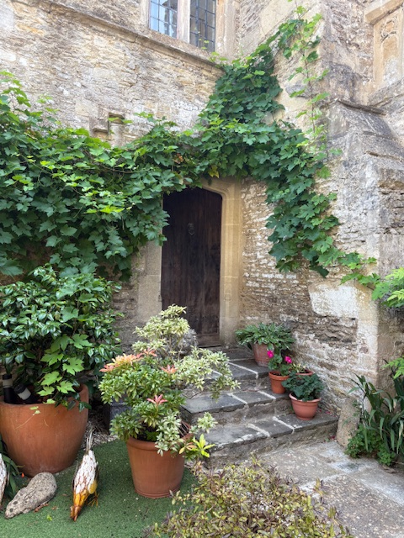

Fig. 16. New (1990s) Tudor Gothic courtyard doorway and steps to west wing.
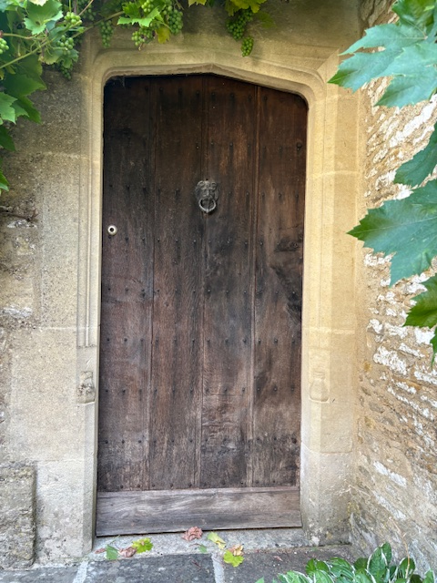
Fig. 17. New courtyard doorway to west wing, showing carved stone Tudor Gothic transom and jambs.

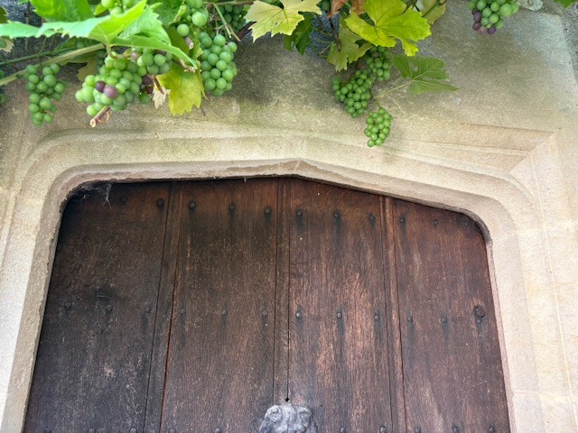
Fig. 18 New courtyard doorway, close-up view of carved stone Tudor Gothic transom.

- We can certainly lament the disappearance of the mediaeval gate-house and two-storey front porch illustrated in the 17th c. woodcut in the Victoria County History but the manor’s charm and historic interest today lies in the many alterations and additions, some of which were occurred in the 20th c. This could not reasonably be said to describe the poorly-designed and defectively constructed mid-20th c. lavatory extension, whose overall effect may be said to have detracted from the overall charm.
26. It is submitted that
(a) removal of the eyesores (e,g, asbestos roof and industrial metal windows) contributes to a positive restoration of the historic setting and the rebuilt stone-work is an improvement physically and aesthetically;
(b) moving the west wall of the extension a few feet outwards does no harm to the integrity of the manor historically or architecturally and makes for a more logical construction connecting the extremity of the south wall with the north wall. This also adds previously sorely-lacking cloakroom space for boots, wet-weather clothing etc essential for a substantial country house.

- By contrast, the setting of the manor has been significantly harmed by the consented developments in Bradfield Manor Farm.

- The grade 2 former threshing barn is now a pub, with an external eating area with table-benches and parking for dozens of cars (Figs. 19 and 21)

- Change of use was granted to convert a former Dutch barn into a brewery, which is now surrounded by fencing, shipping containers for storage other paraphernalia of the business etc. (Fig.20)

- In 2024, consent was granted to convert a former dairy into 8 retail units (not yet constructed).

The overall effect has been to convert an agricultural unit into a retail/leisure complex, which destroys the nature of the connection between the manor and the farm, which was previously regarded as integral to the grade I and grade 2 listed buildings.
Consent for these changes was granted on grounds that the development would support businesses and jobs in the locality. This is understandable but it inevitably comes at the cost of appreciable harm to the architectural and historic setting of Bradfield Manor.

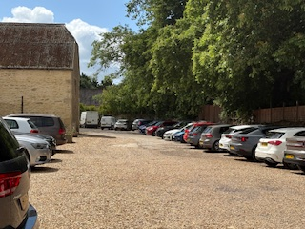
Fig. 19. Effect of car-parking on Grade 2 barn (to left) and listed buildings at Bradfield Manor (to right behind wall and vegetation)

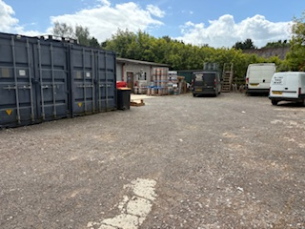
Fig. 20. Effect of storage containers and commercial vehicle parking adjacent to Grades 1 and 2 listed buildings at Bradfield Manor (behind laurel hedge).

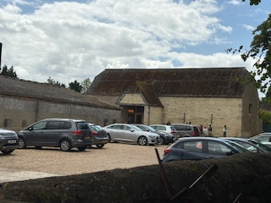
Fig 21. Effect of car parking and external eating/drinking area on Grade 2 threshing barn at Bradfield Manor Farm. The foreground wall is the boundary with Bradfield Manor.

28. This Grade 2 listed threshing barn was until the 1990s an integral part of the complex of working farm buildings within the curtilage of the Grade 1 listed manor. That feature is now entirely lost as a direct result of the conversion of most of the farm buildings into a leisure complex - including a pub with an outside eating/drinking area with table-bench seating for several dozen people, assorted commercial paraphernalia - shipping containers, open-air metal cask storage, waste bins and a car park for several dozen cars; shortly to be joined by 8 retail units directly overlooking the manor’s entrance.
29. Consent was also given in 2024 to convert the building on the left of Fig. 18 into 8 retail units, which will wholly obliterate any remaining agricultural use of the site and complete its change in character to a retail/leisure complex. Protection of architectural heritage was trumped by other planning considerations e.g. rural employment.
30. However understandable the planning decision reasoning, the combined effect of the recent grants of planning/listed building consent have inevitably significantly damaged the setting of Bradfield Manor visually.
31. In my respectful submission, the remedial works to the very small mid-20th c. extension in this application, by contrast do no harm to architectural integrity or setting because :
(a) they do respect the historic use and setting of the manor, (b) are not visible from outside its totally private walled garden, (c) cause no nuisance of any kind and (d) offend no-one’s eye.
.

Neil Hamilton
15 August 2025

