KEEVIL VILLAGE PLANNING POLICY
Reviewed and approved without change at the Annual Meeting of the Parish Council 12 May 2025

PART I: SUPPLEMENTARY PLANNING GUIDANCE FOR PLANNING APPLICATIONS
Policy Statement
The following statements are the basis on which the Parish Council makes its response as a Consultee for all planning applications in the Parish of Keevil. It is primarily based on the Village Design Statement (VDS) 2003, a material source of reference (see Part II) which the Parish Council expects developers and the Local Planning Authority (LPA) to reference when considering planning applications within the Parish.
- VILLAGE SETTING:
We will preserve local wildlife and habitats, and protect Keevil’s conservation area and historic buildings.
  - The landscape setting is important to Keevil’s essential character. The open aspect of the surrounding countryside, with its mature trees and hedgerows surrounding the fields, should be protected, conserved, or enhanced.
  - Existing boundary walls and hedges are important features throughout the length of Main Street and should be retained.
  - The existing network of footpaths should be retained to enable people to appreciate and enjoy Keevil’s surroundings.
  - The airfield provides an important haven for wildlife.
  - Wild areas within gardens provide habitats for a diversity of wildlife.
- SETTLEMENT
We do not wish to see development on green fields or farmland.
  - Development should respect the historic pattern of the village.
  - Much of the village is designated as a conservation area. As a result, it is desirable to preserve or enhance the character or appearance of the conservation area.
  - Open spaces or gaps, which make a significant contribution to the character or appearance of the street scene, should be protected; particularly where they provide views to the open countryside.
  - Trees, which are identified as being important to village character, should be retained. New planting should involve the planting of native species wherever appropriate.
  - Future development must take into account the capacity of the existing infrastructure.
  - Within the historic village core there may be archaeological remains from earlier settlement activity. Any proposed development should be checked to see whether it may impact such remains.
- NEW BUILDING
We recognise renovation or change of use of existing buildings and the need for smaller more affordable homes. However, all development must be in keeping with the existing landscape and character setting.
  - Any future development in the village, including extensions to existing buildings, should respect the building types and details of the central area around Main Street and its immediate environs.
  - Any new building should incorporate materials and designs in harmony with the built environment.
  - Within the conservation area, or where new development may affect the settings of listed buildings, the preservation of their special character will be the primary consideration.
Keevil Village Policy Limits
Keevil is one of over 150 designated ‘small’ villages in the Wiltshire Core Strategy (WCS), and under Core Policy (CP) 1 Settlement Strategy no longer has a settlement boundary. This policy states that ‘some very modest development may be appropriate at Small Villages, to respond to local needs and to contribute to the vitality of rural communities. Any development at Small Villages will be carefully managed by CP2 Delivery Strategy and the other relevant polices of this plan’.
Additionally, ‘the delivery strategy defines the level of growth appropriate within the built up area of small villages as infill. For the purposes of CP2, infill is defined as the filling of a small gap within the village that is only large enough for not more than a few dwellings generally only one dwelling’ (CP1, para 4.16 refers).
Keevil Conservation Area
The Keevil Conservation Area was designated in 1973 to preserve and enhance the special architectural and historic interest in this part of the village. Preserving the special character or appearance within or adjacent to this area, is the primary consideration when assessing, proposals for development. Stricter planning controls exist in conservation areas over minor alterations to land uses and buildings, and over proposals for demolitions or tree work.
CP58 Ensuring conservation of the historic environment, and CP57 Ensuring high quality design and place shaping, are routinely applicable in most situations in Keevil Parish, and all involving the Conservation Area.
CP51 Landscape and CP52 Green Infrastructure may also apply.
VDS AS MATERIAL PLANNING GUIDANCE
Under the Localism Act 2011 additional means such as Neighbourhood Plans were introduced as a way for communities to be more specific about their needs regarding planning and development. Local Village Design Statements that have not been superseded, however, remain material planning guidance.

Wiltshire Core Strategy page references | page
Delivering the vision – the spatial strategy for Wiltshire | 37
Core Policy 1: Settlement Strategy | 40
Core Policy 2: Delivery Strategy | 44
Delivering strategic objective 1: delivering a thriving economy | 216
Core Policy 34: Additional Employment Land | 218
Core Policy 35: Existing Employment Land | 221
Core Policy 36: Economic Regeneration | 224
Core Policy 37: Military Establishments | 225
Core Policy 38: Retail and Leisure | 227
Core Policy 39: Tourist Development | 230
Delivering strategic objective 4: helping to build resilient communities | 254
Core Policy 48: Supporting Rural Life | 255
Core Policy 49: Protection of rural services and community facilities | 258
Delivering strategic objective 5: protecting and enhancing the natural, historic and built environment | 260
Core Policy 50: Biodiversity and Geodiversity | 260
Core Policy 51: Landscape | 264
Core Policy 52: Green Infrastructure | 269
Core Policy 57: Ensuring High Quality Design and Place Shaping | 283
Core Policy 58: Ensuring the Conservation of the Historic Environment | 287
List of Saved and Replaced Policies | 432
List of Settlement Boundaries Retained | 459
List of Settlement Boundaries Removed | 461
PART II: KEEVIL VILLAGE DESIGN STATEMENT
Keevil’s Conservation Area was designated in 1973 to ‘preserve and enhance the special architectural and historic interest’ in some parts of the village.
Following widespread village consultation under the guidance of the then West Wiltshire District Council (WWDC), a Village Design Statement (VDS) was published to provide guidance for future planning and development within Keevil, and adopted by the Local Planning Authority as Supplementary Planning Guidance (SPG) on 12th March 2003.
The VDS supplemented policies within the West Wiltshire District Plan (WWDP) in place at that time, and draft policies in the emerging WWDP 1st Alteration, which was adopted June 2004.
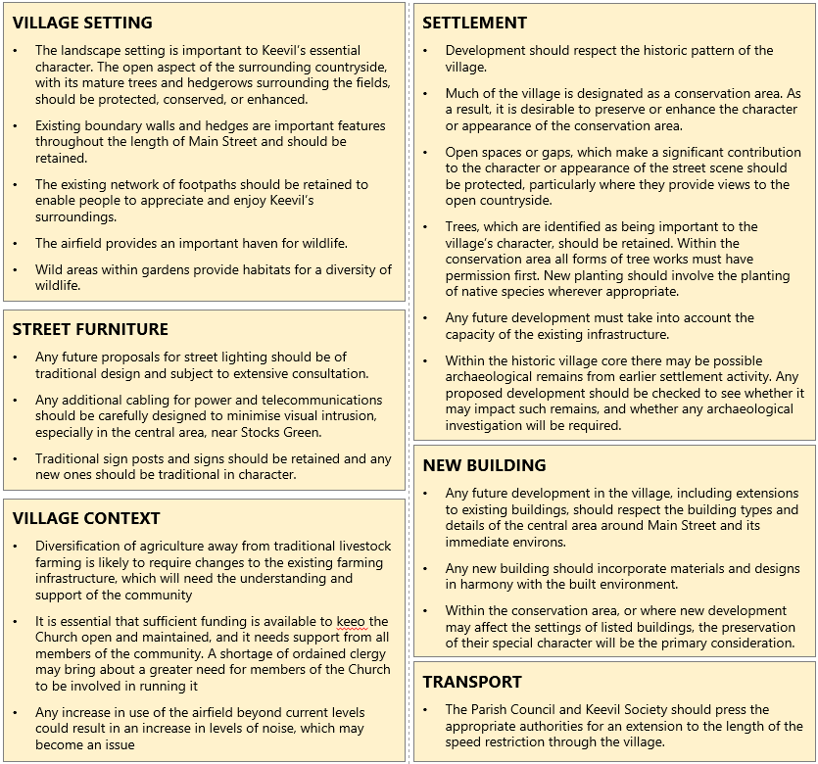
The VDS describes the character of village buildings, street pattern, trees and open spaces, and recommends design guidelines which influence the character of future development in Keevil, summarised in six ‘yellow boxes’ which remain as relevant today as ever, although the policies on which they were based have changed…

Relationship to WC Local Plan and the Wiltshire Core Strategy
The National Planning Policy Framework (NPPF) sets out the Government’s national planning policy and how it expects the policy to be applied, and places the LPA’s development plan at the heart of decision-making.
Since 2003, WWDC has become a unitary authority. Wiltshire Council (WC) meets its obligations under the NPPF through the Wiltshire Local Plan, which forms the development plan for Wiltshire. It is a legally required document containing planning policies and site allocations to deliver the Council's strategic priorities, and the basis against which planning applications are determined.
The current Local Plan is the Wiltshire Core Strategy (WCS) adopted in 2015, which provides the planning policy framework for Wiltshire to 2026*. This incorporates saved policies from former Local Plans that were not replaced by the WCS, which will continue to be saved until replaced as part of the Local Plan Review process.
* The new Wiltshire Local Plan was submitted to the Inspectorate in November 2024. If successful, it is expected to be adopted in late 2025.
POLICY REFERENCE MATRIX
Policy groups referenced in the Keevil VDS that were part of the West Wiltshire District Plan (WWDP) | REPLACED BY
C12-C17 Conservation Areas: - C12 (Redundant Military Land), C15 (Archaeological Assessment), C17 (Conservation Areas) | CP58 Ensuring conservation of the historic environment  C13, 14, 16, 17 not mentioned
C18-C21 Listed Buildings | CP58 Ensuring conservation of the historic environment.
C29 Trees and Tree Planting | Not mentioned
R2 Protection of Recreation Areas | Not mentioned
H4 Flat Conversions (Urban Mixed Use Brownfield Allocation) | Not relevant
H5 Village Policy Limits | CP1 & CP2
H6 Areas of Minimum Change (Land East of Melksham) | Not relevant
H9 Residential Conversions in the Countryside (Land at Southview, Trowbridge) | Not relevant
E5 Rural Employment (Loss of Employment Floorspace) | CP35 Existing employment sites
E6 Farm Diversification (Rural Employment) | CP34 Additional Employment Land
E8 Horse Related Development (Rural Conversions) | CP34 Additional Employment Land
CF3 Rural and Village Facilities | CP49 Protection of services & community facilities
Policy groups referenced in Keevil VDS that were part of emerging WWDP 1st Alteration referenced in the Keevil VDS | REPLACED BY
C17-C25 Conservation Areas: -C17-23 & 25 replaced by >>>  C24 (Advertisements) replaced by >>> | CP58 Ensuring conservation of the historic environment.  CP57 Ensuring high quality design and place shaping
C26-C29 Listed Buildings: - C26 & 28 replaced by >>>  CP27 & 29 not mentioned | CP58 Ensuring conservation of the historic environment.
C31a Design | CP57 Ensuring high quality design and place shaping
C40 Trees and Tree Planting | Continue to save
R2 Protection of Recreation Areas | Not mentioned
H16 Flat Conversions | Continue to save
H17 Village Policy Limits | CP1 Settlement Strategy, and CP2 Delivery Strategy
H18 Areas of Minimum Change | Continue to save
H21 Residential Conversions in the Countryside (Conversions of Rural Dwellings) | CP48 Supporting Rural Life
H24 New Housing Design | CP57 Ensuring high quality design and place shaping
E6 Rural Employment | CP34 Additional Employment Land
E7 Farm Diversification | CP34 Additional Employment Land
E8 Employment Conversions in Countryside (Rural Conversions) | CP34 Additional Employment Land
E10 Horse Related Development | Continue to save
TO3 Hotels, Guest Houses and Self Catering Accommodation | CP39 Tourist Development
TO4 Camping, Caravans, Holiday Homes | CP39 Tourist Development
CF3 Rural and Village Facilities (Villages and Rural Areas) | CP49 Protection of services and community facilities

PART III: SUPPLEMENTARY INFORMATION THAT INFORMS THE PART I POLICY
Keevil Village Survey 2019
Keevil Parish Council conducted a wide-ranging Village Survey in 2019, the results of which, although not specifically designed to align with the VDS, support the VDS Guidelines:
- 90% want local wildlife and habitats preserved;
- 90% want Keevil’s conservation area and historic buildings protected;
- 90% agree that future development must be in keeping with the existing landscape and character setting;
- 80% agree that our existing protection for the conservation of our landscape should be strengthened;
- 62% would not wish to see development on green fields or farmland;
- 60% agree with the renovation or change of use of existing buildings.
Although other responses around housing needs had high skip rates, it was clear that the need for smaller and more affordable homes is recognised.
- 56% felt negatively about the availability of parking;
- 50% felt negatively about the condition of roads, verges and byways;
- 45% felt negatively about speeding traffic through the village.

FOOTNOTE
Although the settlement needs of the village have changed little in the last twenty-five years, Keevil continues to welcome new residents and families of all ages in the natural ebb and flow of village life. However, the planning landscape has changed, and there is a clear desire for a detailed review of policy options available to us that align with the Local Plan and Core Policy.
This will require a substantial commitment of time and resources from both Councillors and residents. However, with the new Government’s implementation of the revised NPPF and, as noted above, the new Wiltshire Local Plan under consideration by the Inspectorate, we cannot be certain of any change (or not) in Core Strategy until late 2025. This policy should therefore be reviewed within twelve months of approval.
In the short term, we must take steps to soften any vulnerability in material planning guidance:
- By ensuring this policy is consistently referenced by the Parish Council in its consultee responses to planning applications, and
- By ensuring this policy is made available to the Local Planning Authority.

Sources: Keevil Village Design Statement 2003, Village Survey 2019, Wiltshire Core Strategy 20105
First adopted by resolution of the Parish Council on 5th September 2022.
Reviewed without change at the Annual Meeting of the Parish Council 2023 and 2024.
Revised and approved at the Ordinary Meeting of the Parish Council on 3rd March 2025

