Wiltshire Council Planning Consultation Response
URBAN DESIGN

Officer name:
Brian Johnson Dip Arch
Senior Urban Design Officer
Wiltshire Council

Date: 09.07.2025
Application No:  Proposal:  Site Address:  Case Officer: | PL/2025/02257  Outline planning application (with all matters reserved except access) for residential development, including the construction of up to 149 dwellings, new vehicular access with footways and cycleways, public open space, landscape and associated infrastructure  Land to the North of Whychurch Farm and West of Crudwell Road, Malmesbury  Gen Collins

Reference:

The covering letter identifies the drawings submitted for Approval: Land Use Parameter Plan; Building Heights Parameter Plan and Proposed Site Access and that for information only is a Framework Plan and Illustrative Masterplan. A Design & Access Statement is also submitted which also conveys Reserved Matters design. I advise no weight should therefore be attributed in any condition of planning approval i.e. ‘NOT ‘in accordance with’ to the latter two plans and the Design statement in regard to the Reserved Matters design they convey on which I comment below.

Policy and guidance: which should inform the design

Wiltshire Core Strategy Core Policy 57 ‘Ensuring high quality design and place shaping’ ; Wiltshire Design Guide (Wiltshire Council adopted March 2024); Building for a Healthy Life and companion Streets for a Healthy Life (both Homes England 2021); National Planning Policy Framework (December 2024).

Comment

- The ‘Existing public right of way’ (MALM7) leading some 500 metres from the edge of the development to the road off the roundabout at the foot of Tetbury Hill would be a strong desire line from the proposed development to the School, community centre and foodstore and riverside access off this at the foot of the hill and the direct pavement and street into the town centre and wider neighbouring residential areas. This is a rough marked track through the field. No change is identified to this. The Illustrative Masterplan and the Framework Plan (which labels this as ‘informal footpath’) shows this route within the site but does not show its continuation beyond the site boundary.

Given the substantial size of the overall development at 149 dwellings and its extension in this direction (compared to the current separate Full planning application PL.2023.08687 for the 71 dwellings in just the northern part of this overall site,) it would be reasonable to consider this PROW to be upgraded /made into a loose bound surfaced footpath and cycleway throughout across to its connection with the proposed streets. This would then meet Wiltshire Design Guide expectation 5.1.1 and 5.1.5 giving people choice and an attractive all weather surface.

The alternative pedestrian route into the town centre via the B4040 is along a narrow and not continuous pavement for a considerable distance.

- The Illustrative Masterplan in the two closes below (see extracts below left and centre) would not meet Wiltshire Design Guide expectation 5.1.8 that cul de sacs turning head /far end should be visible from the junction with a through road. ( These labelled ‘Secondary Streets’ on Design & Access Statement page 45 plan).

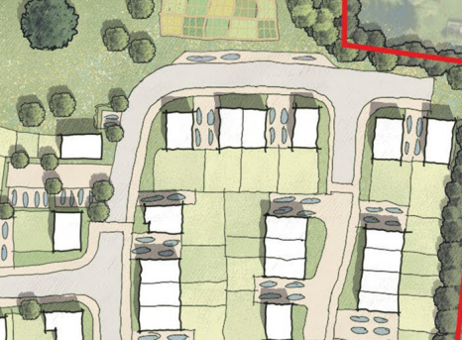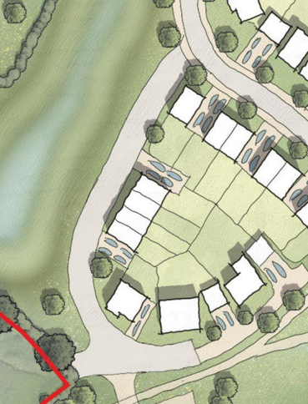
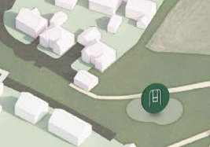
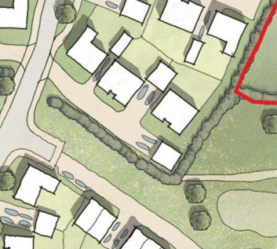

- On the Illustrative Masterplan the garage shown across the end of the private drive ( extract above right) and on the 3D Massing visual (extract above left from Design & Access Statement page 53) would be strongly apparent from within the public open space now formed with the overall extended layout whereas this was just a field edge on current PL.2023.08687 with the footpath distanced from it. While the existing hedgerow is retained this building would present a visually inactive, blank façade backdrop to this open space. I also question the retention this portion of hedgerow when the active frontage of dwellings in the close could visually provide an active window frontage onto this side of the space and direct access onto it.

- On the Illustrative Masterplan there is no vehicle access/ parking to the Community Orchard /allotments ( labelled on the Design & Access Statement plans page 37 and page 41) for its practical use and upkeep or that it would be a suitably enclosed area to prevent informal access.

- The Design & Access Statement Local Context analysis of built form identifies brick as one material but does not quantify the characteristic extent of the various materials. As a reserved Matter of Appearance this should recognise that brick is very sparingly used feature of the town and appropriately absent from the current separate Full planning application PL.2023.08687 for the northern part of the extended site now proposed. It would be reasonable to expect the limited range of materials /finishes proposed in PL.2023.08687 and disposition/proportion of these to be carried through across the extended site. These are the identified Local buff reconstituted stone facades ; Render facades (in Cream and Chalk); the Eternit reconstituted slate roof tiles and Sandtoft 2020 clay roof pantiles , noting that natural not concrete roof materials are required in the Malmesbury Neighbourhood Plan volume II ( and as respected on other recent development proposals).

