REPORT FOR THE STRATEGIC PLANNING COMMITTEE
Date of Meeting | 19 March 2025
Application Number | 20/03641/OUT
Type of application | Outline planning permission: Some matters reserved
Site Address | Land South of White Horse Business Park, Trowbridge, Wilts
Proposal | Outline application for up to 70 dwellings, landscaping, green infrastructure, associated drainage measures and vehicular access from the A363 as well as all associated works. Matters to be considered: Access into the site
Recommendation | Approve with Conditions
Applicant | Neil Cowley
Town/Parish Council | North Bradley CP
Electoral Division | Southwick (Historic)
Case Officer | Jemma Foster

Reason for the application being considered by Committee

The application is brought before the Strategic Planning Committee by Councillor Prickett, if recommended for approval, for the following reasons:

- Scale of development
- Visual impact upon the surrounding area
- Relationship to adjoining properties
- Design – bulk, height, general appearance
- Environmental/highway impact

- Recommendation: For the reasons set out within this report, officers recommend that the committee endorse the officer recommendation to approve the above mentioned application, subject to a s106 legal agreement and planning conditions.

- Purpose of Report

The purpose of the report is to assess the merits of the proposal against the policies of the development plan and other material considerations and to consider the recommendation that the application be approved subject to completion of a Section 106 legal agreement.

- Report Summary

The main issues to be considered are:
- Principle of development
- Impact on the character of the area
- Ecology
- Impact on the significance of heritage assets
- Archaeology
- Impact on neighbour amenity
- Highway matters
- Public Rights of Way
- Drainage
- Section 106 Legal Agreement
- Planning balance
- Conclusion
- Site Description

The site is located outside of the limits of development of Trowbridge but is an allocated housing site within the Wiltshire Housing Site Allocations Plan (WHSAP), as is shown on the following plan.

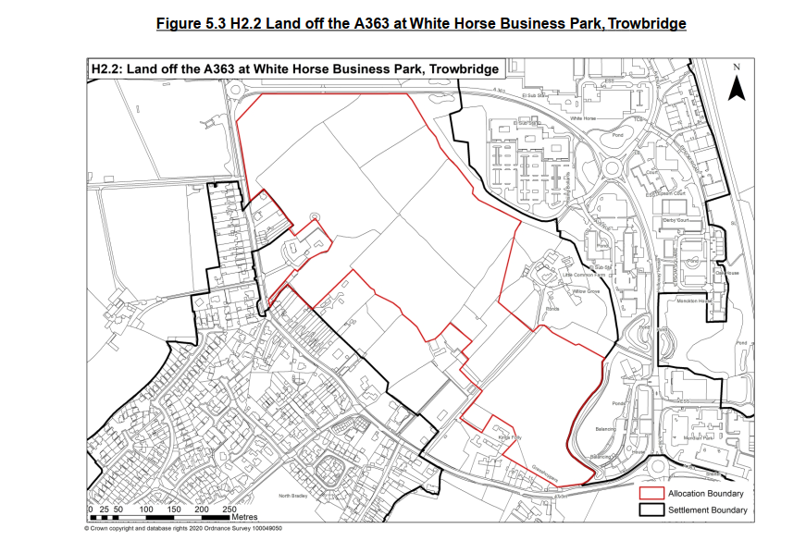

The application site includes part of the allocation and covers the following area:

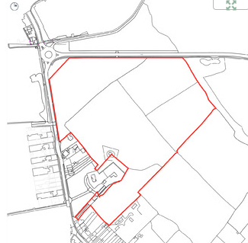

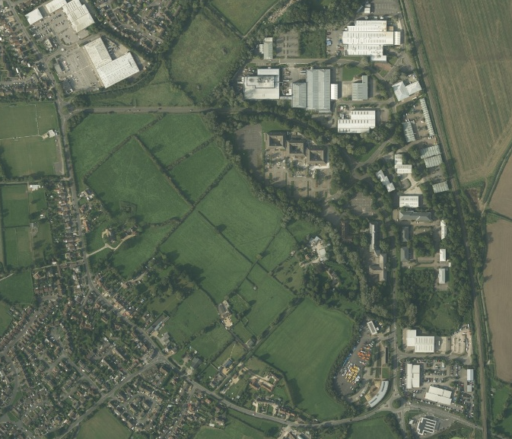

The site sits in the Avon Vale Countryside Character Area. The Agricultural Land Classifcation is Grade 3 and 4 and there are three Tree Preservation Orders (TPO’s) on the site. Small areas of the site are at risk of surface water flooding but the site lies within Flood Zone 1.

The site generally falls in a north easterly direction towards the A363 Bradley Road, with the lowest point being in the north eastern corner of the site.

The site has mature hedgerows and a woodland belt along its eastern boundary with the White Horse Business Park. The northern boundary faces onto Bradley Road. The western boundary sees properties along Woodmarsh Road, with the south of the site facing onto agricultural land which is also subject of the Housing Site Allocation Plan allocation.

- Planning History

19/12090/SCR – EIA screening opinion for residential development of up to 99 dwellings and a care home facility - EIA not required

W/07/01620/FULES – New football stadium, covered pitches and clubhouse facilities, training pitch and associated facilities - Withdrawn

- The Proposal

This application seeks outline planning permission with all matters reserved for subsequent approval except for access. As originally submitted, the application sought consent for 92 dwellings and a 64 bed care home. The number of dwellings has now been reduced to 70 and the proposed care home has been removed and replaced with public open space.

The site measures approximately 8.37 hectares and would have an average density of 42 dwellings per hectare. The scheme proposes ta mix of houset ypes up to 2.5 storeys, with 30% being dedicated to affordable housing. 6.6 hectares of the site will be classified as green infrastructure which equates to approximately 79% of the overall site – this will include both formal and informal play areas, on-site attenuation features and landscape planting. Access is to be off the main A363 (Bradley Road) with a ghost island right turn lane.

The detailed matters relating to appearance, landscaping, layout and scale of the proposed development are reserved for a later reserved matters application. However, to assist the Council with its assessment of this outline application, the applicant has submitted an Illustrative Masterplan which is shown below:

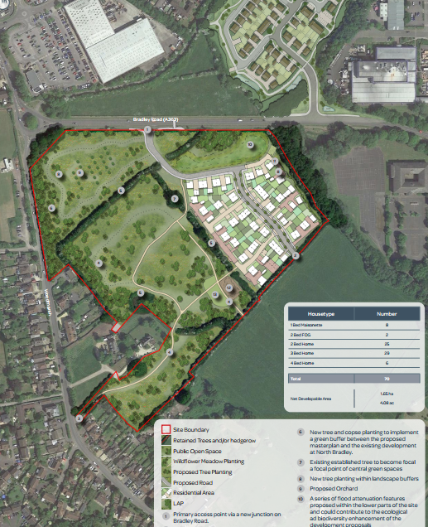

- Planning Policy

National Context:
National Planning Policy Framework (NPPF) – revised December 2024
Planning Practice Guidance (PPG)
Planning (Listed Buildings and Conservation Areas) Act 1990
Habitat Regulations
Streets for a Healthy Life – A Companion to Building for a Healthy Life
Building for a Healthy Life
Manual for Streets

Local Context:

Wiltshire Core Strategy (WCS) adopted 2015:

CP1 – Settlement Strategy, CP2 – Delivery Strategy, CP3 – Infrastructure Requirements, CP29 - Spatial Strategy Trowbridge Community Area, CP41 – sustainable construction , CP43- Providing Affordable Homes, CP48 – Supporting Rural Life, CP50 – Biodiversity and Geodiversity, CP51 – Landscape, CP52 – Green Infrastructure, CP55 – Air Quality, CP56 – Contaminated Land, CP57 – Ensuring High Quality Design and Place Shaping, CP58 – Ensuring the Conservation of the Historic Environment, CP60 – Sustainable Transport, CP61 – Transport and New Development, CP64 – Demand Management, CP67 - Flood Risk

Saved Policies from the West Wiltshire District Local Plan (1st Alteration):
U1a - Foul Water Disposal, U2 - Surface Water Disposal, I1 – Implementation

Other

Wiltshire Leisure Services Strategy – Indoor Facilities Action Plan 2011 – 2025 adopted April 2012
Open Space provision in New Housing Developments – A Guide (Supplementary Planning Guidance) and Wiltshire Council’s Playing Pitch Strategy February 2017
Affordable Housing Supplementary Planning Guidance adopted August 2004
Art and Design in the Public Realm in Wiltshire May 2024
Air Quality SPD (July 2023)
Leisure and Recreation Development Plan Document
Wiltshire Car Parking Strategy
North Bradley Neighbourhood Plan (made May 2021)
Trowbridge Bat Mitigation Strategy
Bat SAC Planning Guidance for Wiltshire, 2015
LTN1/20 – Cycle Infrastructure Design
Wiltshire Active Travel Standards and Travel Parking Standards
Wiltshire Design Guide 2024
Housing Land Supply Statement June 2024 (with baseline date of April 2023) – However it is important to note that the June 2024 HLS has been superseded by fresh calculations made following release of the revised NPPF in December 2024 and members should refer to the following:
Wiltshire Council Briefing Note No.24-20 (17 December 2024)

Wiltshire Housing Site Allocations Plan February 2020
Wiltshire Waste Core Strategy adopted July 2009
Wiltshire Council’s Waste Storage and Collection: Guidance for Developers Supplementary Planning Document,

West Wiltshire Landscape Character Assessment, March 2007

- Summary of Consultation responses

North Bradley Parish Council: Object for the following reasons:

- The site deviates from the TBMS
- Concerned about the short distance between the access point to H2.1 and the Elm Grove development – how will these two junctions interact
- Concerned with potential road safety hazards, the central refuge island shown to the east would serve no useful purpose as it makes it less easy for drivers turning right into the development and encourages pedestrians to crossthe A363. A refuge to the west would be more sensible
- Concerned about the additional traffic that will use Woodmarsh. Traffic calming must be incorporated into a S106
- Application should not be decided until the applications for the remainder of the sites have been submitted so to accord with the requirement of a masterplan
- A wider landscape buffer should be provided
- We want to see a pedestrian/cycle access onto Woodmarsh Road on a surfaced route suitable for a shared use
- We would rather see a shared roundabout with Elm Grove rather then two junctions
- No account has been taken of the Spitfire Retail Park and the associated traffic
- Care home has been removed from the plan but no accommodation for the elderly has been provided
- The Primary street should be 20mph

Trowbridge Town Council: No objection subject to the open spaces being offered to the Town Council and not adopted by Wiltshire Council and therefore we should be party to the S106 and there should be S106 funding towards the establishment of additional burial space within the Trowbridge Community Area.

Wiltshire Council Highways Officer: No objection subject to conditions and S106 contributions

Wiltshire Council Drainage Officer: No objection subject to conditions

Wiltshire Council Conservation Officer: No objection

Wiltshire Council Archaeology Officer: No objection

Wiltshire Council Housing Officer: S106 contributions should be sought

Wiltshire Council Climate Change Officer: Conditions would be required

Wiltshire Council Landscape Officer: No objection

Wiltshire Council Public Rights of Way Officer: No objections subject to S106 contributions

Wiltshire Council Waste Officer: Conditions and S106 contributions should be sought

Wiltshire Council Public Arts Officer: S106 contributions should be sought

Wiltshire Council Ecology Officer – More information required 22/11/22

Wiltshire Council Education: S106 contributions should be sought

Wiltshire Arboricultural Officer – No objection

Wiltshire Council Land Contamination Officer – No objection subject to a condition

Wiltshire Council Air Quality Officer – S106 contribution is required

Wiltshire Council Urban Design: No objection

Wiltshire Council Public Open Space Officer: S106 requirements and contributions would be sought

Wiltshire Council Public Protection Officer – No objection subject to conditions

NHS: No response at time of writing

Salisbury and Wilton Swifts: request conditions

Natural England: Support the Councils Ecologist recommendation

Environment Agency – no comment

Wessex Water – No objection

Network Rail – Initially made no objections to the proposal but then objected to the amended plans due to the additional risk to safety at the nearby Level Crossings

Sport England – No comment; refer to previous comments

Wiltshire Police Architectural Liaison Officer – no objection

- Publicity

Circa 40 letters of objection have been received from the general public over the period of two public consultation periods with a final expiry date of 26th December 2023, which make the following comments that have been summarised below:

Principle

- Incompatible with the Neighbourhood Plan, Wiltshire Core Strategy and NPPF
- It is in open countryside

Impact on Area

- Not enough landscape gap to separate the development from the village.
- Loss of animal habitats and green spaces and bat corridors
- Loss of a rural area
- Loss of a green belt
- Developments not working together so they will be disjointed with no one identity
- Why are there no bungalows proposed?

Impact on Neighbour Amenity

- Garden spaces are small

Highways

- Increase in the volume of traffic will exacerbate existing congestion problems
- It will not be safe for pedestrians
- We do not want an access on Woodmarsh Road
- Existing road juncitons will struggle to cope with more traffic
- Westbury Road is unsuitable for any additional traffic
- The footway widening on the A363 should protec the block paving surface and grass verge which are a part of the character
- There are always queues into the Spitfire Retail Park – no evidence of this has been submitted by the Applicant
- The Applicant should include traffic calming measures on Woodmarsh Road
- The access is very close to the proposed access for Elm Grove
- We do not appreciate a public right of way running right alongside our property in Woodmarsh as it makes us feel vulnerable

Other

- North Bradley has limited infrastructure and wont be able to cope with the additional population
- Village school will not be able to accommodate all the children
- Medical facilities are full
- The play area is out of sight of the majority of the housing
- Because the developers cannot work together the application should be refused

- Planning Considerations

Section 38(6) of the Planning & Compulsory Purchase Act 2004 and Section 70(2) of the Town and Country Planning Act 1990 require that planning applications must be determined in accordance with the Development Plan, unless material considerations indicate otherwise.

10.1 Principle of development

Wiltshire Core Strategy (WCS)
Trowbridge is defined in Core Policy 1 as a Market Town, based on an assessment of its role and function. Market towns are defined as settlements that have the ability to support sustainable patterns of development through their current levels of facilities, services and employment opportunities, and have the potential for significant development that can improve self-containment.

WCS Core Policy 2 sets out the Delivery Strategy for growth for the period to 2026 and aims to distribute development in a sustainable manner. Within the defined limits of development for settlements, there is a presumption in favour of permitting sustainable development.

Development proposals outside these defined limits are not supported in principle unless the proposal has come forward through a number of sources identified at paragraph 4.24 of the WCS, one of which is sites identified through DPD’s and neighbourhood plans.

The Wiltshire Housing Site Allocations Plan (WHSAP)
The WHSAP was adopted in February 2020 and allocated new sites for housing to ensure the delivery of homes across the plan period, in order to help demonstrate a five-year supply in each of Wiltshire’s three Housing Market Areas over the period to 2026. This document allocated a site of approximately 20.52 hectares of land off the A363, south west of the White Horse Business Park. It is known in the WHSAP as H2.2. The development subject of this application falls within this housing allocation.
The WHSAP plan allocates the site for the following:
- Approximately 175 dwellings
- Vehicular access from the A363
- Development to be directed to the north and east of the site; and
- Improvements to cycling and walking routes through the site to link into the existing network.
The allocation also states the the development will be subject to the following requirements:
- core bat habitat will be protected and enhanced. Design and layout will be informed by appropriate surveys, impact assessments and the Trowbridge Bat Mitigation Strategy (TBMS);
- appropriate mitigation to protect bats, including financial contributions towards management, monitoring and any off-site measures as necessary, as informed by the TBMS;
- retention and enhancement of existing hedgerows and trees as part of wider landscaping and green infrastructure requirements, incorporating open space provision. Development will be expected to enhance a key gateway approach to the town and retain visual separation between the town and North Bradley;
- sensitive design and layout, which ensures the significance of heritage assets and their settings are not subject to unacceptable harm.This shall be informed by appropriate heritage and archaeological assessments. Development prposals will make a positive contribution towards conserving and enhancing the significance of the Baptist burial ground, its gateway and its setting; and
- a Flood Risk Assessment (incorporating an assessment of the predicted effects of climate change) and comprehensive drainage strategy to inform site layout and design so that surface water is controlled and does not exacerbate flooding off-site.
The development subject of this application is only for part of the wider allocation and seeks consent for up to 70 dwellings. At the time of writing this report, there is an existing full application being assessed by Wiltshire Council for the remainder of the site which is currently seeking consent for 62 dwellings (ref. PL/2022/05426). This could result in a total number of dwellings for the entire site allocation of 132.

The provision of approximately 132 dwellings is 43 dwellings short of the WHSAP allocation, which requires approximately 175 dwellings, but this has come about due to more up-to-date information regarding bats and bat corridors which has resulted in a reduced area that is capable of being built on. As this report will demonstrate, it is considered that the development subject of this application would provide dwellings at an appropriate density, a vehicular access off the A363 and make improvements to the cycling and walking routes alongside protecting core bat habitat, and retaining landscaping features. As such, it is considered to comply with the principles of the WHSAP and would therefore be acceptable in principle.

Housing supply and delivery
On 12 December 2024, the Government issued an update to the National Planning Policy Framework (NPPF). On the same date, the Government also issued revisions to the Planning Practice Guidance (PPG), including the standard methodology for assessing and setting Local Housing Need, and published the 2023 Housing Delivery Test results (The 2023 Housing Delivery Test results were published on 12 December 2024). These indicate that Wiltshire had delivered 135% against its housing requirement in the last three years, which is the period over which housing delivery is assessed in the test. This results in a 5% buffer to be applied on the five-year requirement in the housing land supply calculation.
The revisions that are pertinent to the housing land supply calculation and its implications are summarised as follows:

- Local Planning Authorities are now required to demonstrate a deliverable supply of housing sufficient to meet five years against their housing requirement set out in adopted strategic policies (or against their Local Housing Need where the strategic policies are more than five years old) in all circumstances. Under the previous NPPF, Wiltshire was only required to demonstrate a four-year housing land supply because its draft Local Plan had reached an advanced stage.

- Local Planning Authorities are now required to add a buffer to the housing requirement in the five-year housing land supply calculation in all circumstances. The buffer to apply is driven by the council’s latest Housing Delivery Test results, which for Wiltshire indicates a 5% buffer to be added. Under the previous NPPF, a buffer was only required if the council’s Housing Delivery Test results indicated under-delivery of 85% or lower against the housing requirement, which was not the case for Wiltshire.

- The revisions to the PPG have set out a revised standard methodology for the Local Housing Need – this is the calculation that establishes the housing figure to be used in the housing land supply calculation. The revision has changed the method from being based on future household projections, to being based on the amount of existing housing stock in the local authority area. The revision has also changed the adjustment factor which is based on the affordability of housing in the local planning authority. The figure for Wiltshire has changed as follows:

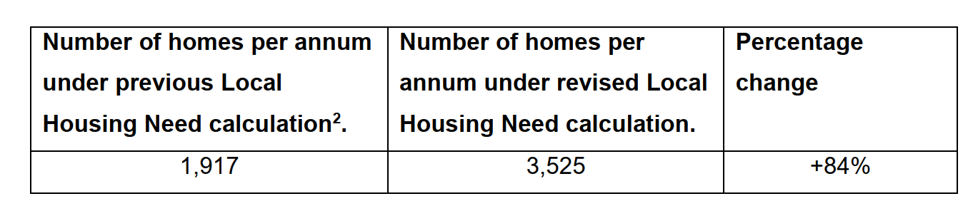
- The consequences of not being able to demonstrate a five-year housing land supply are that the presumption in favour of sustainable development (often referred to as the ‘tilted balance’) applies. This is set out in paragraph 11d of the NPPF. This paragraph has also been amended in two ways. Firstly, where there are exception policies that prevent the ‘tilted balance’ applying, that these provide a ‘strong’ reason for refusal, rather than a ‘clear’ reason for refusal. Secondly, to ensure that when the planning balance is being carried out, that particular regard is had to certain key policies in the Framework related to directing development to sustainable locations, making effective use of land, securing well-designed places and providing affordable homes, individually or in combination.

In summary, the changes to the NPPF now require Wiltshire to demonstrate a five-year housing land supply, including a 5% buffer, and must apply the revised Local Housing Need for decision-taking immediately. As the table in paragraph 3.c above shows, this results in a significant increase in the five-year housing requirement to be met from the previous calculation. When this is assessed against the housing land supply which can be delivered within five years, the recalculation shows a significant reduction in the number of years supply. A five-year housing land supply in Wiltshire therefore cannot be demonstrated. A 2.03 years supply can be demonstrated which is considered to be a substantial shortfall.
As such, the tilted balance in paragraph 11(d) of the NPPF should be used when making a decision on this application.
Neighbourhood Plan
The North Bradley Neighbourhood Plan (NP) was made in May 2021 and forms part of the development plan framework for Wiltshire.
Paragraph 14 of the NPPF (Dec 24) states:
In situations where the presumption (at paragraph 11d) applies to applications involving the provision of housing, the adverse impact of allowing development that conflicts with the neighbourhood plan is likely to significantly and demonstrably outweigh the benefits, provided the following apply:
- The neighbourhood plan became part of the development plan five years or less before the date on which the decision is made; and
- The neighbourhood plan contains policies and allocations to meet its identified housing requirement (see paragraphs 69-70)

The North Bradley NP has policies and allocations within it to meet its identified need and therefore is a relevant up to date document that has to be taken into consideration when making a decision on this application. It supports new housing development (policy 2) within the defined limits of development and does support the erection of up to 175 dwellings on the wider H2.2 housing allocation site.

As the neighbourhood plan is less than 5 years old, and contains policies and allocations to meet its identified need, paragraph 14 of the NPPF applies and development should be refused where “the adverse impact of allowing development that conflicts with the neighbourhood plan is likely to significantly and demonstrably outweigh the benefits.”

It is considered however, that the proposal complies with the Neighbourhood Plan as it supports residential development identified in Policy H2.2 of the WHSAP.
10.2 Impact on the character of the area
Core Policy 45 of the adopted WCS requires "new housing, both market and affordable, must be well designed to address local housing need incorporating a range of different types, tenures and sizes of homes to create mixed and balanced communities".
Core Policy 51 (‘Landscape’) of the Wiltshire Core Strategy states that new development should protect, conserve and where possible enhance landscape character, and should not have a harmful impact on landscape character. The policy requires applications to demonstrate how development proposals conserve and where possible enhance landscape character through sensitive design, landscape mitigation and enhancement measures.

Core Policy 57 of the adopted WCS requires a "high standard of design" for all new developments. This policy requires developments to "create a strong sense of place through drawing on the local context and being complementary to the locality" with applications being accompanied by appropriate information to demonstrate how the proposal would "make a positive contribution to the character of Wiltshire" and sets out a list of criteria that proposals for new development must comply with.

This application is seeking outline planning permission, with all matters reserved except for access, for the future development of up 70 dwellings, landscaping, green infrastructure and associated drainage measures with an access from the A363. It should therefore be noted however that appearance, landscaping, layout and the scale of the development are matters reserved for a decision at a later date, and therefore the submitted details with this outline submission, are indicative only.

There are no landscape designations covering the site and the area is not considered to form part of a valued landscape in the context of paragraph 187 of the NPPF.

A masterplan document has been submitted with the application which covers the entire allocated site identified as Policy H2.2 and enables a holistic approach for the parcels of land being developed separately. One of the plans within this masterplan document is as follows:
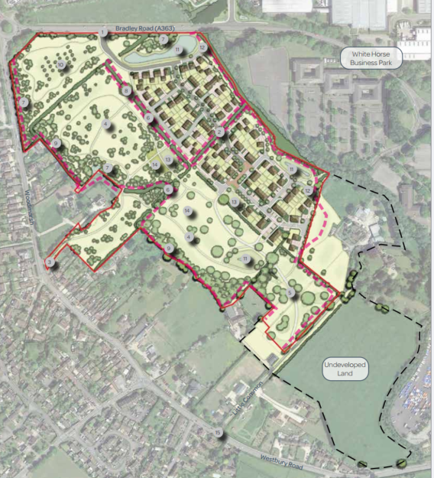

A Landscape and Visual Impact Assessment and separate note have been submitted with the application which forms the basis of the landscape strategy for the site subject of this application. The documents have been prepared following current best practice and published technical guidance and have been assessed and supported by the Council’s Landscape Officer.

The proposal includes 6.6 hectares of green infrastructure (approximately 70% of the site) and an integrated ecological strategy with planting retention and additional habitat improvements, which is welcomed.
A landscape separation zone has been proposed along the western boundary in order to create a visual and physical separation between North Bradley and the proposed development, which would also avoid coalescence. At the closest point, there would be a gap of approximately 137 metres between a proposed dwelling and the rear garden of 18 Woodmarsh, with the widest gap being approximately 290 metres between the proposed dwellings and Woodmarsh. This landscaped separation zone would include footpaths and a play space. Existing trees and hedges would be retained and enhanced, with additional planting including a woodland belt that would be approximatey 25-30 metrs in depth and would include Oak, Beech, Alder, Field Maple, Hornbeam, Silver Birch, Rowan among others. The Public Open Space is to be kept informal and is to be lightly managed with the addition of wildflowers and tree planting and is to remain open to retain the current field composition. This space has been designed to be multi- functional to incorporate human activity, as well as ecological, hydrological and visual integration.
There are three Tree Preservation Orders (TPO’s) within the site. Two are located along the central hedgerow which runs in a north west to south east direction, and the third is located in the southernmost field, to the south of Woodmarsh Farm Cottage. In order to preserve these trees and hedgerow, a landscape buffer would be applied either side of the hedgerow. The Council’s Arboriculturalist has assessed the application and whilst supporting the principles of the submitted information, has confirmed that the submitted Arboricultural Impact Assessment does not comply with the amended plans and therefore a future reserved matters application should include a revised Arboricultural Impact Assessment complete with a tree constraints plan, tree protection plan and method statement that should be prepared in accordance with BS5837:2012. This element can be conditioned as the illustrative masterplan may change upon submission of a reserved matters application.
Although illustrative, the submitted Design and Access Statement confirms that there would be a palette of materials reflecting the local character. Full details would be provided within a future reserved matters application but could include brick and render under reconstituted slate or red/brown tiles. The proposed houses would predominantly be 2 storey in height, with some variation in roof heights to create interest. There would be some 2.5 storey dwellings to act as nodal points and end of street vistas. Boundary treatments would include timber close boarded fences and brick walling. Hedgerow and street trees would also be used to delineate public and private spaces. It is considered that these landscaping principles are acceptable although the detail would need tobe assessed at the reserved matters stage. To ensure there is an appropriate mix of housing on site to meet local need, a condition can be imposed requiring the reserved matters application to provide justification for its housing provision. The Parish Council have raised a concern that whilst the care home has been removed from the plan, no accommodation has been provided for the elderly. This is something that would be assessed at the reserved matters stage and would be controlled via the suggested condition above.
It is accepted that there would be some landscape impact as a result of the development, the character of which would change from a green field to a built form, however, the principle of this impact was assessed and considered acceptable when the site was allocated for housing in the WHSAP.
The Council’s Urban Design officer has confirmed that the ‘Illustrative Sketch layout’ 4005 Rev K in general would form a suitable basis to develop a future reserved matters application; however, with regard to layout, the cul de sacs should be connected with paths for pedestrians and cyclists to accord with national guidance. There should also be a connection from the south west corner lane into the planned continuation of housing into the field to the south, and likewise in regard to the open space corridor /watercourse shown inside the north east hedge boundary, which should also be well overlooked by ground and first floor habitable rooms to adjacent dwelling facades along its length, following national principles. An informative can be added to the decision to cover these points.
In landscape terms, the proposal is considered to comply with the requirements of Policy H2.2 in the WHSAP and Core Policies, 51, 57.
Land Contamination
Although the site is ‘greenfield’, it would need to be ensured that there is no historic use that could cause a source of potential contamination to future occupiers. Therefore, the Council’s Public Protection Officer has recommended that a condition is attached to any approval to ensure this is the case – this is considered to ensure that the proposal complies with CP56.

Agricultural Land Classification
Paragraph 187 of the NPPF requires planning decisions to contribute to and enhance the natural and local environment. Footnote 65 of the NPPF confirms that where significant development of agricultural land is demonstrated to be necessary, areas of poorer quality land should be preferred to those of a higher quality. The Agricultural Land Classifcation for the site in question is grade 3 and 4 (he majority of which is 4) which is considered to not be the best and most versatile agricultural land. Consequently, there is no objection to the loss of this agricultural land since the proposal would comply with the requirements of the NPPF.
Climate Change
CP41 requires new development to incorporate design measures to reduce energy demand. A sustainability statement has been submitted with the application which confirms that homes will be built to reduce carbon emissions and go beyond Part L 2013, a fabric-first approach to design to reduce energy demand such as solar panels and air source heat pumps, net zero ready, all electric and designed to take into account annual temperatures and to minimise the risk of overhearing. The statement also confirms that the dwellings would use low carbon or locally sourced materials and use water efficient fixtures and fittings re reduce water consumption.
The Council’s Climate Change Officer has confirmed that, whilst the statement covers the required areas, any future reserved matters application should be supported with updated sustainable energy strategies to detail exactly what measures are being proposed once the detailed information has been developed.
10.3 Ecology
Core Policy 50 requires all development proposals to “incorporate appropriate measures to avoid and reduce disturbance of sensitive wildlife species and habitats throughout the lifetime of the development”… “all development should seek opportunities to enhance biodiversity. Major development in particular must include measures to deliver biodiversity gains through opportunities to restore, enhance and create valuable habitats, ecological networks and ecosystem services”…. “Sustainable development will avoid direct and indirect impacts upon local sites through sensitive site location and layout, and by maintaining sufficient buffers and ecological connectivity with the wider environment. Damage or disturbance to local sites will generally be unacceptable, other than in exceptional circumstances where it has been demonstrated that such impacts:
- Cannot reasonably be avoided
- Are reduced as far as possible
- Are outweighed by other planning considerations in the public interest
- Where appropriate compensation measures can be secured through planning obligations or agreements”

Policy 5 of the North Bradley Neighbourhood Plan requires all developed to comply with the Trowbridge Bat Mitigation Strategy
The application site is a greenfield site located within the yellow medium risk zone of the Trowbridge Bat Mitigation Strategy (TBMS), which is a Supplementary Planning Document (SPD) (adopted Feb.2020). The application is screened into apprppriate assessment in relation to the Bath and Bradford on Avon Bats SAC and therefore the application must assessed against the Habitat Regulations. The HRA for the site allocation in the WHSAP confirmed that compliance with the TBMS would be sufficient to demonstrate that the applications would not lead to adverse effects alone, and in combination with, other plans and projects.
The SAC’s qualifying features are as follows:
1. Bechstein’s bat Myotis bechsteinii
2. Greater horseshoe bat Rhinolophus ferrumequinum
3. Lesser horseshoe bat Rhinolophus hipposideros
This application is located approximately 1.7 km west of Pickett and Clanger Woods and approximately 2.6 km south-west of Biss Woods. These woods are publicly accessible woods south of Trowbridge, each supporting a colony of Bechstein’s bats, which together are believed to form a meta population of national importance.

Bat ringing data has shown the same bats using the woodlands and the SAC. The woodlands are therefore considered to be functionally linked to the SAC and it is possible the conservation objectives for the SAC may not be met if the bats are disturbed or prevented from breeding there. Studies have shown that Bechstein’s bats are not confined to the woodlands but travel to find additional foraging and roosts outside them. Consequently, the TBMS recognises the importance of Pickett & Clanger Woods (and Green Lane/Biss Woods) and their surrounding habitats through 2 buffer zones. Extending 600m from the woodland edge, the red zone is an area of development restraint due to the high probability that this zone is of current and future importance for maintaining the breeding colonies. Beyond this the yellow zone, which takes into consideration the foraging areas and flightlines of horseshoe bats, is anticipated to be able to accept a degree of development pressure provided applications are designed in accordance with the principles in the TBMS. The grey hatched zone identifies the distance within which 75% of visitors to Green Lane Wood, Biss Wood, Picket and Clanger Woods are expected to come from and a package of mitigation measures is identified in the TBMS to accommodate the anticipated growth within this zone.

Habitats within the site comprise three cattle-grazed, species-poor, semi-improved grassland fields bordered by hedgerows. Bat activity surveys have been completed on site in accordance with BCT Good Practice Guidelines, Wiltshire Bat SAC Planning Guidance and the Trowbridge Bat Mitigation Strategy and demonstrated that all three qualifying bats were using the boundaries consistently throughout the year. No trees were recorded as having potential roosting features for bats. The proposed development demonstrates that the core bat habitat remains connected with the wider habitat network and buffers are being provided in accordance with the TBMS alongside attenuation ponds which will improve the capacity of the site to provide insects as a food source for the bat population. A lighting report was submitted with the application which shows a 30m dark corridor along the western part of the site and a 20m dark zone in the middle of the development to provide the main commuting and foraging coridors for the bat community.

The existing woodland edge and hedgerows offer suitable habitat for birds, bats and replites and provide connectivity to nearby offsite habitats. The proposal seeks to retain and improve these existing assets. A number of bat flight paths were identified across the site and as such the habitat along this corridor is to be retained. Additionally an east to west bat corridor is proposed between Great Elm in the East to Axe and Cleaver Lane in the West. These habitats are proposed to remain dark and where necessary sensitive lighting will be proposed.

The Council’s Ecologist has confirmed that the revised layout will deliver a large swathe of bat habitat that will enhance the site for all biodiversity especially bats and will ensure functionality for bats is retained across the site. The south/south western habitat has been designed specifically as informal bat habitat and includes an area of orchard, native woodland planting, scrub, wildflower grassland areas, SuDS and management of the ares will encourage natural regeneration. The layout also proposes a series of footpaths, cycle paths and public open space which will not be lit. A concern was raised regarding lighting in the the north-eastern boundary where the residential area lies adjacent to the offiset woodland belt and where core bat habitat crosses the access road leading south from the A363 where lux levels need to be low. As such, a condition can be imposed to ensure that the reserved matters application is submitted with additional lighting information so that this can be fully assessed. A Landscape and Ecology Management Plan (LEMP) will also be required to secure the habitats, in line with the landscape strategy, ecological mitigation plan, which is considered to be an appropriate approach.
North Bradley Parish Council has raised concerns that the proposed development is not in accordance with the TBMS. However, Natural England has supported the revised layout and is satisfied that greater benefits for bats will be secured, including the Annexe II species for which the Bath and Bradford on Avons Bats SAC is noted, than if the TBMS criteria were to be strictly followed.
Other protected species
The attenuation basins proposed as part of the SuDS system will also provide a suitable breeding habitat for other protected specieis, such as Great Crested Newts, and a newt crossing point is also proposed along the entrance road to aid their movement.
Bird and bat boxes are proposed to be tree-mounted and log piles are proposed to provide essential habitats for wildlife
A dormouse and reptile survey was also undertaken, with small numbers of slow worm being recorded along the western boundary, which will benefit from the additional landscape features proposed as part of the development.
Swifts in the UK are on the Birds of Conservation Concern (BoCC) Red List and are classified as Endangered on the IUCN Red List assessment of extinction risk for Great Britain. As such, a condition should be attached to any permission requesting an installation plan for integral nest boxes to be installed on site at a ratio of 1:1 in line with BS 42021:2022 Integral nest boxes – Selection and installation for new developments.
An Ecological Parameters Plan (EPP) has been submitted with the application, which identifies those areas of the site which are unconstrained, those areas where sensitive design or restrictions may be required, and any areas of the site which are to be retained, remain undeveloped, enhanced, form part of the landscaping for the purposes of protecting and enhancing biodiversity, and any areas to be used as compensatory habitat in line with the submitted ecology documents, including the Biodiversity Net Gain Calculator spreadsheet. The EPP will become an ‘approved document’ of any outline permission granted and any reserved matters application must be also be in compliance with the plan.
The application site lies within the 6.4km buffer zone of the Salisbury Plain SPA and in light of the HRA for the Wiltshire Core Strategy and the HRA for the Wiltshire Housing Site Allocations Plan, it is screened into Appropriate Assessment due to the potential impact of recreational pressure on stone curlew in combination with other plans and projects. In April 2023, Natural England (NE) confirmed that the 2018 Appropriate Assessment for Salisbury Plain continues to be supported by NE. That Appropriate Assessment reached a conclusion of no adverse effects on site integrity for development within 6.4km of the SPA boundary provided that the mitigation scheme continues to be implemented. Annual stone curlew monitoring and protection measures continue to be secured by the Council.
The Council’s Ecologist submitted an Appropriate Assessment under the provisions of the Habitats Regulations and in accordance with Regulation 63 of the Regulations to Natural England which concluded that the proposed development would not have an adverse effect on the integrity of the Bath and Bradford on Avon Bats SAC. Natural England raised no objection providing all the mitigation required by the Councils Ecologist are appropriately secured in any permission given.
The Councils Ecologist and Natural England have raised no objections to the scheme subject to conditions regarding the submission of an Ecological Parameters Plan, Landscape and Ecology Management Plan and a Construction Environmental Management Plan. Details regarding the construction of the SuDs, details of integrated roosting/nesting features, and the development to be built in accordance with the Biodiversity Metric. Along side conditions restricting new lighting. As such the proposal is considered to comply with CP50 and has overcome the previous reason for refusal relating to ecology.
Biodiversity Net Gain
Schedule 7A of the Town and County Planning Act 1990 (as inserted by Schedule 14 of the Environment Act 2021) requires every housing application to provide a 10% biodiversity net gain on the site as of 2nd April 2024. The biodiversity value attributable to the development must exceed the pre-development biodiversity value of the onsite habitat by at least 10% which will be secured for 30 years either via a condition or a unilateral undertaking. If the 10% BNG is to be provided off-site, it will need to be registered on a Biodviersity Net Gain Register.
The proposal provides 100% mitigation for the loss of greenfield habitat within the site and therefore complies with this requirement.
10.4 Impact on the significance of heritage assets
Section 66 of the Planning (Listed Buildings and Conservation Areas) Act 1990 requires ‘special regard’ to be given to the desirability of preserving a listed building or its setting.
Paragraph 212 of the NPPF states that "when considering the impact of a proposed development on the significance of a designated heritage asset, great weight should be given to the asset's conservation. ..This is irrespective of whether any potential harm amounts to substantial harm, total loss or less than substantial harm to its significance".

Core Policy 57 of the Wiltshire Core Strategy states: “A high standard of design is required in all new developments, including extensions… Development is expected to create a strong sense of place through drawing on the local context and being complementary to the locality. Applications for new development must be accompanied by appropriate information to demonstrate how the proposal will make a positive contribution to the character of Wiltshire through… being sympathetic to and conserving historic buildings”

Core Policy 58 of the Wiltshire Core Strategy echoes the above national policy in seeking the protection, conservation and, where possible, enhancement of heritage assets.

The site comprises an area of level agricultural land between North Bradley village and the White Horse Business Park, part of a site allocated in the Wiltshire Housing Sites Allocation DPD for 175 houses. Whilst the construction area is not included within a designated conservation area and contains no major standing heritage, the wider area includes a series of farmsteads, both listed and non-designated, and the listed components of a Baptist burial ground (gate and overthrow and tombs).

The established character of the area is of a historic agricultural landscape currently accessed from North Bradley village via field entrances or a narrow single-track rural lane. Field boundaries within the site are largely unchanged from those shown on early C19 mapping and reflect piecemeal post medieval enclosure around a pattern of dispersed farmsteads. There is a sense of rural tranquillity across the site which belies its location on the edge of Trowbridge and adjacent to a major Business Park

As part of the development of the Site Allocations DPD, the Council commissioned a Heritage Impact Assessment, undertaken by Land Use Consultants, to provide a broad assessment of the issues which would be involved in the development of several of the proposed sites. The Council’s Conservation Officer generally agrees with the risks and potential impacts identified in this report, as referenced within the Historic Environment Desk Based Assessment which accompanies the application.
In discussing potential options for sustainable development on this site, the LUC report concludes that “As the designated assets are clustered in the eastern half of the site – and any development would difficult to accommodate without giving rise to harm – a more sustainable option may be to concentrate development at the western end of the site. Conserving the relationships between Kings Farmhouse, Willow Grove, Little Common Farm and the Baptist burial ground could reasonably be prioritised to secure both the settings of the assets and a representative section of the historic agricultural landscape that provides the context for North Bradley more generally.” The report notes that “While harm to the setting of Woodmarsh Farm (non-designated 19th century farmhouse) would likely occur, this may offer a lower level of policy conflict.”
The current site proposals are in broad accordance with the findings of the report in that they comprise proposals to direct the greater part of the allocation on land towards the western side of the wider site. The Council’s Conservation Officer agrees with the report’s findings that there would be a largely neutral impact on the designated heritage assets to the east of the site. However, in line with the LUC report, the DBA identifies a level of harm to the non-designated Woodmarsh Farm that will result from the loss of its historic agricultural holding which provides the context within which it is experienced and understood. It is agreed that, as stated in the report, the potential mitigation measures outlined in the illustrative layout, which include a landscaped buffer area, could limit the impact of the development to a degree.
Therefore, whilst some level of remnant harm will result, the concentration of development in this zone should assist in limiting potential impact from the wider allocation on the designated heritage assets further east. Taking into account that the site has been examined by an Inspector and allocated for development, it is assumed that the low to moderate harm which will result to this non-designated heritage asset has been considered to be outweighed by the public benefits of the development as a whole.
As a result, the Council’s Conservation Ofifcer considers that the current proposals are in broad accordance with the requirements of conservation legislation, policy and guidance and raises no objection to a recommendation for approval provided that the mitigation measures suggested by the illustrative layout are achieved and subject to the usual requirements for good design.
10.5 Archaeology
Core Policy 58 requires development to protect, conserve and where possible enhance the historic environment. The application was submitted with an archaeology evaluation report which confirms that there are no overriding archaeological constraints within the site that would prevent the illustrative masterplan being development. The evaluation did identify locally significant archaeology activity in the shape of an Iron Age settlement in the south east of the site and therefore the County Archaeologist requires a full archaeological excavation in order to mitigate the impact of the development upon this archaeological resource. Some of the trenches also need to be the subject of monitoring by qualified archaeologists during prepatory groundworks prior to the commencement of construction on site. Both of these can be secured via an appropriate condition. The proposal is therefore considered to comply with the requirements of CP58.
10.6 Impact upon neighbour amenity
WCS CP57 requires proposals to have regard to the compatibility of adjoining buildings and uses, the impact on the amenities of existing occupants, and ensuring appropriate levels of amenity are achievable within the development itself, including the consideration of privacy, overshadowing, etc.
To ensure future occupiers of the site are not adversely impacted by noise, a noise impact assessment has been submitted with the application that identifies that the site is influenced significantly by road traffic noise on the proposed dwellings facing north and north west (towards Bradley Road and the the Industrial Estate). A Stage 2 assessment was undertaken by the applicant, which demonstrated that the proposed properties along the northern edge would experience unacceptable levels of noise at night with fully open windows. To mitigate against this issue, the applicant has confirmed that they can provide passive ventilation approaches such as attenuated louvres, vents or plenum windows to overcome this area of concern. The Council’s Public Protection Team have assessed the information and accept that the revisions (which see a reduced number of properties and the re-design of the layout) ensure that a large proportion of the development is now able to meet the standard requirements. However, there are a number of dwellings that would still have internal noise levels above the recommended level on at least one façade with windows open. As such, it is imperative that the reserved matters application demonstrates that the external and internal layouts of these properties have been designed to minimise windows servin habitable rooms being on facades where the problem arises. This can be sought via a condition seeking an acoustic design scheme to be submitted for approval.
To protect the amenity of future occupiers, a reserved matters application will also be required to demonstrate that the proposed dwellings would meet the minimum sizing requirements noted in the Government’s Technical Housing Standards, with their associated gardens at least the same size as the ground floor of the dwelling they serve in accordance with the Council’s Design Guide. Each dwelling in Wiltshire has access to 1 x 180 litre household waste bins, up to 2 x 240 litre wheeled bins, up to 2 x 55 litre black recycling box and the option of 1 x180 litre chargeable garden waste bin; as such sufficient space should be provided at each dwelling for the storage of these waste bins/boxes alongside appropriate cycle storage without impacting upon the useable garden areas. The submitted details appear to show that it is capable of delivering these requirements as well as no significant overlooking or overshadowing between the dwellings.

With regard to the impact on existing residential amenity, due to the substantial tree belt proposed, it is considered that there would be a sufficient distance to notraise amenity concerns with regard to overlooking, overshadowing or overbearing although further details regarding this matter would be assessed at the reserved matters stage once a layout and elevations have been provided.

As such, the proposal is considered to comply with the relevant criteria of CP57.

10.7 Highway Matters
The objectives of Core policies 60 and 61 are to reduce the need to travel particularly by private car, and support and encourage the sustainable, safe and efficient movement of people and goods within and through Wiltshire, and identify that new development should be located and designed to reduce the need to travel particularly by private car, and to encourage the use of sustainable transport alternatives.

This outline application seeks to approve the meas of access to the site. Access to the site would be off the main A363 (Bradley Road) through the use of a right turn lane access/junction which also includes a new Toucan crossing, 4 metre segregated foot/cycle paths and 2 new bus stops (including shelters and raised kerbs).

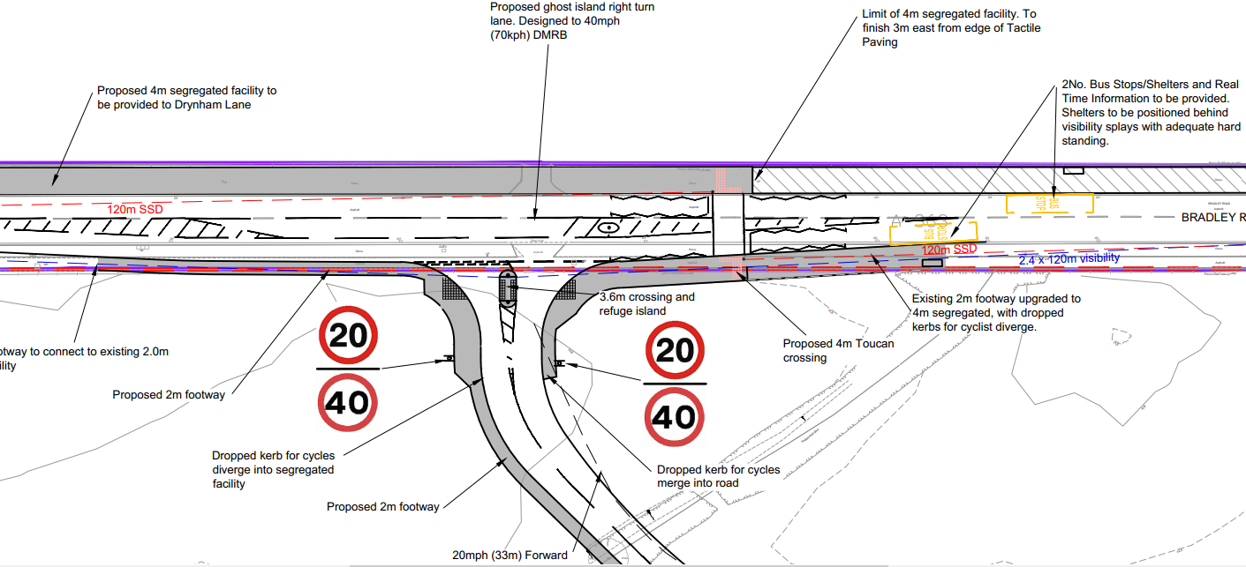

There is a primary central route through the middle of the development which would connect to the wider H2.2 site. Three secondary vehicle routes are proposed off the primary route which consist of reduced carriageway widths. Also proposed are private drives and lanes that are located on the green edges which will consist of shared surfaces to emphasise pedestrian priority. The speed limit is to be reduced to 20mph which will commence directly from the 40mph limit on the A363. The following illustrative plan identifies what the scheme could look like:

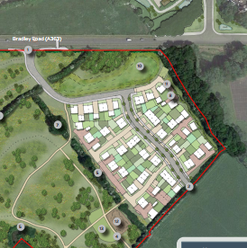

Car parking is proposed in accordance with the Council’s parking standards (1 space per 1 bedroom unit, 2 spaces per 2-3 bedroom unit and 3 spaces per 4 bedroom unit and visitor parking at a ratio of 0.2 spaces per dwelling). Cycle storage is also to be provided within garages, sheds or storage facilities, the detailed design of which would come forward in a future reserved matters application.

A public right of way to Woodmarsh has been requested by the Council’s Highway Officer, which is shown on the proposed layout but can be conditioned to be included within a future reserved matters application.

The Council’s Highway Officer is supportive of the scheme subject to conditions and S106 contributions. In accordance with the Trowbridge Transport Strategy (May 2018), the proposed development should make a proportionate contribution towards the pedestrian and cycle improvement schemes referenced as PC07, PC08 which would equate to £107,370.00. A further contribution of £121,000.00 would be required towards the Trowbridge Transport Strategy Public Transport Improvements Scheme. A full travel plan would also be required which will include £250 Green Travel Vouchers to each household, a free bus season ticket per household which will be valid for at least 6 months. A £7500.00 Travel Plan monitoring fee has also been requested.

Concerns have been raised by the Parich Council regarding the short distance between the proposed access and the access for the Elm Grove development and how these two junctions would interact alongside the proposed refuge island. Their preference would be for a roundabout. The Council Highway Officers involved are aware of both developments and have liaised with each other to ensure that the proposed junctions will work. As such, no highway concerns have been raised regarding the two proposed junctions. The Parish Council have also raised concerns regarding an increase in traffic on Woodmarsh Road. Whilst there may be a future increase in vehicle movements, this would not be so significant as to warrant the installation of traffic calming measures.

Air Quality
Air Quality is of significance in Trowbridge due to development pressures and prevailing air quality concerns. The adopted Wiltshire Council Air Quality Strategy commits to “securing air quality objectives in the eight AQMAs” and “maintaining good air quality across the county” and as such air quality needs to be protected across the county where development adds internal combustion engine vehicles using its road network. Vehicles from new development in Trowbridge use the road network that is in continuity with the AQMAs of Bradford on Avon, Devizes and Westbury. As such an Air Quality Assessment has been undertaken by the applicant and in response to this, the Council’s Public Protection Officer has requested a commuted sum of £10,000.00 which is considered reasonable. As such, the proposal is considered to comply with CP55.

10.8 Public Rights of Way
There are no recorded Public Rights of Way (PROWs) that cross the site. The Council’s Rights of Way Officer has assessed the application and has requested Section 106 contributions towards nearby PROWs which is considered to be acceptable.
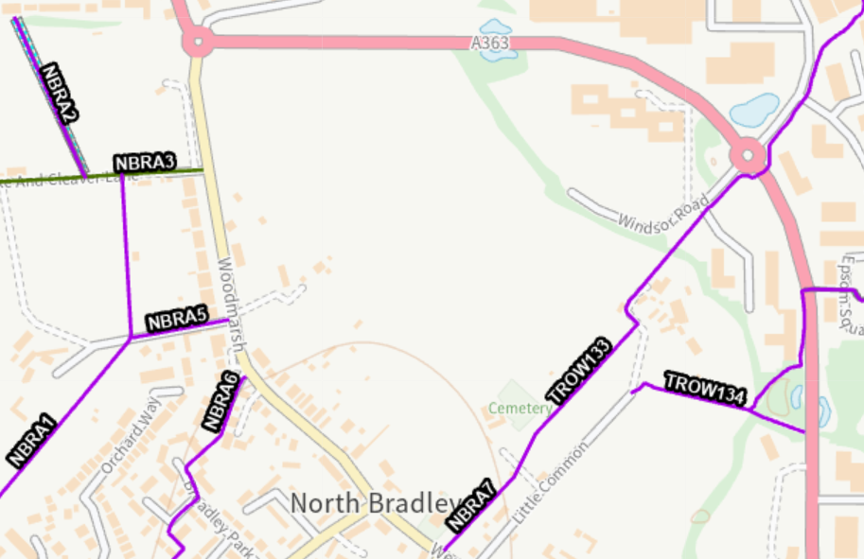
Public and cycle paths are proposed within the site to link it to Trowbridge. Key pedestrian and cycle routes are proposed to connect to Bradley Road and a pedestrian link to Woodmarsh Road, the latter of which would provide a quick access to the local bus service at the Mash Tun Bus Stop which has routes to Trowbridge, Bath, Frome and Warminster. The link to Bradley Road will allow pedestrians and cyclists to access the White Horse Business Park and the amenities on the South side of Trowbridge. Bus stops within the business park provide connections to Trowbridge, Bath, Warminster and Devizes. Within the site, informal pedestrian routes will be provided to support recreational activity.
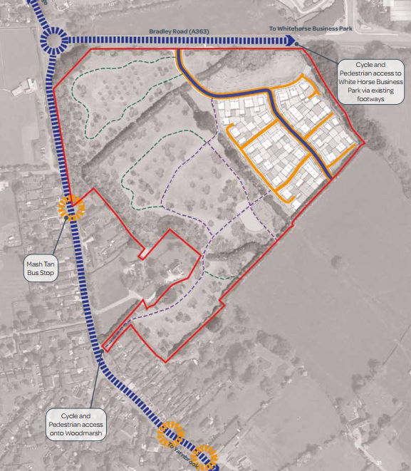
The Parish Council have requested that, alongside the pedestrian connection to Woodmarsh Road, a cycle access is also provided. Whilst this is not proposed and has not been requested by the Council’s Highway Officers, the applicant has confirmed that they would be willing to explore a cycle connection in this location as part of a reserved matters application. As such, an informative is recommended requiring this to be explored further.
Network Rail
Network Rail is a statutory consultee in England for any development within 10 metrs of the railway which is likely to result in a material increase in the volume or a material change in the character of traffic using a level crossing over a railway.
The proposed development is to be located on the public footpath network that leads and gives access to both Yarnbrook and White Horse level crossings (TROW133 & 135).
Network Rail have supported the development subject to a prior commencement condition requiring the developer to stop up and/or divert PROW TROW135 to prevent any public access to the Yarnbrook railway crossing.

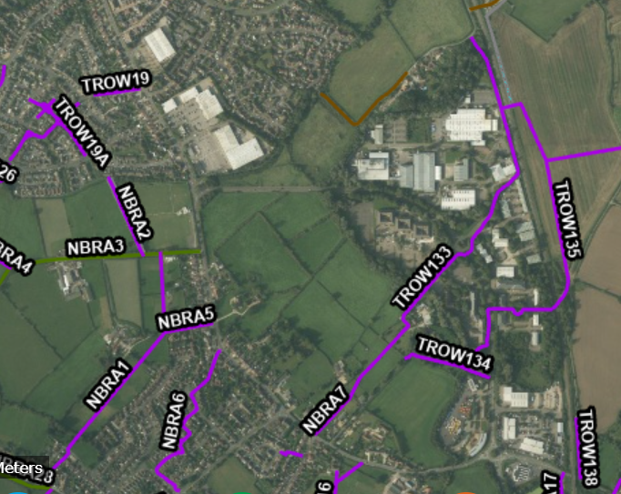

Wiltshire Council and Network Rail have been in long discussions regarding this matter as conditions imposed on planning applications must pass 6 tests which are as follows (paragraph 57 NPPF):
- Necessary
- Relevant to planning
- Relevant to the development to be permitted
- Enforceable
- Precise; and
- Reasonable in all other aspects.
It is considered that Network Rail are not a statutory consultee on this application due to the location of the site futher than 10 metres away from the railway line network. Network Rail are of the opinion that they should be a statutory consultee because the proposed development is likely to result in a material increase in the volume and a material change in the character of traffic using the level crossing.
The example they have given involves the average household in England being 2.4 residents and one person taking 267 walking trips over a year. Using these sums, they have calculated that there could be 34 recreational trips per day generated by the development.
Network Rail are concerned that this site, along with the adjoining site in the allocation, would generate approximately 31 recreational trips a day; that the awaited Trowbridge Urban Extension at West Ashton (15/04736/OUT for 2,500 dwellings) would generate approximately 1250 recreation trips per day; and that the approved application for 261 dwellings at Elm Grove (19/11459/OUT) would generate approximately 130 recreational trips per day, meaning there would be a material cumulative increase in the use of the level crossing.
The awaited Trowbridge Urban Extension West Ashton (15/04736/OUT) does see the closure of these level crossings within the associated S106 Legal Agreement which resulted in Network Rail supporting this current application as originally submitted as well as the adjoining site and Elm Grove (19/11459/OUT). However, due to the delays in securing a decision on application 15/04736/OUT, Network Rail have made the decision that they cannot rely on the West Ashton site and that other residential sites coming forward should be required to ensure the closure of these two level crossings. They have suggested a Grampian condition or a commuted sum to provide a footbridge/tunnel but no costing for the footbridge/tunnel has been put forward.
In assessing this current application on its own merits, the WHSAP plan (in respect of which Network Rail would have been a consultee) does not require a commuted sum for these level crossings. It is also considered that of the proposed 34 recreational trips a day from the site, the majority of these would be towards the Town Centre, Trowbridge Retail Park and on the PROW network that leads directly from the site to the south and east. It cannot be said that all of the proposed 34 recreational trips would lead towards the two level crossings through the industrial estate or Elm Grove, which is due to be developed within the next 12 months. As such, it is considered that there would not be a material increase in the volume of trips using the level crossings that would warrant their closure. The Council’s PROW Officer has confirmed that, whilst they would support a S106 contribution being sought, it is their belief that the increased usage on the level crossings as a result of this development would be minimal.
Elm Grove (19/11459/OUT) immediately abuts the railway line and the developer did not provide a commuted sum towards a footbridge/tunnel as Network Rail supported the outline application. It is therefore considered unreasonable to request the developer proposing to build up to 70 dwellings much further away from the rail infrastrucuture to provide a footbridge or tunnel over one, or even both, of the level crossings.
As such, the request from Network Rail is not considered to pass the required tests for conditions, notably – reasonable, relevant for the development to be permitted and necessary and as such the suggested condition/commuted sum is not being requested as part of this application.
10.9 Drainage
CP67 of the WCS states that all new development will include measures to reduce the rate of rainwater run-off and improve rainwater infiltration to soil and ground (SUDs).
The site is located within Flood Zone 1 which is the least likely to flood and some areas of the site are at risk of flooding from surface water which is show in blue on the diagram below:
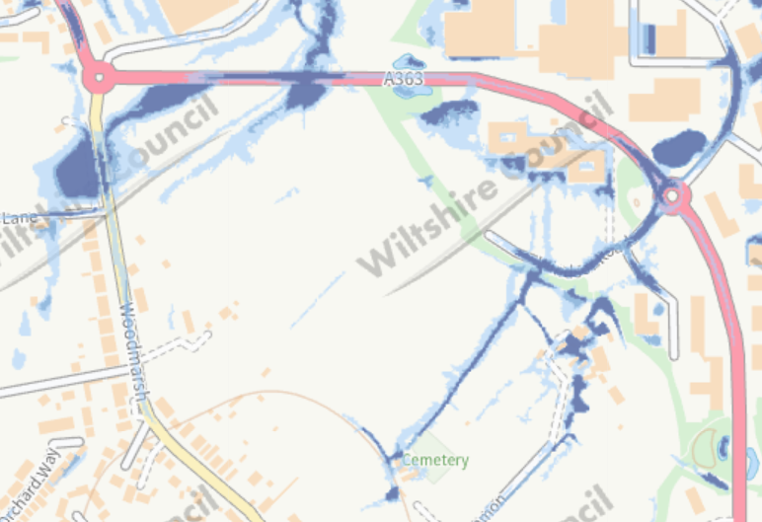

The submitted Flood Risk Assessment has confirmed that there is an existing open field ditch within the site as well as along the southern and eastern boundaries. The nearest open watercourse is approximately 0.2 km north east which is unaned. There are no on site surface water manholes except for inspection chambers associated with the Wessex Water main that crosses the site.
Wessex Water have confirmed that there is a strategic 450mm water main crossing the site and welcome the amended plans that reduce the number of dwellings and moves all housing to the northeast of the site away from the trunk water main corridor. There must be no buildings or structures within 6 metres either side of the water main and this also includes tree planting and play equipment and the water main must not run through private gadens as Wessex Water require unrestricted access to maintain and repair their apparatus. This would need to be demonstrate at reserved matters stage.
The foul sewerage flows north-east to manhole ST85558805 which is Wessex Waters preferred point of discharge and have confirmed that they will adopt a foul pumping station and sewers through a formal S105 Agreement. There are to be no dwellings within 15 metres of the pumping station and satisfactory access arranagements must be made for tanker lorry movements directly off an adopted road or a dedicated Wessex Water access track. Again this would need to be demonstrated in the reserved matters application.
The proposal sees surface water sewerage being disposed of via a SuDS system including attenutation basins with a controlled discharge to a watercourse of which needs approval from the Local Lead Flood Authority.
Wessex Water have confirmed that they can and will provide a point of connection for the supply of water to the north of the site in the A363 Bradley Road.
The Council,s Drainage Officers have supported the application subject to a number of conditions which are considered to be acceptable. As such, the proposal is considered to comply with CP67.
10.10 Section 106
CP3 states that all new development will be required to provide necessary on-site and where appropriate off-site infrastructure requirements arising from the proposal.
The infrastructure items listed below are those that are relevant to the application site and are required in order to mitigate the impact of the proposed scheme, in line with the tests set under Regulation 122 of the Community Infrastructure Levy Regulations 2010, and Paragraph 58 of the National Planning Policy Framework ‘The Framework’. These are:
- Necessary to make the development acceptable in planning terms
- Directly related to the development; and
- Fairly and reasonably related in scale and kind to the development
Policy 6 of the North Bradley Neighbourhood Plan states all new housing and employment proposals in the area will be expected to contribute towards local infrastructure and in accordance with National and Wiltshire Core Strategy Policy.
Policy H2.2 of the WHSAP plan requires appropriate contributions to be sought to increase capacity at local schools, local GP surgeries and dentistry in the town.
The developer has agreed to the following Section 106 requirements:
Affordable Housing: Section 5 of the NPPF requires a sufficient supply of homes including affordable. CP43 states that on dwellings of 5 or more affordable housing provision of at least 30% will be provided. If the site were to be developed for 70 dwellings this would result in a need for 21 affordable homes. From this, the Local Planning Authority would require a tenure split of 60% affordable rented homes, 40% shared ownership homes. These dwellings will need to be transferred to a Registered Provider
Open Space: The principle of obtaining quality open spaces and opportunities for sport and recreation is stated in paragraph 103 of the NPPF. The Leisure and Recreation DPD requires developers to provide public open space. The requirement for this development is 2577.12m2 of public open space and 107.38m2 of equipped play which has been calculated using the latest Sport England Guidance and is to be provided on site through a Local Area of Play (LAP) and a Local Equipped Area of Play (LEAP) and informal recreation. The proposal would also generate a requirement of 2147.60m2 of Sports and Pitches & Courts which equates to an off-site financial contribution of £21,476 which would go towards the upgrading of the playing pitch and ancillary provision at Trowbridge Town Football Club and or a sports/playing pitch proivision within the vicinity of the land.
Education: The NPPF (paragraph 100) encourages Local Authorities to ensure that sufficient choice of school places is available to meet the needs to existing and new communities. In order to fulfill this requirement the proposed development is required to fund the following:
Early Years Assessment: There are currently 4 preschools nurseries and 8 childminders within a two-mile safe walking route of this proposed development which are at full capacity. The Local Planning Authority has a duty to provide sufficient childcare for working parents under Section 6 of the Childcare Act 2006. As a result of a development providing 70 dwellings there would be a need to provide 7 places at a cost of £17,522 each with a total cost of £122,654.00 (indexed linked)
There are no requests from the Education Department regarding Primary or Secondary School Contributions due to recently updated school forecasts.
Highways: CP 61 states that where appropriate contributions will be sought towards sustainable transport improvements and travel plans will be required to encourage the use of sustainable transport alternatives. CP 63 identified transport strategies for Wiltshire’s Principle Settlements (Trowbridge being one of them) which seek to achieve a major shift to sustainable transport by helping to reduce reliance on the private car and by improving sustainable transport alternatives. Part of the funding for these strategies is to be derived from developer contributions. Such requests are also listed under Core Policy 3 as infrastructure priory theme 1.

The highways contributions are as follows;
- £107,370.00 towards pedestrian and cycle improvement schemss referenced as PC07, PC08 in accordance with the Trowbridge Transport Strategy (May 2018)
- A further contribution of £121,000.00 would be required towards the Trowbridge Transport Strategy Public Transport Improvements Scheme.
- A full travel plan would also be required which will include £250 Green Travel Vouchers to each household, a free bus season ticket per household which will be valid for at least 6 months.
- A £7500.00 Travel Plan monitoring fee has also been requested
- Provision of the highway and access works, which shall include, but not be limited to the provision of a right turn lane and full width resurfacing on A363, toucan crossing, 4m segregated foot/cycle paths along the A363, associated drainage and street lighting alterations and two new bus stops with shelters, raised kerbs and RTPI, all as shown on the Badingham drawing “Proposed Right Turn Lane Access” 003 – Revision F.

Air Quality:Paragraph 199 of the NPPF requires planning decisions should take into account Air Quality Management Areas and take opportunities to improve air quality. CP55 states that where appropriate contributions would be sought towards the mitigation of the impact a development may have on levels of air pollutants which is supported by CP3. A contribution is required in respect of air quality and the ongoing monitoring activity that takes place in the Trowbridge Area. As such a sum of £10,000 would be required for the updating of air quality monitoring equipment and its maintenance within Trowbridge.
Public Rights of Way: CP52 states “Development shall make provision for the retention and enhancement of Wiltshire’s Green Infrastructure network and shall ensure that suitable links to the network are provided and maintained”. This is also confirmed in Saved Policy CR1 of the Leisure and Recreation DPD and the Local Cycling and Walking Infrastructure Plan which is nearing adoption. The NPPF at paragraph 105 requires planning decisions to protect and enhance public rights of way and take opportunities to provide better facilities for users.
This development will lead to an increase usage of the Public Rights of Way network particularly and as such a contribution of £20,000 (index linked) is required to go towards surfacing improvements, improvements to drainage and upgrade to access furniture on NBRA3, NBRA4 SWCK2.
Ecology: In accordance with the Trowbridge Bat Mitigation Strategy a contribution of £777.62 per dwelling will be required to mitigate the residual effects from loss /degradation of bat habitat and would be required prior to the commencement of development.
Waste:Under Core Policy 3 and WCS6 the Waste Team will require contributions towards the provision of waste and recycling containers for each residential unit (£101 per dwelling) and therefore a total cost of £7070.00 for a total of 70 dwellings would be required. This is in conformity with the Wiltshire Council Waste Collection Guidance for New Development
Arts Contribution:Core Policy 57: Ensuring high quality design and place shaping [page 287, paragraph xii)] which promotes “the use of high standards of building materials, finishes and landscaping, including the provision of street furniture and the integration of art and design in the public realm”. Core Policy 3: Infrastructure Requirements [page 58, paragraph 4.42]. This promotes and defines public art as a type of place-shaping infrastructure and states that the cost of providing infrastructure can be met through the use of planning obligations. This is supported in the Councils adopted Art and Design in the Public Realm in Wiltshire. In addition, the NPPF recognises that cultural wellbeing is part of achieving sustainable development and includes cultural wellbeing within the twelve core planning principles that underpin both plan-making and decision-taking. The PPG complements the NPPF and states that “Public art and sculpture can play an important role in making interesting and exciting places that people enjoy using.”

A contribution based on £300 per dwelling and £3 per square metre of non-residential commercial land) would be required to deliver a public art scheme on or within the vicinity of the site.

Management Company: The S106 Legal agreement would need to ensure that the proposed dwellings are served by a management company to ensure that the area of public open space and other shared areas are managed and looked after in perpetuity. The Management Company would also be responsible for maintaining the biodiversity habitat within the application site and within the public open space and be required to implement the LEMP for the lifetime of the development. It is understood that Trowbridge Town Council are interested in taking over the public open spaces and this will be an option within the S106 legal agreement but will require further negotiation outside of the planning application process. If the land is to be transferred to Trowbridge Town Council as the management company, they do not need to part of the S106 Legal Agreement.

S106 Monitoring Fee: A S106 monitoring fee would be required to be included within the S106 Legal Agreement which would be 1% of the total financial contributions capped at £10,000.00.
Other
Wiltshire Council adopted CIL (Community Infrastructure Levy) on 18th May 2015 and therefore the proposed dwellings subject of this application will be liable to pay CIL and therefore an informative should be added to any approval informing the applicant. The site lies within Charging Zone 2 which requires £55 per dwelling.
11 PLANNING BALANCE
Paragraph 11 (d) and footnote 8 of the NPPF state that where a Local Planning Authority cannot demonstrate a five-year housing land supply then, for applications including housing provision, the policies which are most important for determining the application should be considered out-of-date. As a result, the presumption in favour of sustainable development (often referred to as the ‘tilted balance’) should be applied and permission should be granted unless protection policies set out in footnote 7 of the NPPF apply, or the adverse impacts of granting permission would significantly and demonstrably outweigh the benefits.
However, Paragraph 14 of the NPPF states that in situations where the presumption (at paragraph 11(d)) applies to applications involving the provision of housing, the adverse impact of allowing development that conflicts with a neighbourhood plan is likely to significantly and demonstrably outweigh the benefits should be refused. A set out earlier in the report, due to the North Bradley Neighbourhood Plan being less than 5 years old and containing policies and having allocations to meet the identified housing need, paragraph 14 applies and the application should therefore only be refused if the adverse impacts are likely to significantly and demonstrably outweigh the benefits.
In this particular case, there are no protection policies that would prevent the tilted balance being engaged and there are no technical objections to the application. Furthermore, the site is allocated in the WHSAP and therefore has already received approval in principle for the site to be developed for housing.
There are benefits as a result of this proposal which include the provision of market housing which is a key part of national and local planning policy and has recently been re-enforced by the Written Ministerial Statement and would contribute to the Council’s housing supply. The site is in an accessible location with access to public transport links.The proposal would also provide 30% affordable housing where there is a current shortfall against the Council’s target. The site would also generate short term economic benefits during construction and long term economic benefits from the expenditure on local goods and serices by the future residents.
The provision of public open space, BNG and public rights of way improvements would result from the proposed development but would provide some benefit to existing residents in the area and therefore moderate positive weight is given to these.
The development of a field into housing would impact on the character of the area but due to the proposed landscaping and existing built form in the immediate area, the impact would be limited and therefore limited negative weight is given to this harm.
12. Conclusion
The site is allocated for housing in the WHSAP plan and the proposal subject of this application complies with the principles contained within the WHSAP, as such the proposal is considered to comply with CP1, CP2 and CP12 of the WCS.
A five year housing land supply is not able to demonstrated and the approval of this strategic allocation would help towards meeting this requirement. When assessing the application against paragraph 11dii and Footnote 8 of the NPPF as well as paragraph 14, the application has received support from statutory consultees and this report demonstrates that there are no adverse impact arising from the proposal on the wider landscape, ecology, highways or amenity. As detailed above, there would be some significant benefits of the proposal with the most important being the contribution to the current identified housing need in Wiltshire without causing demonstrable harm.

13. RECOMMENDATION
Defer and Delegate to the Head of Development Management to grant full planning permission subject to the prior completion of a Section 106 legal agreement to cover the contributions identified in Section 10.10 of the report, and subject to the conditions set out below:

- The development hereby permitted shall be begun either before the expiration of three years from the date of this permission, or before the expiration of two years from the date of approval of the last of the reserved matters to be approved, whichever is the later.

REASON: To comply with the provisions of Section 92 of the Town and Country Planning Act 1990 as amended by the Planning and Compulsory Purchase Act 2004.

- Application(s) for the approval of all of the reserved matters (should this development be advanced on a phased manner) shall be made to the Local Planning Authority before the expiration of three years from the date of outline permission being granted.

REASON: To comply with the provisions of Section 92 of the Town and Country Planning Act 1990.

  - The development hereby permitted shall be carried out in accordance with the following approved plans and documents:

Drawing Number 1001 (Location Plan) received by the Local Planning Authority on 1st June 2020

Drawing Number NPA 11020 301 Rev P03 (Green Infrastructure Parameters Plan), 500 Rev K (Parameter Plan – Land Use) received by the Local Planning Authority on 29th August 2023

Drawing Numbers: 003 Rev F (Proposed right turn lane access) 006 rev D (swept path analysis) received by the Local Planning Authority on 14th Feb 2024

REASON: For the avoidance of doubt and in the interests of proper planning.

- No development shall commence on site until a Phasing Plan has been submitted to and approved in writing by the Local Planning Authority. Thereafter, the development shall proceed in phases and each reserved matters application shall refer to a phase, phases, or part thereof, as identified in the Phasing Plan, as may be approved. Any subsequent changes to the approved Phasing Plan must be submitted to and approved in writing by the Local Planning Authority.

REASON: to ensure the proper planning and delivery of the development and to deliver a sustainable development that protects protected species and habitats.

- A detailed housing mix strategy, including the number and size of dwelling units shall be submitted with each reserved matters application which provides details of the proposed dwellings. The development shall be carried out in accordance with the approved housing mix

REASON: The application contained insufficient information to enable this matter to be considered prior to granting planning permission and the matter is required to be agreed with the Local Planning Authority before development commences in order that the development is undertaken in an acceptable manner and to ensure that the proposed development provides a diverse and balanced range of housing types and sizes, contributing to the creation of a sustainable and inclusive community, in accordance with local planning policies and housing needs.

- A revised Sustainable Energy Strategy shall be submitted with each reserved matters application which provides details of the proposed dwellings and shall include details of operational energy, embodied carbon, climate change adaptation measures. sustainable transport, low-carbon and renewable energy technologies, electric vehicle charging points. The development shall be carried out in accordance with the details approved by the Local Planning Authority.

REASON: The application contained insufficient information to enable this matter to be considered prior to granting planning permission and the matter is required to be agreed with the Local Planning Authority before development commences in order that the development is undertaken in an acceptable manner and in response to climate change

- An Acoustic Design Scheme or a scheme for the protection of the proposed dwellings from external traffic noise shall be submitted with each reserved matters application which provides details of the proposed dwellings. The Scheme shall use Good Acoustic Design (in accordance with the Professional Practice Guidance: Planning and Noise New Residential Development (May 2017 or later versions)) to achieve the following noise limits:

  - bedrooms shall achieve an 8-hour LAeq (23:00 to 07:00) of 30dB(A) and an LAmax,F of 45dB.
  - living rooms and dining rooms shall achieve a 16-hour LAeq (07:00 to 23:00) of 35dB(A)
  - external noise levels within private external amenity spaces shall not exceed 50 dB LAeq,16hr (0700 – 2300)

The development shall be carried out in accordance with the details

approved by the Local Planning Authority prior to the first occupation.

REASON: The application contained insufficient information to enable this matter to be considered prior to granting planning permission and the matter is required to be agreed with the Local Planning Authority before development commences in order that the development is undertaken in an acceptable manner and to protect the amenity of future occupiers

- A revised Arboricultural Impact Assessment, with Tree Constraints Plan, Tree Protection Plan and Arboricultural Method Statement, prepared in accordance with BS5837:2012, shall be submitted with the first reserved matters application and each subsequent reserved matters application. to demonstrate the consideration and protection of the trees within the revised design, as well as the appropriate methods and materials used for construction. The development shall then be carried out in accordance with the details approved by the Local Planning Authority.

REASON: The application contained insufficient information to enable this matter to be considered prior to granting planning permission and the matter is required to be agreed with the Local Planning Authority before development commences in order that the development is undertaken in an acceptable manner, to ensure the amenity of protection of existing trees and hedges.

- The development shall be completed in accordance with the Biodiversity Metric 3.0, NPA, July 2023 P02 or a subsequent revised Biodiversity Metric Calculation to be submitted to and approved in writing by the Local Planning Authority. This condition will be discharged when a report has been submitted to and approved in writing by the Local Planning Authority which demonstrates that the development has been completed in accordance with the approved metric calculation. The report will demonstrate for habitats and hedgerows and that the development will achieve at least 100% mitigation (ie: no net loss) for land lost to development. The development shall then be carried out in accordance with the details approved by the Local Planning Authority.

REASON: In the interest of Ecology and to meet the requirements of the Trowbridge Bat Mitigation Strategy

- Prior to any construction starting on site, the site area covered by Trenches 13, 14, 15 as detailed in the submitted Archaeological Evaluation Report carried out by Cotswold Archaeology dated May 2021 shall be monitored by qualified archaeologists during preparatory groundworks. A full archaeological excavation shall also be carried out on the site area delimited by evaluation Trenches 18-22. A report identifying the results shall

be submitted to and approved in writing. The development shall then be carried out in accordance with the approved details.

REASON: The application contained insufficient information to enable this matter to be considered prior to granting planning permission and the matter is required to be agreed with the Local Planning Authority before development commences in order that the development is undertaken in an acceptable manner and in the interests of archaeology.

- No development shall commence on site until an investigation of the history and current condition of the site to determine the likelihood of the existence of contamination arising from previous uses (including asbestos) has been carried out and all of the following steps have been complied with to the satisfaction of the Local Planning Authority:

Step (i) A written report has been submitted to and approved by the Local Planning Authority which shall include details of the previous uses of the site and any adjacent sites for at least the last 100 years and a description of the current condition of the sites with regard to any activities that may have caused contamination. The report shall confirm whether or not it is likely that contamination may be present on the site and the potential impact of any adjacent sites.

Step (ii) If the above report indicates that contamination may be present on, under or potentially affecting the proposed development site from adjacent land, or if evidence of contamination is found, a more detailed site investigation and risk assessment should be carried out in accordance with DEFRA and Environment Agency’s “Model Procedures for the Management of Land Contamination CLR11” and other authoritative guidance and a report detailing the site investigation and risk assessment shall be submitted to and approved in writing by the Local Planning Authority.

Step (iii) If the report submitted pursuant to step (i) or (ii) indicates that remedial works are required, full details must be submitted to the Local Planning Authority and approved in writing and thereafter implemented prior to the commencement of the development or in accordance with a timetable that has been agreed in writing by the Local Planning Authority as part of the approved remediation scheme. On completion of any required remedial works the applicant shall provide written confirmation to the Local Planning Authority that the works have been completed in accordance with the agreed remediation strategy.

REASON: To reduce and manage the risks associated with land contamination.

- No development shall commence on site until the the following information regarding drainage have been submitted to and approved in writing by the

Local Planning Authority:
- Calculations and drawings for the drainage system design showing designated holding areas and conveyance routes based on no flooding on site for a 1 in 30 year rainfall event with no flooding on site
- Calculations which demonstrate that the required 20% betterment against greenfield rates has been achieved for all storm events between the 1 in 1 year and the 1 in 100year return period storm events.
- Mitigation measures that are to be put in place to reduce the risk of flooding to any property in the 1 in 100 year + climate change event]
- details of the finished floor levels which should be at minimum 150mm above the 1 in 100 year + climate change flood level
- groundwater monitoring that accounts for seasonal variation to determine the highest groundwater level
- confirmation that groundwater can interact with the proposed attenuation basins and if necessary provide flotation calculations and consider lining the attenuation basin
- arrangements for ownership and ongoing maintenance of SuDS over the lifetime of the development.
- an emergency plan due to the access predicted to flood

The development shall then be carried out in accordance with the approved details.
REASON: The application contained insufficient information to enable this matter to be considered prior to granting planning permission and the matter is required to be agreed with the Local Planning Authority before development commences in order that the development is undertaken in an acceptable manner in the interest of drainage.

- No development shall commence on site (including any works of demolition), until a Construction Management Statement, together with a site plan, which shall include the following:
- the parking of vehicles of site operatives and visitors;
- loading and unloading of plant and materials;
- storage of plant and materials used in constructing the development;
- the erection and maintenance of security hoarding including decorative displays and facilities for public viewing, where appropriate;
- wheel washing facilities;
- measures to control the emission of dust and dirt during construction;
- a scheme for recycling/disposing of waste resulting from demolition and construction works; and
- measures for the protection of the natural environment.
- hours of construction, including deliveries;
- pre-condition photo survey
has been submitted to, and approved in writing by, the Local Planning

Authority. The approved Statement shall be adhered to throughout the construction period. The development shall not be carried out otherwise than in accordance with the approved construction method statement.

REASON: The application contained insufficient information to enable this matter to be considered prior to granting planning permission and the matter is required to be agreed with the Local Planning Authority before development commences in order that the development is undertaken in an acceptable manner and to minimise detrimental effects to the neighbouring amenities, the amenities of the area in general, detriment to the natural environment through the risks of pollution and dangers to highway safety, during the construction phase.

- No development shall commence on site (including any works of demolition), until a Construction Method Statement, which shall include the following:
- Routing plan
- Traffic Management Plan (including signage drawing(s))
- Number (daily/weekly) and size of delivery vehicles.
- Number of staff vehicle movements.
- Details of temporary/permanent Traffic Regulation Orders
- Phases plan

has been submitted to, and approved in writing by, the Local Planning Authority. The approved Statement shall be adhered to throughout the construction period. The development shall not be carried out otherwise than in accordance with the approved construction method statement.

REASON: The application contained insufficient information to enable this matter to be considered prior to granting planning permission and the matter is required to be agreed with the Local Planning Authority before development commences in order that the development is undertaken in an acceptable manner and to minimise detrimental effects to the neighbouring amenities, the amenities of the area in general, detriment to the natural environment through the risks of pollution and dangers to highway safety, during the construction phase.

- No development shall commence on site, including demolition, ground works/excavation, site clearance, vegetation clearance and boundary treatment works, until a Construction Environmental Management Plan (CEMP) shall be submitted to the local planning authority for approval in writing. The CEMP shall include a detailed marked-up plan showing detail of the avoidance, mitigation and protective measures to be implemented before and during the construction phase, including but not necessarily limited to, the following:
- Phasing plan for bat habitat creation and landscape works along the

eastern boundary and the area of informal bat habitat in the south/south- western part of the site.
- Identification of ecological protection areas/buffer zones/bat habitat and tree root protection areas and details of physical means of protection, e.g. exclusion fencing and including who will be responsible for its installation.
- Locations of temporary work areas/construction compounds.
- Details on locations of any construction lighting (if required: Note: this must be kept away from boundary features).
- Working method statements for protected/priority species, such as nesting birds, and reptiles.
- Mitigation strategies already agreed with the local planning authority prior to determination, such as for great crested newts/bats; this should comprise the pre-construction/construction related elements of strategies only.
- Work schedules for activities with specific timing requirements in order to avoid/reduce potential harm to ecological receptors; including details of when a licensed ecologist and/or ecological clerk of works (ECoW) shall be present on site.
- Key personnel, responsibilities and contact details (including Site Manager and ecologist/ECoW).
- Timeframe for provision of compliance report to the local planning authority; to be completed by the ecologist/ECoW and to include photographic evidence.

The development shall then be carried out in accordance with the approved CEMP.

REASON: The application contained insufficient information to enable this matter to be considered prior to granting planning permission and the matter is required to be agreed with the Local Planning Authority before development commences in order that the development is undertaken in an acceptable manner and to ensure adequate protection and mitigation for ecological receptors prior to and during construction, and that works are undertaken in line with current best practice and industry standards and are supervised by a suitably licensed and competent professional ecological consultant where applicable.

- No development shall commence on site until a Landscape and Ecology Management Plan (LEMP) has been submitted to and approved in writing by the Local Planning Authority. The LEMP shall be based on the approved Green Infrastructure Parameters Plan NPA 11020 301 P03 and the Biodiversity Metric 3.0 (NPA July 2023 P02 submitted with the application, or a revised Biodiversity Metric submitted and approved. The LEMP will include long term objectives and targets, management responsibilities and maintenance schedules for each ecological feature within the development in perpetuity, together with a mechanism for monitoring success of the management prescriptions, incorporating review and necessary adaptive management in order to attain targets.

The LEMP shall include a plan to clearly indicate who the area will be adopted and maintained by and shall also include details of the legal and

funding mechanism(s) by which long-term implementation of the plan will be secured.

The LEMP shall be implemented in full and for the lifetime of the development in accordance with the approved details.

REASON: The application contained insufficient information to enable this matter to be considered prior to granting planning permission and the matter is required to be agreed with the Local Planning Authority before development commences in order that the development is undertaken in an acceptable manner and to ensure the long-term management of landscape and ecological features retained and created by the development, for the benefit of visual amenity and biodiversity for the lifetime of the scheme.

- No development shall commence on site until a plan (details) for the selection, siting, positioning and installation of integral roosting/nesting features (ratio of 1 feature: 1 building) for bats and birds has been submitted to, and approved in writing by, the local planning authority. The plan should show the green infrastructure that the development is to provide, illustrating how birds and bats that will be using the features have access to the relevant habitat/food resource in nearby suitable habitat.
The installation plan should be prepared in accordance with the requirements of BS 42021.

The integral feature should identify, as a minimum:
- the bird/bat species likely to benefit from the proposed integral nest feature.;
- the type of integral feature to be installed;
- the specific buildings on the development into which features are to be installed, shown on appropriate scale drawings. Note: where integrated features are being provided for colonial nesters e.g. swifts, house sparrows some buildings will have more integrated features and some buildings will have no integrated features and this is acceptable;
- the location on each building where features are to be installed, shown on all appropriate building plans and elevations;

The integral feature plan should be implemented in accordance with the approved details and all features retained in that manner for the lifetime of the development.

REASON: For the protection, mitigation and enhancement of biodiversity

- No development shall commence on site, a detailed scheme and timetable for the provision and creation of the SuDs located in the northern part of the site/within the public open space area has been submitted to and approved in writing by the Local Planning Authority. The SuDs shall be designed as a permanent waterbody with a diverse marginal structure using trees, shrubs and grasses to provide suitable aquatic habitat for foraging bats.

The development shall then be carried out in accordance with the approved details.

REASON: The application contained insufficient information to enable this matter to be considered prior to granting planning permission and the matter is required to be agreed with the Local Planning Authority before development commences in order that the development is undertaken in an acceptable manner, in the interests of mitigation and enhancement of biodiversity.

- The development hereby approved shall be carried out in accordance with the following documents:
⦁ Ecological Impact Assessment (NPA 11020) April 2020)
⦁ Ecology Addendum (NPA 11020, January 2022)
⦁ Ecology Addendum (NPA 11020, July 2023).

REASON: For the avoidance of doubt and for the protection, mitigation and enhancement of biodiversity

- The dwellings hereby approved shall not be first occupied until a post- development lighting strategy survey has been submitted to and approved in writing by the Local Planning Authority. The survey shall be conducted in accordance with the Trowbridge Bat Mitigation Strategy and shall demonstrate compliance with the approved lighting plans, having implemented and retested any necessary remedial measures

REASON: In the interests of the amenities of the area, to minimise unnecessary light spillage above and outside the development site and to core bat habitat meets the requirements of the Trowbridge Bat Mitigation Strategy

- No development shall commence on site until full details of the pedestrian route and connection to Woodmarsh has been submitted and approved in writing by the LPA. The pedestrian route shall thereafter be provided prior to the occupation of the 35th residential unit on the site and shall remain open for public use at all times in perpetuity.

Reason: In the interests of highway safety and encouraging sustainable

travel.

- No part of the development hereby approved shall be first occupied, until the visibility splays shown on the approved plans have been provided with no obstruction to visibility at or above a height of 600mm above the nearside carriageway level. The visibility splays shall always be maintained free of obstruction thereafter.

Reason: In the interests of highway safety

- No external lighting shall be installed on site until plans showing the type of light appliance, the height, and position of fitting, illumination levels and light spillage in accordance with the appropriate Environmental Zone standards set out by the Institute of Lighting Engineers in their publication GN01:2021, ‘The Reduction of Obtrusive Light’ (ILP, 2021), have been submitted to and approved in writing by the Local Planning Authority.

The approved lighting shall be installed and shall be maintained in accordance with the approved details.

REASON: The application contained insufficient information to enable this matter to be considered prior to granting planning permission and the matter is required to be agreed with the Local Planning Authority before development commences in order that the development is undertaken in an acceptable manner and to minimise unnecessary light spillage above and outside the development site and to core bat habitat meets the requirements of the Trowbridge Bat Mitigation Strategy.

- Notwithstanding the submitted details, the proposed development hereby approved shall not be first occupied until means/works have been implemented to avoid private water (any supply of water intended for human consumption which is not provided by a water company) from entering the highway.

Reason: To ensure that the highway is not inundated with private water

Informatives: (10)

- This permission shall be read in conjunction with an Agreement made under Section 106 of the Town and Country Planning Act, 1990 and dated the [INSERT].

- The applicant is advised that the development hereby approved may

represent chargeable development under the Community Infrastructure Levy Regulations 2010 (as amended) and Wiltshire Council's CIL Charging Schedule. If the development is determined to be liable for CIL, a Liability Notice will be issued notifying you of the amount of CIL payment due. If an Additional Information Form has not already been submitted, please submit it now so that we can determine the CIL liability. In addition, you may be able to claim exemption or relief, in which case, please submit the relevant form so that we can determine your eligibility. The CIL Commencement Notice and Assumption of Liability must be submitted to Wiltshire Council prior to commencement of development. Should development commence prior to the CIL Liability Notice being issued by the local planning authority, any CIL exemption or relief will not apply and full payment will be required in full and with immediate effect. Should you require further information or to download the CIL forms please refer to the Council's Website https://www.wiltshire.gov.uk/dmcommunityinfrastructurelevy.

- The applicant is advised to use the letter from Wessex Water dated 14th November 2023 when designing the final layout of the proposed development.

- Wiltshire Council is the land drainage authority under the Land Drainage Act 1991. Land drainage consent is required if a development proposes to discharge flow into an ordinary watercourse or carry out work within 8m of an ordinary watercourse. [An ordinary watercourse is a watercourse that does not form part of a main river. The term watercourse includes all rivers and streams and all ditches, drains, cuts, culverts, dikes, sluices, sewers (other than public sewers within the meaning of the Water Industry Act 1991) and passages, through which water flows].

- The developer/applicant will be expected to enter into a S278 Agreement with the Highway Authority in respect to the access/highway works on the A363, before commencement of the works on site hereby approved. The access works shall include, but not be limited to the provision of a right turn lane, toucan crossing, 4m segregated foot/cycle paths, two new bus stops with shelters, raised kerbs and RTPI and any necessary alterations to highway drainage and to street lighting all as shown on the Badingham drawing “Proposed Right Turn Lane Access” 003 – Revision F.

- With regards to the submission of an Acoustic Design Scheme using closed windows to achieve the internal noise level target shall only be considered once all other good acoustic design acoustic mitigation measures have been utilised. A good acoustic design process should be followed to ensure that the internal noise criteria are achieved with windows open. Using closed windows to achieve the internal noise level target shall only be considered once all other good

acoustic design acoustic mitigation measures have been utilised. When relying on closed windows to meet the internal guide values, there needs to be an appropriate method of ventilation that does not compromise the façade insulation or the resulting internal ambient noise level.

- The reserved matters application shall explore a cycle path connection from the site to Woodmarsh Road to enable the free flow of pedestrian and cycle traffic through the site.

- It is advised that the reserved matters application should include connected streets through the use of pedestrian and cycle paths to ensure the proposal accords with Streets for a Healthy Life (P.53). This should also include a connection from the South West Corner into the planned continuation of housing into the field to the south and likewise in regards to the open space corridor shown inside the north east hedge boundary.

- The housing mix strategy shall demonstrate how the proposed development will meet the latest up to date local housing needs and provide a balanced mix of dwellings, with consideration given to the requirements of the local housing market and any relevant housing policies.

- The scheme will be operating under a District Level Licence (DLL) for Great Crested Newts. Great Crested Newts are protected under Conservation of Habitats and Species Regulations 2017 and the Wildlife and Countryside Act 1981 (as amended). Planning permission for development does not provide a defence against prosecution under this legislation.

