PL/2024/11358 - Land at the rear of 2 Lydiard Green, Lydiard Millicent, Swindon, SN5 3LP

This application is for the demolition of 2 industrial units and replacement with 3 five bedroomed houses.

Google Earth View

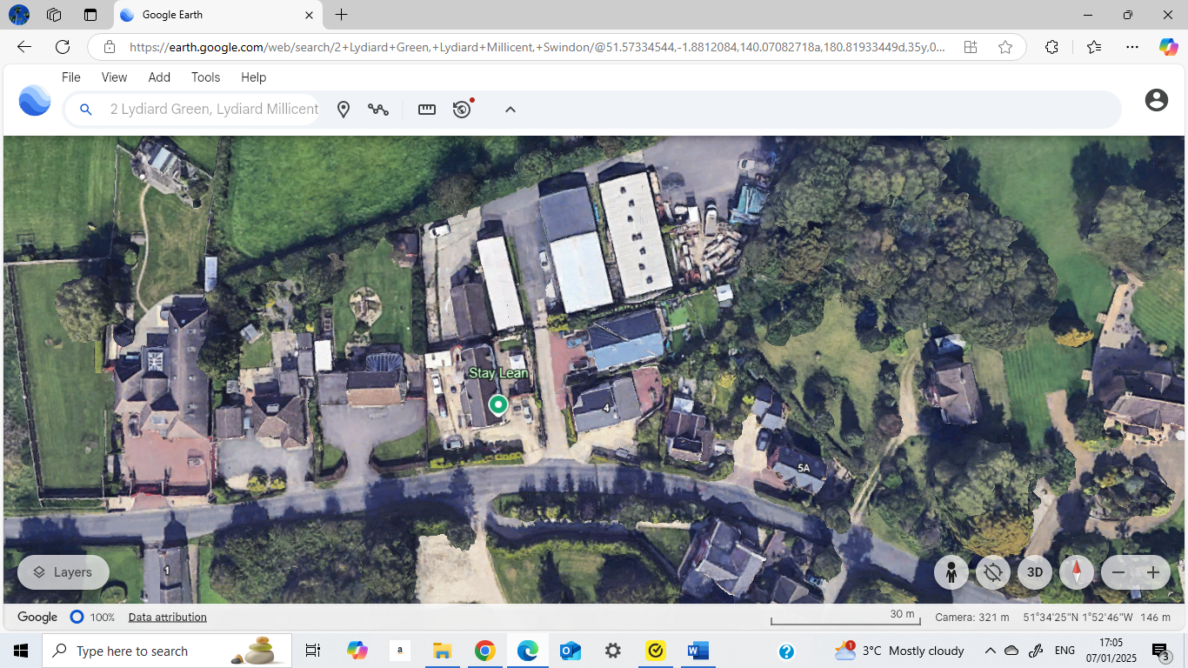

Existing Site Plan (PL/2024/11358)

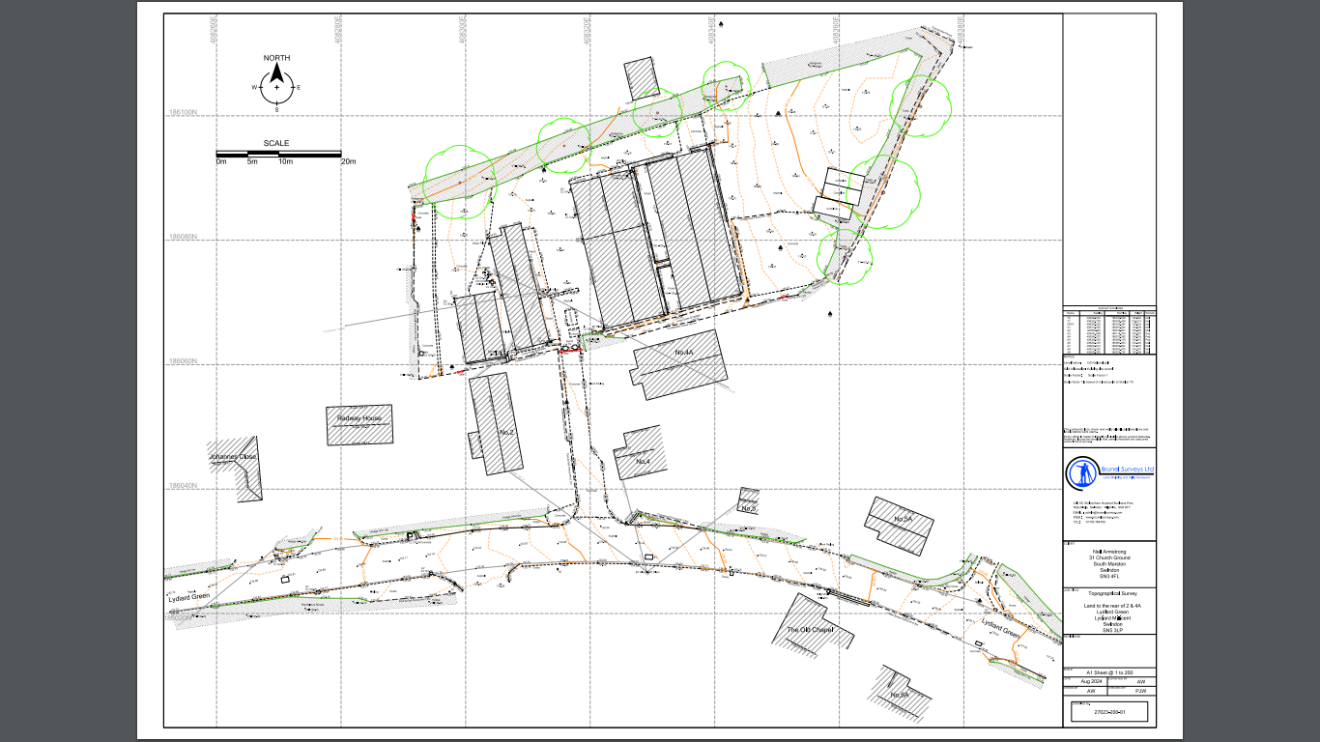

Proposed Site Plan (PL/2024/11358)

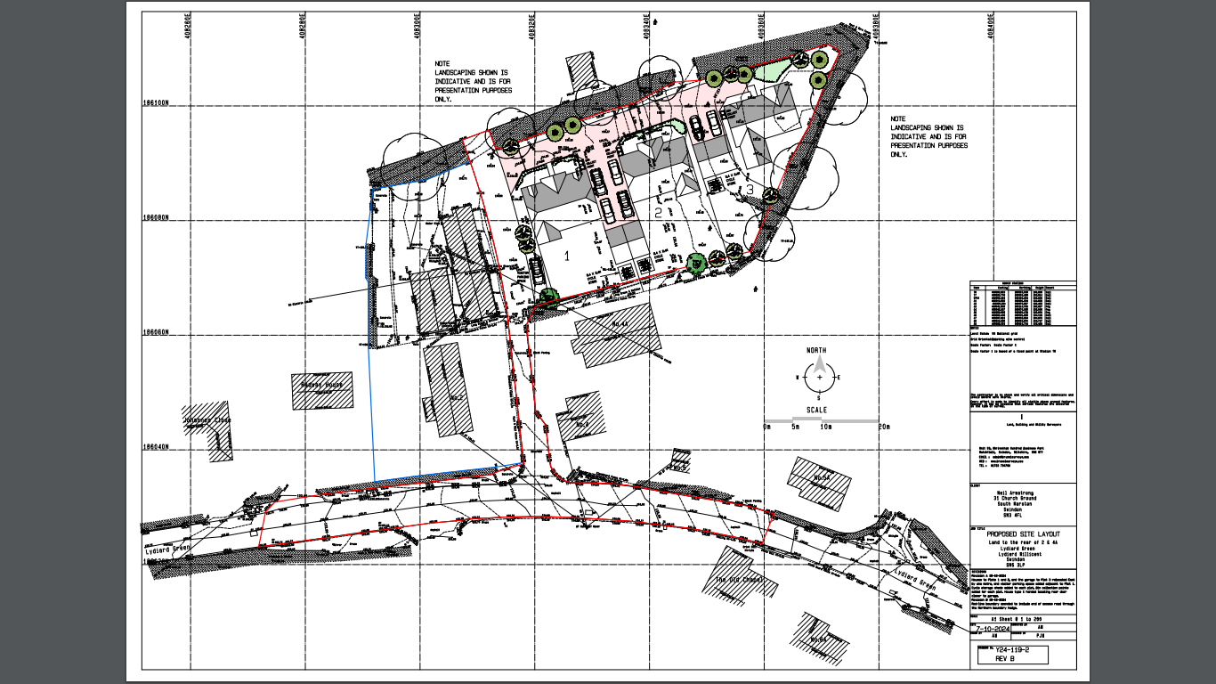

Location Plan

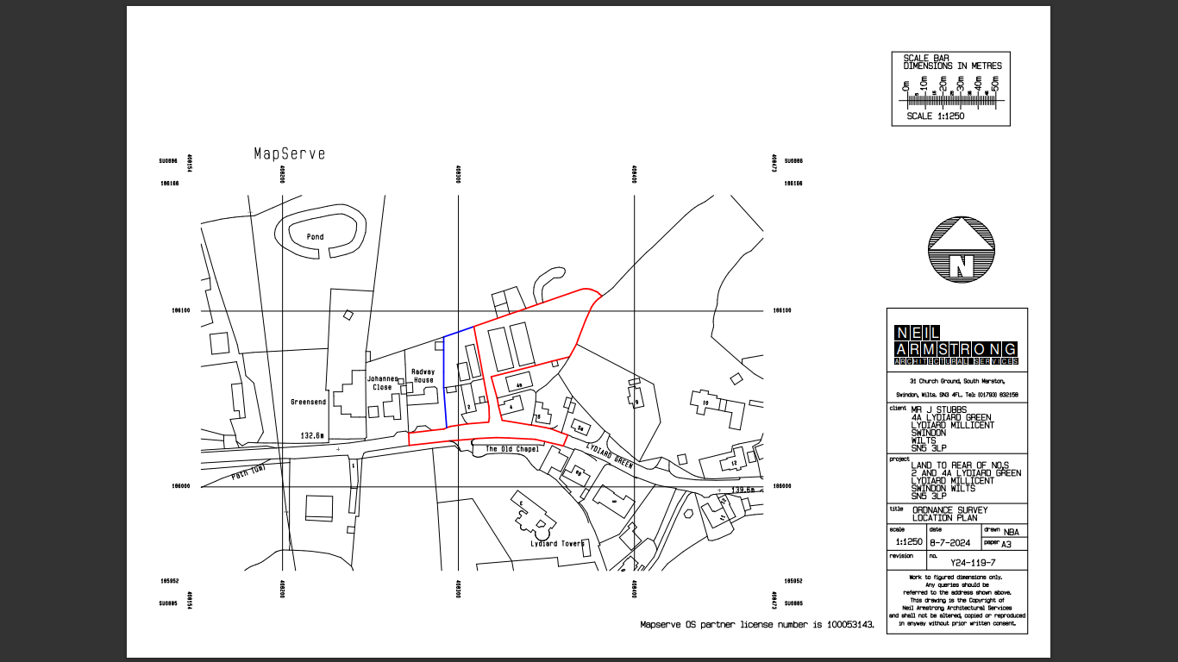

The Lydiard Millicent Neighbourhood Plan mentions Lydiard Green specifically.

LM2 – Managing Design in Lydiard Green
Any development proposals in Lydiard Green must sustain and enhance the distinctiveness of the village and where appropriate the character and appearance of Lydiard Green Conservation Area and its setting.

The use of building forms and materials that reflect the vernacular may be considered appropriate, provided it can be demonstrated that they adhere to the essential village character.

In these regards, infill development within the built area of Lydiard Green, in accordance with Core policies 1 and 2 of Wiltshire Core Strategy would be supported, provided it has full regard to the importance to defining the essential village character of the settlement of brick and stone built cottages and relatively large open green spaces between properties.

The pre-application response from Wiltshire Council (ENQ/2022/01178) talks about replacing 3 workshops and 1 garage plus parking area with 5 residential properties as being unsuitable and to reduce the number of dwellings to no more than 3 across the whole site. The site for the current application is shown as just being the area to the right of the service road with 2 existing workshops and the parking area. This is approximately 80% the original site from the pre-application. The third workshop and the garage not part of the plan marked for development.

A total of 10 parking spaces have been allocated for the 3 houses, 4 of those spaces are assumed to be within garages. In addition, there would be one visitor parking space on the single track access road. LMPC are concerned that there is not enough parking on the site for the number of cars that could realistically belong to 5 bedroomed houses plus visitors. The number allocated conforms to the minimum requirement for Wiltshire Council (3 for 4 plus bedrooms). This may be sufficient for locations where is it possible to park on the public highway, but here it would be dangerous for any parking on the road anywhere through Lydiard Green especially near this location as the access road exit is where the road is narrow and near a bend where visibility is reduced. This is a busy road and used by 53 bus service and school bus/coaches and as a cut through for local traffic and is especially busy at school start and finish and at peak times.

As the proposed properties are behind the existing residential properties they cannot strictly be classed as infill. Lydiard Millicent Parish Council agree with Wiltshire Council that as a brownfield site, this could be a suitable location for residential properties. However, the Neighbourhood Plan states explicitly that “In these regards, infill development within the built area of Lydiard Green, in accordance with Core policies 1 and 2 of Wiltshire Core Strategy would be supported, provided it has full regard to the importance to defining the essential village character of the settlement of brick and stone built cottages and relatively large open green spaces between properties.”

Lydiard Millicent Parish Council object to the application for the reasons stated above. However, if this development were for two smaller “cottages” with larger gardens and sufficient parking, this could be supported.

