Breach of condition 18 of 15/11604/OUT
The Tree Protection Plan approved by the discharge of Condition 18 of planning application 15/11604/OUT is shown below.

The condition clearly states:
“the protective fencing shall be erected in accordance with the approved details. The protective fencing shall remain in place for the entire development phase and until all equipment, machinery and surplus materials have been removed from the site. Such fencing shall not be removed or breached during construction operations.”

8.3.3 of the Arb report, prepared by Silverback Consultancy Ltd and dated December 2017 which also forms part of the DOC states:
“ Once erected the fencing will be retained and maintained in position for the duration of the development. If it is necessary to move the protective fencing advice will be sought from Silverback Arboricultural Consultancy and approval requested from the Wiltshire Council Tree Officer before any of the fencing is altered.”
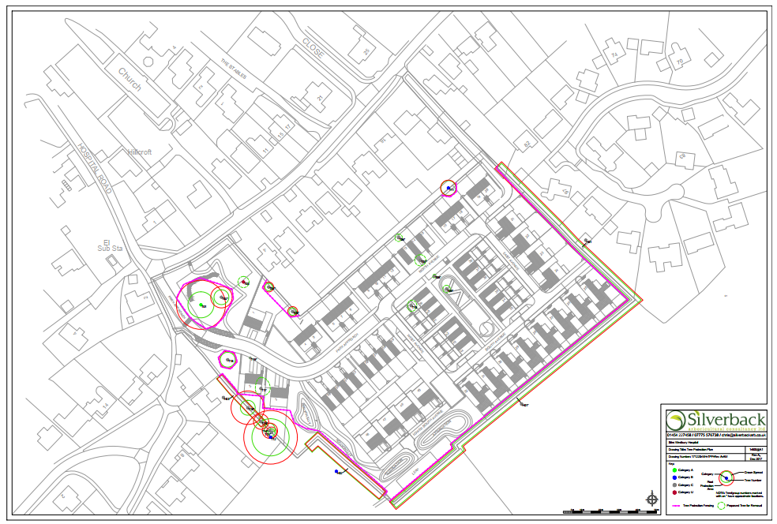

In order to facilitate the construction and installation of the headwall and associated drainage, the protective fencing would needed be moved and significant excavation carried out within the RPA of the protected Cedar tree.

At present,
- no information has been provided regarding correspondence from the Agent/Applicant/Contractor/Arborist seeking approval from the LPA for the change of location of the fencing.
- no information has been provided regarding the methods of construction or installation of the headwall and associated drainage.
- No information has been provided regarding ground level changes within the rooting area of the tree which has been graded as part of the landscaping.
7.3.2 of the approved Arb report states:
“Where any construction activity is proposed which require the repositioning of the tree protection barriers, liaison should be made with the Project Arboriculturalist to ensure no damage occurs to the tree roots.”
The addendum to the arb report dated the 11th of June clearly identifies that the Silverback Arboricultural Consultancy Limited have had no instruction or involvement in the changes of location of the fencing or supervision of the works carried out within the RPA of the tree.

This breach of planning may have caused the severance of structural and fibrous roots which may result in the loss of a healthy protected tree which will significantly alter the visual landscape upon which the proposed development was partly considered. The condition has not been complied with and future action is required to ensure that the tree’s condition is appropriately monitored to avoid concerns relating to risk within a POS, as well as preserving the amenity value and character of the local area.

All information which has not been provided is required to enable the Constructors Project Arboriculturalist to have an accurate measure of the extent of the damage caused and provide a more informed up-to-date addendum. This should include, but is not limited to:
- the location of the underground pipes,
- the area of ground that excavated,
- the method excavation,
- all the materials used to install the headwall and associated infrastructure within the RPA,
- any altering of ground levels,
- the materials used for regrading of the surface during landscaping.

As stated within Condition 18:
“If any retained tree is removed, uprooted, destroyed or dies, another tree shall be planted at the same place, at a size and species and planted at such time, that must be agreed in writing with the Local Planning Authority.”

Due to the lack of information, the tree will require annual monitoring for a period of 5 years by a qualified Arboriculturalist, who should have prior access to the above revised addendum. This is considered an appropriate amount of time to determine if the unauthorised construction works have had a negative impact on the roots of the tree and its physiological processes, and if it will need to be replaced.

