PCT – 15 January 2024 Item 7a

Hannick Homes – Land South of the Forty

1. Overview.

This is an application for a substantial development of up to 49 residential properties on the south-west edge of the town of Cricklade with all rights reserved except for access. The planned development lies outside of the town’s settlement boundary on what is currently a greenfield site. It is important that this development is not considered on its own; it is one of three current speculative planning applications which, if all three were to be approved, would see up to 240 additional properties. This level of development would far exceed the town’s service infrastructure. In addition, the application proposes land for use as a new cemetery, which will be covered separately.

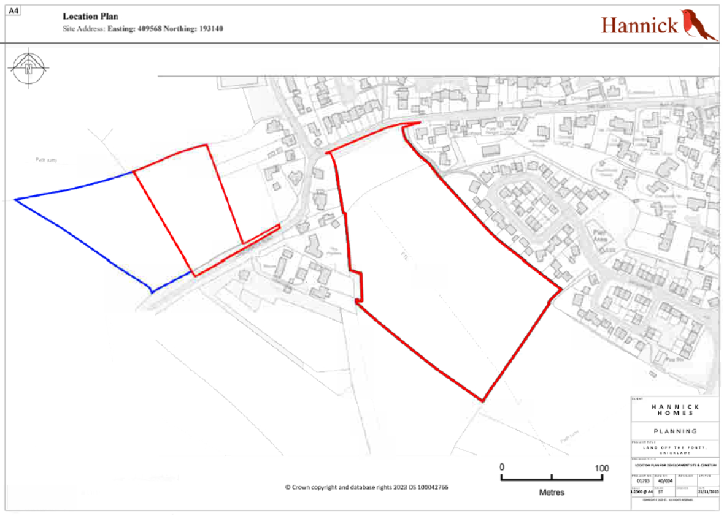

2. Planning Context.

The Planning Statement recognises the fact that the site is outside the Settlement Boundary. Notwithstanding this, the applicant is relying on the overriding provisions of the National Planning Policy Framework that state that policies such as a settlement boundary cannot be relied upon where the Local Planning Authority cannot demonstrate that they have a five-year housing land supply. This is the crux of the applicant’s submission. The latest figures that we have seen from Wiltshire Council indicate that there is currently a 4.6-year land supply i.e. below the five year target.

Wiltshire Council issued their Draft Local Plan in July 2023 which will become the key planning document in the county for the period to 2038. A period of public consultation finished recently. The Plan, after amendment, will then be passed to an Independent Examiner who will carry out hearings in public. The Draft Plan can be amended at any stage of this process before finally being adopted by WC, probably in 2025.

Cricklade is classified as a ‘Local Service Centre’ and so expected to “provide for modest levels of development.” The Draft Local Plan indicates a residual housing requirement for Cricklade of 52 dwellings during the period to 2038.

3. Site and Access.
The site lies to the south of the road known as The Forty, with a main point of access just 50 metres to the east of the junction with Chelworth Road. Plans indicate that there is an existing agricultural access on the southern corner of the development which would be retained, but it is not clear whether agricultural traffic would travel through the proposed development. Cricklade Town Council is concerned that despite the mitigation measures that have been proposed, the increased traffic density at the access point and the adjacent junction will pose a significant risk to vehicles and pedestrians.
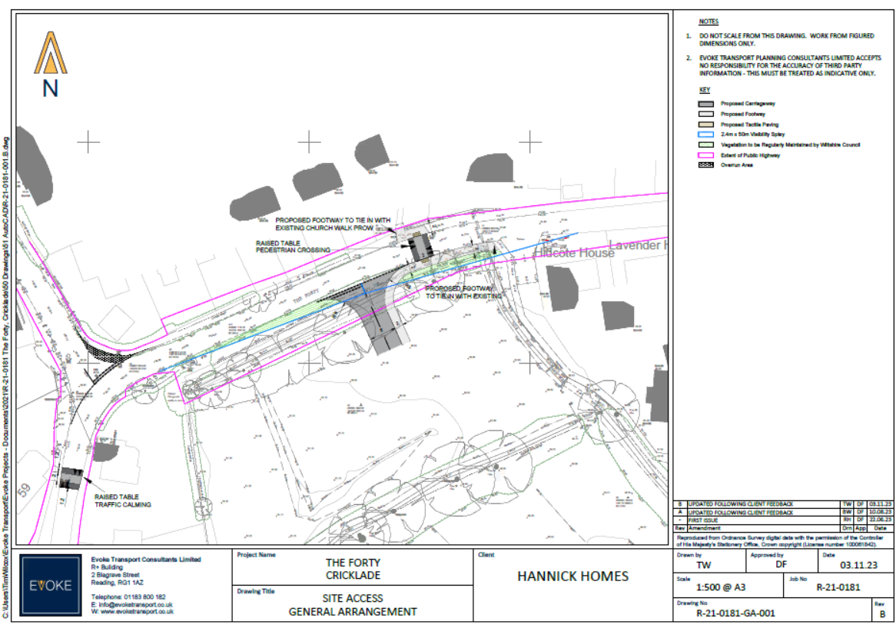

4. Settlement and Housing.
As stated earlier, the proposed development lies outside the Cricklade settlement boundary, and does not comply with the exceptions for building outside the boundary as emphasised by the Wiltshire Draft Local plan. A significant issue with this proposal is the density of housing in the wider area. Taking into account the recent neighbouring development of three houses, the total amount of residential properties will have more than doubled if this development goes ahead. The character of the area would be radically changed from a rural area with historical background to a commuter hub. The development would also reduce the visual and physical separation between Cricklade and surrounding settlements in general and between Cricklade and the strategic housing

development at Tadpole Farm in Swindon in particular. However well designed, the development would not fit with the existing fabric of the town, and is inconsistent with Policies H1, H2 and H3 of the Cricklade Neighbourhood Plan 2026.

5. Traffic Density and Road Safety.
The Forty is a narrow, rural lane and has no pavement on the stretch where the new access is proposed. The increased traffic as a result of this development is a serious concern to current residents. In places, neither The Forty nor The Fiddle are wide enough for two vehicles to safely pass. It is popular with walkers, runners, horse riders, cyclists, families, and dog walkers who could be at increased risk with the additional traffic on The Forty and surrounding roads. The junction of The Forty and The Fiddle/Chelworth Road has reduced visibility and is a collision risk. Emergency vehicles access is also of concern as the route via The Forty or The Fiddle is often single flow due to parked cars on the Forty and the very narrow road on the Fiddle will impede any access. The applicant proposes traffic calming measures at the junction of The Forty and The Fiddle/Chelworth Road, as well as an enhanced footway and improved visibility at the junction of The Forty and Purton Road. Nevertheless, Cricklade Town Council is concerned that, without a major project to improve the full length of The Forty and The Fiddle, the increased traffic flow would pose an unacceptable risk.
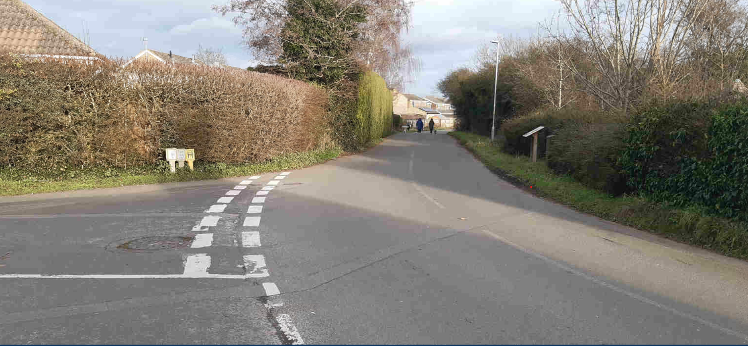
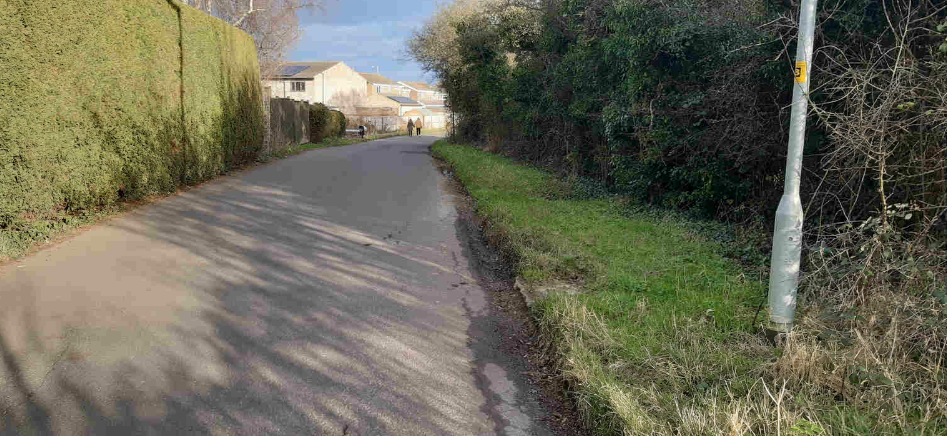

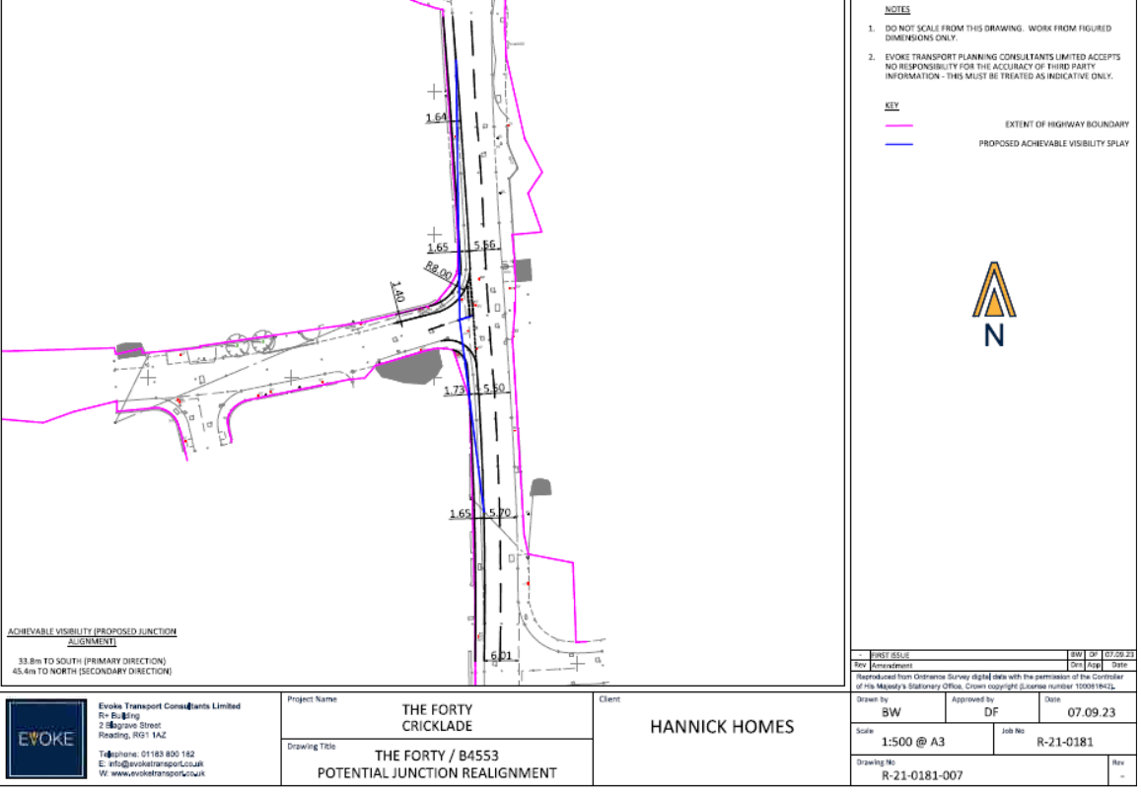

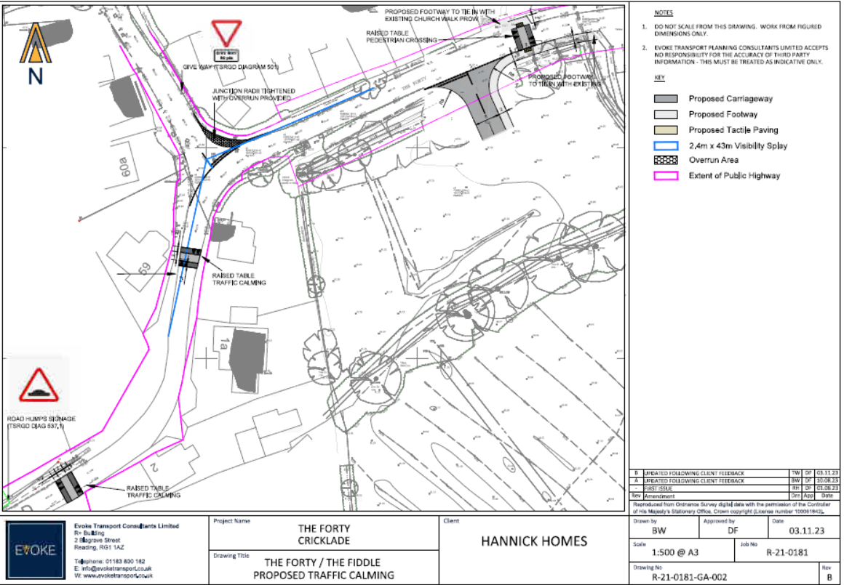

6. Flood Risk.
The Flood Risk Assessment (FRA) provided with this application states correctly that the site lies within Flood Zone 1 but accepts that parts of the proposed site carry a high risk of rainwater flooding. It does not, however, mention the “Flood Relief Scheme”, which involves a 50+ meter long high-capacity culvert crossing The Fiddle/Forty junction, which was installed in 1989 to relieve the previous flooding problems. and discharges rainwater from adjacent land, via the culvert, into the large ditch running along the northern boundary of the proposed site. Cricklade Town Council would need to be reassured that this network of ditches would not be compromised by the development of the site. Regardless of the conclusions of the FRA, it is a fact that the area has seen significant flooding in 2023/4 and before, including surface water flooding of The Fiddle, The Forty and Chelworth Road, as well as the proposed development site.

7. Drainage and Sewerage.
Thames Water have advised that with regard to foul water sewerage network infrastructure capacity, they would not have any objection to this planning application, based on the information provided. However, current residents have reported that the sewerage system in this area is already at capacity, frequently leading to raw sewerage flowing into the road and private land during periods of heavy rain and must avoid flushing downstairs toilets during such weather. Most recently in November 2023, Thames Water attended the area following one such heavy rainfall. Thames Water advised in writing, that this was due to 'hydraulic overload' of the sewer system (it did not have capacity to cope), causing sewerage water to breach the hatches on The Forty and cause flooding onto the road and surrounding properties. Cricklade Town Council would wish to be reassured that a full assessment will be carried out before any final planning application is submitted, but at this stage, the applicant has not demonstrated that they will not increase the risk of flooding or surface water run-off within the site or to any surrounding sites or areas in general. The application therefore fails to satisfy Policy H8 of the Cricklade Neighbourhood Plan 2026.

8. Infrastructure.
The pressure on the town’s service infrastructure that would be exerted by this development cannot be underestimated. While St. Sampson’s primary school has some limited capacity to take on additional pupils, the development would generate an increased transport requirement for secondary school pupils resulting in an increased traffic flow including buses and private cars. Both doctors’ surgeries are assessed as already at maximum capacity, and a mitigation plan would be necessary before the application could be supported. Town centre parking and traffic density is a known issue with safety concerns, and the development is sufficiently far away from the centre that many residents will choose to use motor vehicles, rather than make that journey on foot or bicycle.

9. Open Space.
Cricklade Town Council welcomes the illustrative Site Plan which indicates that the area adjacent to The Forty will remain as open space apart from the access road to be constructed across it. We would like to see that area of green space transferred to the Town Council either under Section 106 or by Unilateral Undertaking. This would ensure that the Council could control what takes place on that land in years to come. Similarly, the land identified for cemetery use is not necessary in planning terms – it is more by way of a community benefit. In these circumstances it could be preferable for the Council to request a Unilateral Undertaking from the applicant to deliver ownership of the cemetery site to the Council should consent for the residential development be approved. That would offer additional flexibility in the use of that land so that ownership would still pass to the Council, even if the cemetery application fails for any reason, so that the land could be used for alternative purposes such as allotments.
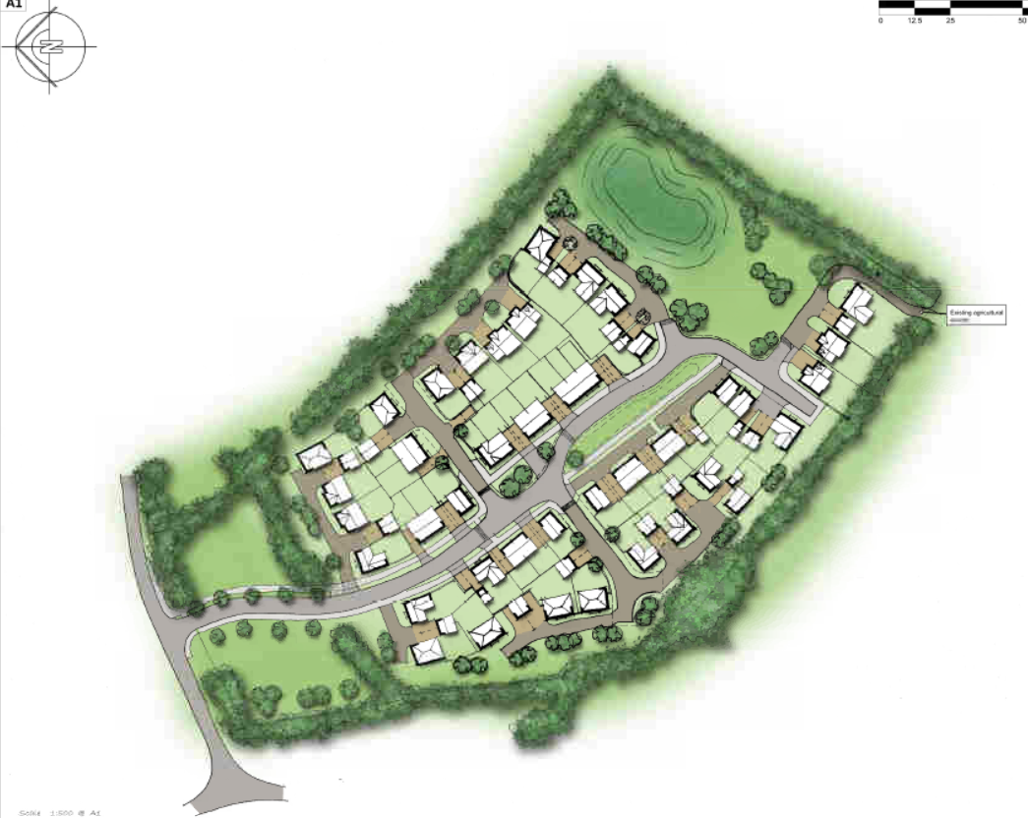
9. Heritage.
The historic route of the North Wilts Branch of the Wilts & Berks Canal passes along the western edge of the development site. The route of the canal is protected under Core Policy 53 Wiltshire’s Canals for historic interest and restoration, which is not referenced in the list of relevant policies in the Planning Statement. Broadly similar protection is proposed in the draft of Wiltshire Council Local Plan 2020-2038.

10. Ecology.
As already stated, this is an application for development on a greenfield site. Cricklade Town Council believes that our surrounding countryside needs to be protected, and that this proposed development would be a loss of grazing land and would drive wildlife away. Further consideration also needs to be given to the effect on the North Meadow Special Area of Conservation. As stated by the Cricklade Court Leet in their letter of 11 January, there are now 3 active speculative planning applications totalling 238 houses within 1.2km of North Meadow SAC, of which this application is one. While it is true that this application would be the least damaging for North Meadow SAC being furthest away from the protected site at 1.2km, the approval of any two of the current speculative planning applications would be seriously damaging to the North Meadow SAC. As stated earlier, therefore, it is important that the entirety of proposed development is taken into account as a whole, rather than considering this and other applications individually.

11. Climate Change.
A detailed response has been submitted by the Climate Team. However, the Wiltshire Core Strategy sets out that the key issues that will contribute to tackling climate change through a number of different areas, such as:
- focusing growth at the larger settlements to help minimise the need for travel,
- ensuring that new development can withstand future changes in climate and add minimally to carbon emissions,
- provide a network of green infrastructure; and
- ensure more sustainable forms of transport.
While build quality is designed to minimize carbon emissions, the location of this proposal does not achieve these aims. Few of the residents of this new development can be expected to find work in Cricklade and, consequently, motorized transport to and from the town will increase significantly. As such, we do not believe that this scale of development is consistent with Core Policy 60, or associated policy requirements set out in the draft Wiltshire Local Plan.

13. Archaeology.
The application does not contain enough information with which to accurately assess the archaeological potential of the application area. A geophysical survey of the site should be undertaken by a competent geo-physics contractor. Following this it is likely that an archaeological trial trench evaluation will be undertaken to test the results of the geophysical survey. This should allow for fully informed advice as to the need for any further archaeological works to mitigate the likely impact of the development upon the archaeological resource.

14. Cemetery.
As part of this planning application, Hannick Homes proposes to make land to the north of Chelworth Road available for use as a cemetery. A new access point would be provided for vehicular traffic, and a safe pedestrian access could be provided along footpath CRIC 29 from The Fiddle.
In terms of need, Cricklade’s existing cemetery will run out of space within the next 10 years, so the proposal is welcome. Should this element of the application be approved, Cricklade Town Council would wish to see a condition requiring the developer to upgrade that section of CRIC 29 to an accessible standard. In addition, flexibility of the use of the site should be permitted because full use as a cemetery is a long-term requirement. To that end, ownership of the site should be transferred to CTC for future management and maintenance.
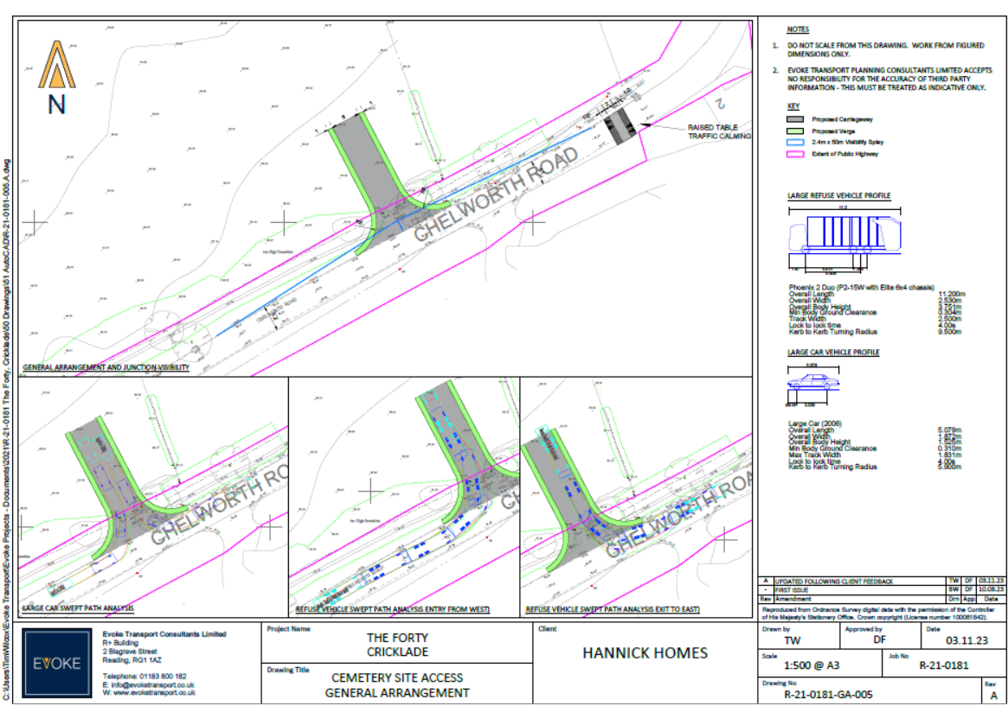

15. Cricklade Town Council Decision.
Cricklade Town Council (CTC) like to publicly commend Hannick Homes as being the only developer who CTC have spoken to in the last 10 years who have listened to the councils concerns and requirements and CTC like to acknowledge their hard work and attempts to deliver on these requirements. In the preliminary plans, houses were shown as directly fronting onto The Forty. At the suggestion of CTC, the development site was moved back, away from the road to allow the field beside the road to become an area of public open greenspace. CTC also asked for bungalows to be in the plans which again Hannick listened to and amended the plans.
Hannick Homes have also picked up from the council infrastructure plan that Cricklade needs a cemetery. Cricklade Town Council are unaware of other developers reading these plans and offering Cricklade something from it. Residents of Cricklade want a cemetery and as a Town Council need to deliver on this. An appeal for an ideal location has gone out for several years with no success.
------------------------------------------------------------------------------------------------------------------
CTC OBJECTS this application as per the recommendation with 6 votes against the application, 2 in support and 2 abstentions, on the grounds that it fails to comply with:
• Wiltshire Council Core Policies CP1 - Settlement Strategy and CP2 - Delivery Strategy,
- Cricklade Neighbourhood Plan Policies H1 - The Settlement Boundary, H2 - Visual Separation of Settlements, and H3 – Design of New Housing,

- Cricklade Neighbourhood Plan Policy H8 - Foul Water Management, Flood Risk and Surface Water Management,

- Wiltshire Council Core Policy CP50 - Biodiversity and Geodiversity

Further, the following elements show that the site is not currently deliverable and so should be REFUSED:

a) Ecology: the inability to quantify the impact on the North Meadow SAC remains a significant concern,
b) Access and Traffic Density: the vehicular access proposals do not adequately address the increased risk to vehicles and pedestrians on The Forty and at the adjacent junction,
c) Archaeology: insufficient information for a full assessment,
d) Surface Water Drainage: the application fails to recognize the surface water flooding that already exists on and around the site, and which would be exacerbated by the development,
e) Foul Water Management: the application fails to recognize the sewerage issues that already exists at times of heavy rain

