Highway Development Management Consultation Response

Planning Application Ref: 20/03641/OUT

Site Address: Land South of White Horse Business Park, Trowbridge, Wilts

Proposal: Outline application for up to 70 dwellings, landscaping, green infrastructure, associated drainage measures and vehicular access from the A363 as well as all associated works. Matters to be considered: Access into the site

Date of Consultation Response: 21/11/2023

I note the consultation relates to revisions made in respect to the development of the site for residential units and that this application has been ‘live’ for a number of years now. Following the departure of my former colleague from this team, I have been asked to consider these latest revisions.

I am aware that the site is housing allocation H2.2, which has been earmarked for up to 175 units. I am also aware that the site subject to this application is only part of the H2.2 allocation, with additional units proposed on adjacent land under application reference PL/2022/05426. I understand that the revisions include a reduction in the number of units on this site, from 100 to 70 units and also, the removal of the care home element. I understand that the existing proposals on the adjacent land now seek the provision of 62 units, bringing the overall H2.2 allocation to 132 units in total, although I am aware that additional land may also be developable that sits outside of the existing planning submissions area. All of these 132 units are intended to be accessed from the A363, with the access arrangements subject to detailed assessment within this submission.

Previously, my former colleague had accepted the principle of development and the principle form of access, which is proposed as a right turn lane, with additional Toucan crossing and footway/cycleway provision. However, there were a number of clarifications and revisions sought in my former colleague’s latest response and this latest submission seeks to address these points.

The right turn lane access arrangement is now shown with 3.5m through lanes and a 3m turning lane, which I consider to be suitable. It is noted that this would require some minor road widening to facilitate the access arrangements. Swept paths have also now been provided for a refuse collection vehicle, showing that all turning manoeuvres are adequate in to and out of the site with 12m corner radii now shown. The proposed Toucan crossing, which is considered to be essential, has been relocated to a position where it sits within the right turn lane. It is unusual for a signal controlled crossing to be located within a right turn lane feature, however, its location does alleviate the concern of backing up on the roundabout and also, provides good connectivity for cyclists/pedestrians from the development to head in both directions, in particular, onward travel journeys towards Trowbridge town centre, via the approved Elm Cross development (19/11459/OUT). I am satisfied that adequate visibility of the Toucan crossing signal head has also been adequately shown for any vehicles waiting behind a stopped bus. This Toucan crossing therefore helps to connect to the Trowbridge Transport Strategy route PC12 and also forms part of/connections to the Primary Route 8 and Secondary Routes 18 and 20 of the emerging Trowbridge Local Cycling and Walking Infrastructure Plan (LCWIP). The right turn lane/toucan crossing/access arrangements and the footway/cycleways will all require detailed approval via the S.278 Highways Agreement process, but for planning purposes, I am satisfied with the level of detail provided.

The latest ‘Proposed Access Plan’ REV D, shows that 3m wide shared use cycle paths will be provided along the full frontage of the site to the West, up to the roundabout and opposite the site, from the new Toucan, to the West to Drynham Lane, including crossing provision on Drynham Lane. To the East of the site access, the cycleway is provided up to the new bus stop and on the Northern side of the A363, the 3m wide cycleway will be provided from the Toucan crossing by the approved development at Elm Cross to the East, which I am aware is secured by condition. Whilst the shared use paths proposed offer an improvement, this infrastructure does not conform to Local Transport Note 1/20 (LTN 1/20), which requires segregated walking and cycling routes.

Having considered these requirements, I feel that the path leading from the access, to the Toucan and bus stop to the East and the full length of the path on the North side of the A363 from the Toucan to Drynham Lane to the West, should be designed to meet LTN 1/20 standards, with a 2m wide segregated cycle path and a separate 2m wide footway. Whilst this seeks additional infrastructure provision in terms of width, the Southern shared path to the West of the site access does not need to be 3m, as this would be suitable as a 2m wide footway only. Revisions to the design will be required to show these essential improvements, which will ultimately all need to be secured through condition/S.106 obligation. Please see below indicative mark-up plan showing the alterations required.

In addition to the revisions mentioned above, I am not satisfied that the cycle path terminates a short way into the site. The site access road extends a significant way into the site before the built-up area of the new residential units and I would expect this first section of access road to include an LTN 1/20 compliant cycle route up to this point. It is noted that the Masterplan for the allocation states that the principle route would be a 30mph limit through the site, however, I disagree with this and believe that as the principle highway route will not have any through traffic, only this first section of access road should be 30mph, with the rest of the route designed to meet 20mph zone guidance and thus facilitate on road cycling. Whilst layout is a reserved matter, the applicant should take note of this requirement, as well as the need to ensure that the principle route has priority at the junction where the residential units start (and not the side road).

I note that the two new bus stops will be provided with shelters, raised kerbs and Real Time Passenger Information boards (RTPI). The bus stops will also need to be included within and provided via the S.278 Highways Agreement process.

I am aware that a Framework Travel Plan has been submitted and that my former colleague was generally content with its content, with the exception of the inclusion of Travel Vouchers for each household to a value of £250 (or £150 where occupants have concessionary travel) and bus season tickets for each unit also. As a detailed Travel Plan will be required for submission once the exact mix of units is confirmed, I am satisfied that these elements can be secured through S.106 Travel Plan obligations.

Noting the allocation, a number of highway contributions will also be required to integrate the development into the wider community. These will need to align with the financial contributions also being sought from the adjacent development parcel. Whilst I note figures were provided by my predecessor, a significant amount of time has since past and these contributions will thus need to be uplifted accordingly.

Therefore, I seek the access/highway amendments discussed above and shown indicatively below, prior to providing a final Highway recommendation;

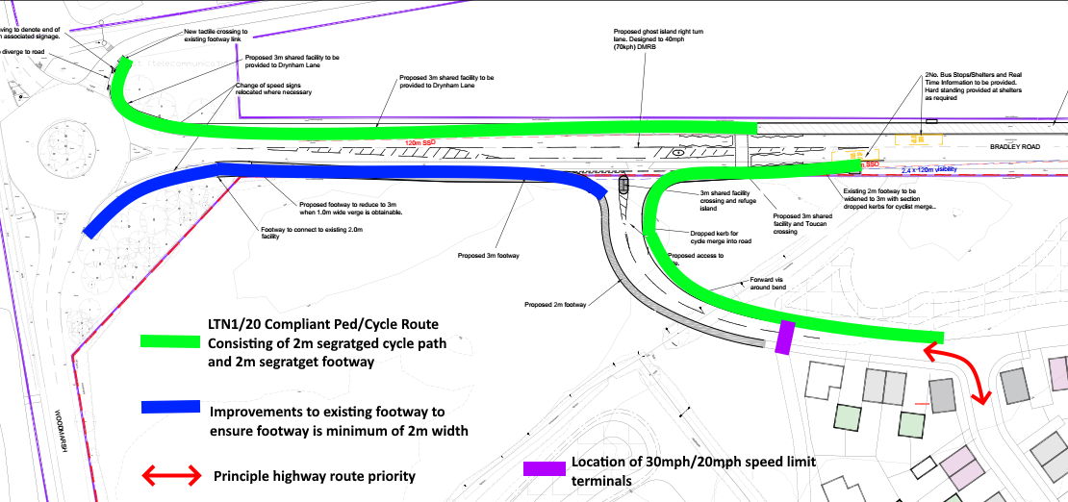

If you have any queries regarding the above advice, please contact Chris Manns on Christopher.Manns@wiltshire.gov.uk

