Wiltshire Council Planning Consultation Response

LANDSCAPE

Officer name: Maxine Russell
Date: 15/10/2020

Application No: | 20/03641/OUT
Proposal: | Outline application for up to 100 dwellings and a care home (Class C2 Use) of up to 64 beds (up to 3,750 sqm), as well as vehicular access from the A363. Matters to be considered: Access in to the site
Site Address: | Land South of White Horse Business Park, Trowbridge, Wilts
Case Officer: | David Cox

Recommendations:

Landscape holding objection - Policy H2.2 Land off A363 at White Horse Business Park of the adopted WHSAP requires that the Development will take place in accordance with a masterplan approved by the Council as part of the planning application process. The design and layout will take account of all policy requirements, including the timely and coordinated provision of necessary infrastructure to achieve a comprehensive development of the site.

The extent of the allocation is illustrated below:
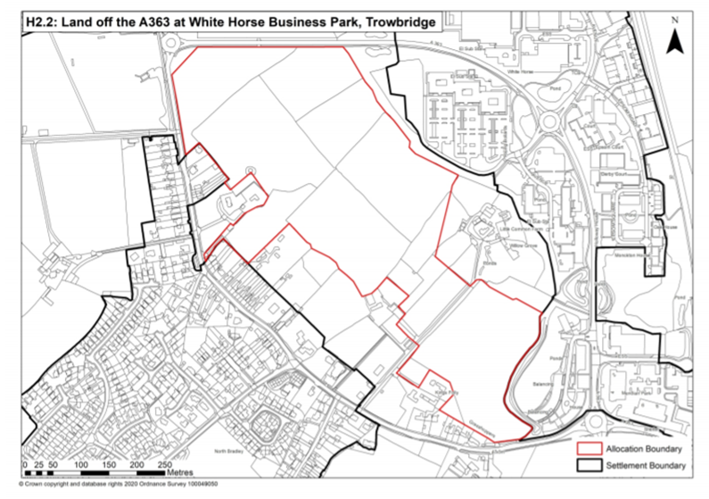

Agreement of the masterplan between the developers and Wiltshire Council is promoted as a positive way to ensure a coherent framework and landscape strategy for the site. This positive approach to master planning the extents of the site has been successfully implemented in the West Warminster Urban Extension. Unfortunately, the allocated site H2.2 has come forward as two separate outline applications without an overarching strategy for the design of the new infrastructure. The result is two distinct places that appear detached rather than part of a holistic strategic site. Furthermore, a third parcel of land to the south of Little Common has been omitted.

The application includes a Landscape and Visual Appraisal (LVA) that has been prepared following current best practice and published technical guidance. The scope of the LVA was agreed with Wiltshire Council and is considered appropriate and proportionate to the scale of the development. The LVA is supported by desktop research and field studies taken during autumn and winter months allowing for the assessment of the worst-case scenario.

In the review of planning policy, guidance and designations the LVA does not identify the requirement for a site wide masterplan for WHSAP Policy H2.2 (para. 3.16-3.17). The review of the Neighbourhood Plan is welcomed. The aspirations of the community for the H2.2 site are explained at para.8.8 of the NP that:
‘…if the site could not be avoided (which the community preferred) then it should be reduced in size and development concentrated to the east and north, leaving as wide a landscape gap between the site and Trowbridge as possible. This was accepted and it was agreed that the LPA and the Parish Council should meet to discuss details. Wiltshire Council agreed to reduce the site in size from a level of 225 (proposed) to 175 homes.’
This is important because this is how the community could ensure there was a physical and visual separation (to the north east) from the proposed houses. The current sketch layout does not support this approach strictly enough.

I agree with the baseline assessment that the site is an undesignated, unremarkable landscape and not considered to be part of a valued landscape in the context of paragraph 170 of the NPPF. It has a rural character with urban influence along the boundaries with Trowbridge and White Horse Business Park to the north/north east. The nature of the flat, rolling topography and the mature hedgerow vegetation close wider views in the landscape reducing the visual envelope to a local scale. As an allocated housing site, the Council accepts that there will be a permanent change in character from rural to urban to meet local needs.

In terms of visual effects, I note that the experience of residents off Woodmarsh Road will vary depending on their existing garden vegetation. The parameters plan defines a minimum offset of 50m between developments. However, the ‘Landscape constraints and opportunities plan’ shows at least 30m (minimum) of this buffer will be used to create new woodland, up against the gardens on Woodmarsh. This will help to filter views of the new houses but I feel it shuts down the relationship of North Bradley and its perceived gap to the NE, which is currently open field. There are obviously huge biodiversity benefits (bats etc) which I wholeheartedly support but it appears to me that gap has been poached; the new planting seemingly screening North Bradley rather than screening the new development. I am interested to hear the residents views on this, whether they would prefer a more open aspect or are quite happy with the proximity of the proposed woodland planting and the change in landscape character they would experience.

Overall I agree with the judgements and conclusions of the LVA. I do consider that the assessment is robust and appropriate to inform a planning decision. The predicted landscape and visual effects will be experienced at a local level on the site and its immediate environs and are not considered to have any significant adverse residual effects. The current proposal retains and enhances the existing vegetation structure where possible and will provide a new quantum of green infrastructure that will be accessible to residents.

Going forward I would like to see a joined-up masterplan approach to Site H2.2 with a separation gap to North Bradley that is appropriate and identifiable. I appreciate that this application is for outline consent with landscaping to be approved as a reserved matter but it would give me some comfort if there was some agreed detail for the landscape strategy at this stage. For example we would expect to see SUDs features to be landscaped with marginal planting rather than simple scrapes; areas of new planting differentiated into woodland, scrub or ornamental; areas of wildflower meadow and amenity grassland identified; opportunities for large canopy trees in public open space. This would provide assurance that a quality landscape scheme will be delivered in the future.

