Planning Application 20/03641/OUT
Land Between North Bradley village and the White Horse Business Park

Comments by David Feather, 3 Broadley Park, North Bradley, BA14 0SS - 01225754688

Transport Aspects

1 A comment from the Highways engineer is :-

Re Proposed Development, Access, Sections 12-13. Common Lane is unlikely to be accepted for any development general vehicular access. The end result for Common Lane will be emergency access for vehicles, access to the existing Common Lane properties, and development pedestrian and cycle access only. The Outline application needs to be submitted on this basis with TA vehicle distribution and local junction impacts also assessed on all vehicular access being via the access point to the northern end of the development.

This is recognised in the Transport Assessment, but whether this will be acknowledged by the developer of what is termed Site B in the Assessment is not known. It is important that both sections of H2.2 development are considered together and a masterplan is required that satisfies the development target of 175 homes, with an allowance for the nursing home.

It should be clear to anyone looking at the site that Little Common Lane is completely unsuitable for more traffic than already uses it. Under normal non-pandemic conditions it is a well used pedestrian route, particularly at lunchtimes with workers from the Business Park and at other times by residents of North Bradley. As such, it is a community resource which needs to be protected.

2 Considering the Transport Assessment by Badingham Limited, all the document processing and checking was done by the same individual. For such an important document this is bad practice, as a significant error could occur and not be picked up. The Wiltshire Transport Planners should check the submitted information extra carefully.

3 The Council Highways engineer was concerned that trip generation data proposed for this development was much lower than that for the Ashton park development. Clearly, they should be the same, but the current pandemic might have a lasting effect on travel patterns. The number of people who will work from home might increase. On the other hand, travellers will avoid buses and trains and the number of children driven to school might go up as parents avoid the school bus. A recent survey by YouGov-Cambridge centre found that 28% of people expected to drive more after the pandemic restrictions whilst only 16% expected to drive less. There could be a step change in trip generation factors, so I suggest that some sample surveys should be done next year to try to assess the new situation.

4 In the Transport Assessment, the analysis of junctions has only gone as far as Silver Street Lane, whereas previous planning applications have shown that the junction of Bradley Road with County Way is the most critical on that route and, as far as I am aware, no proposals to improve it are planned.

5 Table 14 of the Transport Assessment is suspicious as, before the Cova 19 pandemic and travel restrictions, in the evening peak, traffic queued back into the White Horse Business Park from the Bradley Road roundabout. This could be around 200-300m long. It was possibly caused by congestion in Bradley Road, but this caused many drivers to rat-run through Woodmarsh. Adding more vehicles onto the A363 could only increase the rat-running so, as mitigation, the H2.2 developers should pay for traffic calming on Woodmarsh. Unfortunately, I do not see a way of improving the roundabout capacity as the main movement is running into the single lane of Bradley Road north. Increased queuing will have to be accepted if the 175 houses are to go ahead, so the developer should pay to install traffic calming along Woodmarsh to be installed before the houses are occupied.

6 Also, this development should not be permitted to go ahead before the A350 diversion is in operation to offer some alternative route from North Bradley village into Trowbridge.

7 It is clear that the Silver Street Lane/Bradley Road/Wiltshire Drive junctions will be a problem. What the transport consultant might not have appreciated is that practical experience indicates that there will be a requirement for pedestrian crossings at those junctions as the traffic increases. This will severely reduce the traffic carrying capacity and so, produce significant congestion and consequent air pollution. The Elm Grove Farm developer was prepared to improve the junction capacity. Houses on site H2.2 should not be permitted to be occupied until junction improvements, with pedestrian crossings, are carried out.

8 As many other developers have argued. So does this developer eg -

6.42 The junction capacity assessments have demonstrated that the traffic impacts associated with the development of the wider H2.2 site allocation would not have a detrimental impact on the operation of the local highway network.

A number of small impacts added together will have a significant effect. Wiltshire Council should have a strategy to assess what percentage of off-site works should be funded by each developer, as suggested by the consultant :-

6.46 Based on the above modelling, it is therefore considered that the full H2.2 development could be delivered in full without the need for off-site highway mitigation. However, should Wiltshire Council determine that a suitable mitigation scheme is required, this development could provide a contribution towards such improvement that is proportionate to its marginal impact.

Wiltshire Council should pursue this suggestion.

Site Access Design Considerations

9 The refuge will not serve any pedestrian benefit, as the land on the north side is not expected to be developed. Its provision will lead some pedestrians to cross at an inappropriate place and the construction will just be a road safety hazard to vehicular users.

10 The footway at the junction should be designed such that the verge continues up to the access crossing point. It should be carried out in blockwork to match existing. As the developer will own the land, the footway on each side should lead directly to the crossing point, not go around the radii to impose unnecessary movements on disadvantaged footway users.

11 The right turn lane could be avoided and the junction made safer by requiring vehicles to u-turn around the roundabout at Ascot Court, which is large enough to make this manoeuvre safely.

Other Highway Aspects

12 At the Bradley Road roundabout the pedestrian crossing point over Drynham Lane is too far from the junction. Drynham Lane has minimal vehicular traffic and people in pushchairs and pushing prams etc should not be required to go out of their way unnecessarily to use the dropped kerbs. Wiltshire Counci policy is to make pedestrian routes as convenient as possible.

13 Another pedestrian crossing facility will be required across Bradley Road at the Woodmarsh roundabout. It is already very difficult to cross there and the increase in traffic expected would make it impossible without assistance. The Boundary Walk footpath emerges here and there are bus stop movements to consider.

Planning

14 Frustratingly, the landscape assessment consultants seem to have have failed to understand or have ignored the character of North Bradley village and its surrounding area. Even a visitor seeing it for the first time would appreciate that it is a village set in open fields. The suggested woodland alongside Woodmarsh would be alien. What is required to maintain a landscape gap is a reasonably sized field width over the fields involved. Something of the order of 100m would be the minimum.

15 WHSAP specifies 175 as the housing capacity of H2.2 site. This amount and the location were carefully negotiated between Wiltshire Council and North Bradley Parish Council to achieve an appropriate landscape gap. The applicant was aware of this but has ignored it. The current application with 100 houses and a 64 bed nursing home would take up almost the full allocation. It is essential that Wiltshire Council maintains its agreement with North Bradley Parish Council and only grants permission for 175 total (including an allowance for the nursing home) and should make this plain in its response to this application. The developers should be required to submit a joint masterplan on the lines of the co-operation in public consultation and a suitable division of the 175 allocation agreed.

Ecology

16 The applicant’s consultants have made much of the activities of bats foraging in the landscaping of the White Horse Business park. Currently the bats can fly south from this area across to Southwick Country park and so to the Bradford on Avon area. They have shown proposals to bolster this by more tree planting. However they seem to have overlooked the bats’ need for open flight lines. Their housing development, together with the proposed Ashton Park is going to put a deep barrier across the flight line to the Southwick Country Park.

17 Surely there is a need to consider alternative flight lines for the bats. I suggest that something on the lines shown on the attached sketch drawing. The currently central hedge could be widened and thickened, still leaving a suitable landscape gap for North Bradley village.

General

18 I would comment that the planning system is criticised for being slow and unwieldy. I feel that this application provides an explanation of why much of this happens. I can see how this can be the result of developers trying to over-develop a site despite, in this case, having a housing number of 175 clearly set out for them. They are also well aware of the North Bradley Neighbourhood Plan but appear to have effectively ignored it. Similarly they have ignored the views expressed by North Bradley residents at the exhibition. This site seems set for conflict and waste of effort and money on the part of developers and local authority. What a sad situation!

Df 1/7/2020
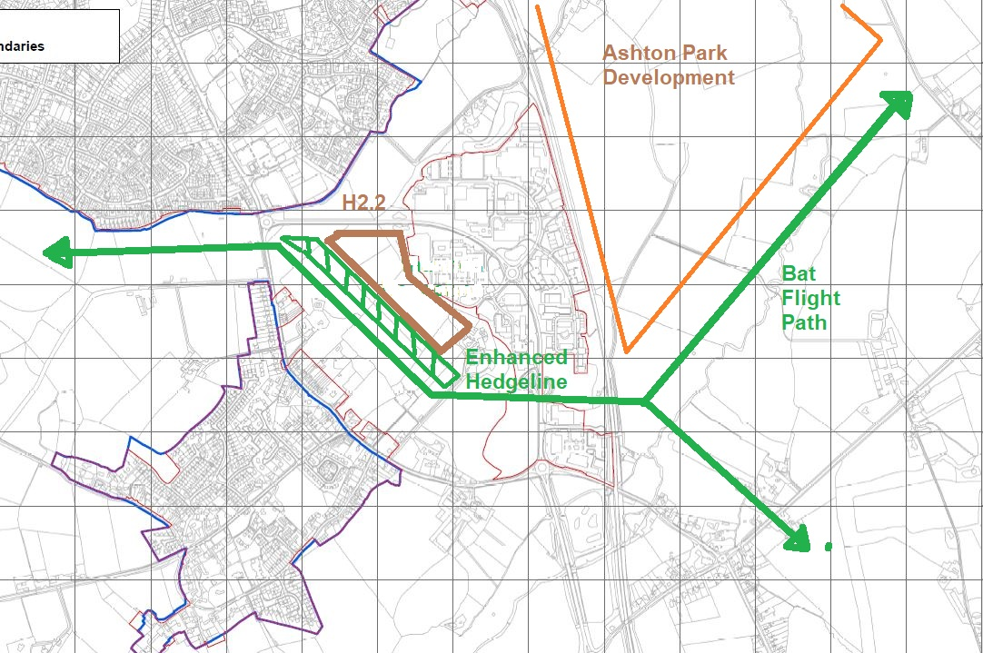
Proposed New Flight Lines for Bats From the East of Trowbridge

